UNITED STATES SECURITIES AND EXCHANGE COMMISSION
Washington, D.C. 20549

FORM 10-Q

☒ QUARTERLY REPORT PURSUANT TO SECTION 13 OR 15(d) OF THE SECURITIES EXCHANGE ACT OF 1934
For the quarterly period ended March 31, 2024
OR
☐ TRANSITION REPORT PURSUANT TO SECTION 13 OR 15(d) OF THE SECURITIES EXCHANGE ACT OF 1934
For the transition period from ______ to ______
Commission File Number 1-31398

NATURAL GAS SERVICES GROUP, INC.
(Exact name of registrant as specified in its charter)
Colorado |  |  |  |  |  | 75-2811855
(State or other jurisdiction of incorporation or organization) |  |  |  |  |  | (I.R.S. Employer Identification No.)

404 Veterans Airpark Ln., Ste 300
Midland, Texas 79705
(Address of principal executive offices)
(432) 262-2700
(Registrant’s telephone number, including area code)
Securities registered pursuant to Section 12(b) of the Act:
Title of each class |  |  | Trading Symbol |  |  | Name of each exchange on which registered
Common Stock, Par Value $0.01 |  |  | NGS |  |  | New York Stock Exchange

Indicate by check mark whether the registrant (1) has filed all reports required to be filed by Section 13 or 15(d) of the Securities Exchange Act of 1934 during the preceding 12 months (or for such shorter period that the registrant was required to file such reports), and (2) has been subject to such filing requirements for the past 90 days.
Yes x |  |  |  |  |  | No o
Indicate by check mark whether the registrant has submitted electronically every Interactive Data File to be submitted pursuant to Rule 405 of Regulation S-T (§232.405 of this chapter) during the preceding 12 months (or for such shorter period that the registrant was required to submit and post such files).
Yes x |  |  |  |  |  | No o
Indicate by check mark whether the registrant is a large accelerated filer, an accelerated filer, a non-accelerated filer, or a smaller reporting company. See the definitions of “large accelerated filer”, “accelerated filer”, and “smaller reporting company” and "emerging growth company" in Rule 12b-2 of the Exchange Act.
Large accelerated filer o |  |  | Accelerated filer o |  |  | Non-accelerated filer ☒ |  |  | Smaller reporting company ☒ |  |  | Emerging growth company ☐
If an emerging growth company, indicate by check mark if the registrant has elected not to use the extended transition period for complying with any new or revised financial accounting standards provided pursuant to Section 13(a) of the Exchange Act.o
Indicate by check mark whether the registrant is a shell company (as defined in Rule 12b-2 of the Exchange Act).
Yes ☐ |  |  |  |  |  | No x

As of May 6, 2024 there were 12,437,074 shares of the Registrant's common stock, $0.01 par value, outstanding.

Part I - FINANCIAL INFORMATION
Item 1. Consolidated Financial Statements
Unaudited Condensed Consolidated Balance Sheets |  |  | Page |  |  | 1
Unaudited Condensed Consolidated Statements of Operations |  |  | Page |  |  | 2
Unaudited Condensed Consolidated Statements of Stockholders' Equity |  |  | Page |  |  | 3
Unaudited Condensed Consolidated Statements of Cash Flows |  |  | Page |  |  | 4
Notes to Unaudited Condensed Consolidated Financial Statements |  |  | Page |  |  | 5
Item 2. Management's Discussion and Analysis of Financial Condition and Results of Operations |  |  | Page |  |  | 14
Item 3. Quantitative and Qualitative Disclosures about Market Risk |  |  | Page |  |  | 20
Item 4. Controls and Procedures |  |  | Page |  |  | 20
Part II - OTHER INFORMATION
Item 1. Legal Proceedings |  |  | Page |  |  | 21
Item 1A. Risk Factors |  |  | Page |  |  | 21
Item 2. Unregistered Sales of Equity Securities and Use of Proceeds |  |  | Page |  |  | 22
Item 3. Defaults Upon Senior Securities |  |  | Page |  |  | 22
Item 4. Mine Safety Disclosures |  |  | Page |  |  | 22
Item 5. Other Information |  |  | Page |  |  | 22
Item 6. Exhibits |  |  | Page |  |  | 23
Signatures |  |  | Page |  |  | 25

PART I – FINANCIAL INFORMATION

Item 1. Financial Statements

NATURAL GAS SERVICES GROUP, INC.
CONDENSED CONSOLIDATED BALANCE SHEETS
(in thousands, except par value)
(unaudited)
 |  |  | March 31, |  |  |  |  |  | December 31,
 |  |  | 2024 |  |  |  |  |  | 2023
ASSETS
Current Assets:
Cash and cash equivalents |  |  | $ | 5,239 |  |  |  |  | $ | 2,746
Trade accounts receivable, net of allowance for doubtful accounts of $933 and $823, respectively |  |  | 42,341 |  |  |  |  |  | 39,186
Inventory, net of allowance for obsolescence of $2,836 |  |  | 18,811 |  |  |  |  |  | 21,639
Federal income tax receivable |  |  | 11,512 |  |  |  |  |  | 11,538
Prepaid expenses and other |  |  | 938 |  |  |  |  |  | 1,162
Total current assets |  |  | 78,841 |  |  |  |  |  | 76,271
Long-term inventory, net of allowance for obsolescence of $1,168 |  |  | 879 |  |  |  |  |  | 701
Rental equipment, net of accumulated depreciation of $197,780 and $191,745, respectively |  |  | 377,999 |  |  |  |  |  | 373,649
Property and equipment, net of accumulated depreciation of $18,061 and $17,649, respectively |  |  | 20,071 |  |  |  |  |  | 20,550
Intangibles, net of accumulated amortization of $2,415 and $2,384, respectively |  |  | 744 |  |  |  |  |  | 775
Other assets |  |  | 7,642 |  |  |  |  |  | 6,783
Total assets |  |  | $ | 486,176 |  |  |  |  | $ | 478,729
LIABILITIES AND STOCKHOLDERS' EQUITY
Current Liabilities:
Accounts payable |  |  | $ | 12,431 |  |  |  |  | $ | 17,628
Accrued liabilities |  |  | 11,995 |  |  |  |  |  | 15,085
Total current liabilities |  |  | 24,426 |  |  |  |  |  | 32,713
Long-term debt |  |  | 172,000 |  |  |  |  |  | 164,000
Deferred income tax liability |  |  | 43,092 |  |  |  |  |  | 41,636
Other long-term liabilities |  |  | 5,392 |  |  |  |  |  | 4,486
Total liabilities |  |  | 244,910 |  |  |  |  |  | 242,835
Commitments and contingencies (Note 9)
Stockholders’ Equity:
Preferred stock, 5,000 shares authorized, no shares issued or outstanding |  |  | — |  |  |  |  |  | —
Common stock, 30,000 shares authorized, par value $0.01; 13,694 and 13,688 shares issued, respectively |  |  | 137 |  |  |  |  |  | 137
Additional paid-in capital |  |  | 116,754 |  |  |  |  |  | 116,480
Retained earnings |  |  | 139,379 |  |  |  |  |  | 134,281
Treasury shares, at cost, 1,310 shares |  |  | (15,004) |  |  |  |  |  | (15,004)
Total stockholders' equity |  |  | 241,266 |  |  |  |  |  | 235,894
Total liabilities and stockholders' equity |  |  | $ | 486,176 |  |  |  |  | $ | 478,729
See accompanying notes to these unaudited condensed consolidated financial statements.

1

NATURAL GAS SERVICES GROUP, INC.
CONDENSED CONSOLIDATED STATEMENTS OF OPERATIONS
(in thousands, except earnings per share)
(unaudited)
 |  |  | Three months ended
 |  |  | March 31,
 |  |  | 2024 |  |  |  |  |  | 2023
Revenue:
Rental income |  |  | $ | 33,734 |  |  |  |  | $ | 22,723
Sales |  |  | 2,503 |  |  |  |  |  | 2,992
Aftermarket services |  |  | 670 |  |  |  |  |  | 905
Total revenue |  |  | 36,907 |  |  |  |  |  | 26,620
Operating costs and expenses:
Cost of rentals, exclusive of depreciation stated separately below |  |  | 13,114 |  |  |  |  |  | 11,645
Cost of sales, exclusive of depreciation stated separately below |  |  | 2,180 |  |  |  |  |  | 3,237
Cost of aftermarket services, exclusive of depreciation stated separately below |  |  | 500 |  |  |  |  |  | 609
Selling, general and administrative expenses |  |  | 4,702 |  |  |  |  |  | 4,562
Depreciation and amortization |  |  | 7,087 |  |  |  |  |  | 6,165
Retirement of rental equipment |  |  | 5 |  |  |  |  |  | —
Total operating costs and expenses |  |  | 27,588 |  |  |  |  |  | 26,218
Operating income |  |  | 9,319 |  |  |  |  |  | 402
Other income (expense):
Interest expense |  |  | (2,935) |  |  |  |  |  | —
Other income, net |  |  | 193 |  |  |  |  |  | 118
Total other income (expense), net |  |  | (2,742) |  |  |  |  |  | 118
Income before provision for income taxes |  |  | 6,577 |  |  |  |  |  | 520
Income tax (expense) benefit |  |  | (1,479) |  |  |  |  |  | (150)
Net income |  |  | $ | 5,098 |  |  |  |  | $ | 370
Earnings per share:
Basic |  |  | $ | 0.41 |  |  |  |  | $ | 0.03
Diluted |  |  | $ | 0.41 |  |  |  |  | $ | 0.03
Weighted average shares outstanding:
Basic |  |  | 12,380 |  |  |  |  |  | 12,213
Diluted |  |  | 12,465 |  |  |  |  |  | 12,354

See accompanying notes to these unaudited condensed consolidated financial statements.

2

NATURAL GAS SERVICES GROUP, INC.
CONDENSED CONSOLIDATED STATEMENTS OF STOCKHOLDERS' EQUITY
(in thousands)
(unaudited)
 |  |  | Preferred Stock |  |  |  |  |  |  |  |  |  |  |  | Common Stock |  |  |  |  |  |  |  |  |  |  |  | Additional Paid-In Capital |  |  |  |  |  | Retained Earnings |  |  |  |  |  | Treasury Stock |  |  |  |  |  |  |  |  |  |  |  | Total Stockholders' Equity
 |  |  | Shares |  |  |  |  |  | Amount |  |  |  |  |  | Shares |  |  |  |  |  | Amount |  |  |  |  |  |  |  |  |  |  |  |  |  |  |  |  |  | Shares |  |  |  |  |  | Amount
BALANCES, January 1, 2023 |  |  | — |  |  |  |  |  | $ | — |  |  |  |  | 13,519 |  |  |  |  |  | $ | 135 |  |  |  |  | $ | 115,411 |  |  |  |  | $ | 129,534 |  |  |  |  | 1,310 |  |  |  |  |  | $ | (15,004) |  |  |  |  | $ | 230,076
Compensation expense on common stock options |  |  | — |  |  |  |  |  | — |  |  |  |  |  | — |  |  |  |  |  | — |  |  |  |  |  | 22 |  |  |  |  |  | — |  |  |  |  |  | — |  |  |  |  |  | — |  |  |  |  |  | 22
Issuance of restricted stock |  |  | — |  |  |  |  |  | — |  |  |  |  |  | 29 |  |  |  |  |  | — |  |  |  |  |  | — |  |  |  |  |  | — |  |  |  |  |  | — |  |  |  |  |  | — |  |  |  |  |  | —
Compensation expense on restricted common stock |  |  | — |  |  |  |  |  | — |  |  |  |  |  | — |  |  |  |  |  | — |  |  |  |  |  | 465 |  |  |  |  |  | — |  |  |  |  |  | — |  |  |  |  |  | — |  |  |  |  |  | 465
Taxes paid related to net shares settlement of equity awards |  |  | — |  |  |  |  |  | — |  |  |  |  |  | — |  |  |  |  |  | — |  |  |  |  |  | (184) |  |  |  |  |  | — |  |  |  |  |  | — |  |  |  |  |  | — |  |  |  |  |  | (184)
Net income |  |  | — |  |  |  |  |  | — |  |  |  |  |  | — |  |  |  |  |  | — |  |  |  |  |  | — |  |  |  |  |  | 370 |  |  |  |  |  | — |  |  |  |  |  | — |  |  |  |  |  | 370
BALANCES, March 31, 2023 |  |  | — |  |  |  |  |  | $ | — |  |  |  |  | 13,548 |  |  |  |  |  | $ | 135 |  |  |  |  | $ | 115,714 |  |  |  |  | $ | 129,904 |  |  |  |  | 1,310 |  |  |  |  |  | $ | (15,004) |  |  |  |  | $ | 230,749

 |  |  | Preferred Stock |  |  |  |  |  |  |  |  |  |  |  | Common Stock |  |  |  |  |  |  |  |  |  |  |  | Additional Paid-In Capital |  |  |  |  |  | Retained Earnings |  |  |  |  |  | Treasury Stock |  |  |  |  |  |  |  |  |  |  |  | Total Stockholders' Equity
 |  |  | Shares |  |  |  |  |  | Amount |  |  |  |  |  | Shares |  |  |  |  |  | Amount |  |  |  |  |  |  |  |  |  |  |  |  |  |  |  |  |  | Shares |  |  |  |  |  | Amount
BALANCES, January 1, 2024 |  |  | — |  |  |  |  |  | $ | — |  |  |  |  | 13,688 |  |  |  |  |  | $ | 137 |  |  |  |  | $ | 116,480 |  |  |  |  | $ | 134,281 |  |  |  |  | 1,310 |  |  |  |  |  | $ | (15,004) |  |  |  |  | $ | 235,894
Compensation expense on common stock options |  |  | — |  |  |  |  |  | — |  |  |  |  |  | — |  |  |  |  |  | — |  |  |  |  |  | 29 |  |  |  |  |  | — |  |  |  |  |  | — |  |  |  |  |  | — |  |  |  |  |  | 29
Compensation expense on restricted common stock |  |  | — |  |  |  |  |  | — |  |  |  |  |  | — |  |  |  |  |  | — |  |  |  |  |  | 245 |  |  |  |  |  | — |  |  |  |  |  | — |  |  |  |  |  | — |  |  |  |  |  | 245
Taxes paid related to net shares settlement of equity awards |  |  | — |  |  |  |  |  | — |  |  |  |  |  | 6 |  |  |  |  |  | — |  |  |  |  |  | — |  |  |  |  |  | — |  |  |  |  |  | — |  |  |  |  |  | — |  |  |  |  |  | —
Net income |  |  | — |  |  |  |  |  | — |  |  |  |  |  | — |  |  |  |  |  | — |  |  |  |  |  | — |  |  |  |  |  | 5,098 |  |  |  |  |  | — |  |  |  |  |  | — |  |  |  |  |  | 5,098
BALANCES, March 31, 2024 |  |  | — |  |  |  |  |  | $ | — |  |  |  |  | 13,694 |  |  |  |  |  | $ | 137 |  |  |  |  | $ | 116,754 |  |  |  |  | $ | 139,379 |  |  |  |  | 1,310 |  |  |  |  |  | $ | (15,004) |  |  |  |  | $ | 241,266
See accompanying notes to these unaudited condensed consolidated financial statements.

3

NATURAL GAS SERVICES GROUP, INC.
CONDENSED CONSOLIDATED STATEMENTS OF CASH FLOWS
(in thousands)
(unaudited)
 |  |  | Three months ended
 |  |  | March 31,
 |  |  | 2024 |  |  |  |  |  | 2023
CASH FLOWS FROM OPERATING ACTIVITIES:
Net income |  |  | $ | 5,098 |  |  |  |  | $ | 370
Adjustments to reconcile net income to net cash provided by operating activities:
Depreciation and amortization |  |  | 7,087 |  |  |  |  |  | 6,165
Amortization of debt issuance costs |  |  | 150 |  |  |  |  |  | 52
Deferred income tax expense |  |  | 1,456 |  |  |  |  |  | 148
Stock-based compensation |  |  | 274 |  |  |  |  |  | 487
Bad debt allowance |  |  | 110 |  |  |  |  |  | 48
Gain on sale of assets |  |  | — |  |  |  |  |  | (25)
Retirement of rental equipment |  |  | 5 |  |  |  |  |  | —
Loss (gain) on company owned life insurance |  |  | (184) |  |  |  |  |  | (18)
Changes in operating assets and liabilities:
Trade accounts receivables |  |  | (3,265) |  |  |  |  |  | (351)
Inventory |  |  | 2,650 |  |  |  |  |  | (986)
Prepaid expenses and prepaid income taxes |  |  | 250 |  |  |  |  |  | 497
Accounts payable and accrued liabilities |  |  | (7,962) |  |  |  |  |  | 11,574
Deferred income |  |  | (418) |  |  |  |  |  | 77
Other |  |  | 358 |  |  |  |  |  | 184
NET CASH PROVIDED BY OPERATING ACTIVITIES |  |  | 5,609 |  |  |  |  |  | 18,222
CASH FLOWS FROM INVESTING ACTIVITIES:
Purchase of rental equipment, property and other equipment |  |  | (10,932) |  |  |  |  |  | (47,792)
Purchase of company owned life insurance |  |  | (9) |  |  |  |  |  | (50)
NET CASH USED IN INVESTING ACTIVITIES |  |  | (10,941) |  |  |  |  |  | (47,842)
CASH FLOWS FROM FINANCING ACTIVITIES:
Proceeds from loan |  |  | 8,000 |  |  |  |  |  | 36,011
Payments of other long-term liabilities, net |  |  | (175) |  |  |  |  |  | (36)
Payments of debt issuance costs |  |  | — |  |  |  |  |  | (2,131)
Taxes paid related to net share settlement of equity awards |  |  | — |  |  |  |  |  | (184)
NET CASH PROVIDED BY FINANCING ACTIVITIES |  |  | 7,825 |  |  |  |  |  | 33,660
NET CHANGE IN CASH AND CASH EQUIVALENTS |  |  | 2,493 |  |  |  |  |  | 4,040
CASH AND CASH EQUIVALENTS AT BEGINNING OF PERIOD |  |  | 2,746 |  |  |  |  |  | 3,372
CASH AND CASH EQUIVALENTS AT END OF PERIOD |  |  | $ | 5,239 |  |  |  |  | $ | 7,412
SUPPLEMENTAL DISCLOSURE OF CASH FLOW INFORMATION:
Interest paid |  |  | $ | 6,220 |  |  |  |  | $ | 855
NON-CASH TRANSACTIONS
Transfer of rental equipment to inventory |  |  | $ | — |  |  |  |  | $ | 708
Right of use asset acquired through a finance lease |  |  | $ | 532 |  |  |  |  | $ | —

See accompanying notes to these unaudited condensed consolidated financial statements.

4

Natural Gas Services Group, Inc.
Notes to Condensed Consolidated Financial Statements
(unaudited)

1. Description of Business

Natural Gas Services Group, Inc. (the "Company", “NGS”, "Natural Gas Services Group", "we" or "our") (a Colorado corporation), is a leading provider of natural gas compression equipment and services to the energy industry. We rent, service and maintain natural gas compressors and related equipment. We also design, fabricate and manufacture compressor units both for sale and rental to our customers. NGS is headquartered in Midland, Texas, with a fabrication facility located in Tulsa, Oklahoma, a rebuild shop in Midland, Texas, and service facilities located in major oil and natural gas producing basins in the U.S. The Company was formed on December 17, 1998.

2. Summary of Significant Accounting Policies

Principles of Consolidation and Basis of Presentation

The accompanying unaudited condensed consolidated financial statements include the accounts of the Company, its subsidiary, NGSG Properties, LLC, which owns the Company's headquarter office building and the rabbi trust associated with the Company's deferred compensation plan. All significant intercompany accounts and transactions for the periods presented have been eliminated in consolidation.

These financial statements include all adjustments, consisting of only normal recurring adjustments, which are necessary to make our financial position at March 31, 2024 and the results of our operations for the three months ended March 31, 2024 and 2023 not misleading. Some adjustments may cause the prior year number in these financial statements to differ from the prior year interim financial statements. As permitted by the rules and regulations of the Securities and Exchange Commission (the "SEC"), the accompanying condensed consolidated financial statements do not include all disclosures normally required by generally accepted accounting principles in the United States of America (GAAP). These financial statements should be read in conjunction with the consolidated financial statements included in our Annual Report on Form 10-K for the year ended December 31, 2023 on file with the SEC. In our opinion, the condensed consolidated financial statements are a fair presentation of the financial position, results of operations, changes in stockholders' equity and cash flows for the periods presented.

The results of operations for the three months ended March 31, 2024 are not necessarily indicative of the results of operations to be expected for the full fiscal year ending December 31, 2024.

Revenue Recognition Policy

Revenue is measured based on the consideration and terms specified in a customer’s contract, excluding any sale incentives and taxes collected on behalf of third parties (i.e. sales and property taxes). Revenue is recognized when a customer obtains control of promised goods or services in an amount that reflects the consideration that we expect to receive for those goods or services. To recognize revenue, we (i) identify the contract(s) with a customer; (ii) identify the performance obligations in the contract; (iii) determine the transaction price; (iv) allocate the transaction price to the performance obligations in the contract; and (v) recognize revenue when, or as, we satisfy the performance obligation(s). Shipping and handling costs incurred are accounted for as fulfillment costs and are included in cost of revenues in our Consolidated Statements of Operations.

Nature of Goods and Services

The following is a description of principal activities from which the Company generates its revenue:

Rental Revenue. The Company generates revenue from renting compressors to our customers. These contracts, which all qualify as operating leases under ASC Topic 842, Leases (ASC 842), may also include a fee for servicing the compressor during the rental contract. Our rental contracts typically range from six to 60 months. Our revenue is recognized over time, with monthly payments over the term of the contract. After the terms of the contract have expired, a customer may renew their contract or continue renting on a monthly basis thereafter. In accordance with ASC 842 – Leases, we have applied the practical expedient ASC 842-10-15-42A, which allows the Company to combine lease and non-lease components.
5

Sales Revenue. The Company generates revenue by the sale of custom/fabricated compressors and parts, as well as exchange/rebuilding customer owned compressors and sale of used rental equipment. Our sales revenue is recognized in accordance with ASC 606.

Custom/fabricated compressors - The Company designs and fabricates compressors based on the customer’s specifications outlined in their contract. Though the equipment being built is customized by the customer, control under these contracts does not pass to the customer until the compressor is completed and shipped, or in accordance with a bill and hold arrangement, in which the customer accepts title and assumes the risk and rewards of ownership at a specified time. We request some of our customers to make progressive payments as the compressor is being built; these payments are recorded as a contract liability on the Accrued Liability line on the consolidated balance sheet until control has been transferred. These contracts also may include an assurance warranty clause to guarantee the product is free from defects in material and workmanship for a set duration of time; this is a standard industry practice and is not considered a performance obligation.

Parts - Revenue is recognized after the customer obtains control of the parts. Control is passed either by the customer taking physical possession or the parts being shipped. The amount of revenue recognized is not adjusted for expected returns, as our historical part returns have been de minimis.

Exchange or rebuild customer owned compressors - Based on the contract, the Company will either exchange a new/rebuilt compressor for the customer’s malfunctioning compressor or rebuild the customer’s compressor. Revenue is recognized after control of the replacement or rebuilt compressor has transferred to the customer based on the terms of the contract, i.e., by physical delivery, delivery and installment, or shipment of the compressor.

Used compressors - From time to time, a customer may request to purchase a used compressor out of our rental fleet. Revenue from the sale of rental equipment is recognized when the control has passed to the customer based on the terms of the contract, i.e. when the customer has taken physical possession or the equipment has been shipped.

Aftermarket Service Revenue. The Company provides routine or call-out services on customer owned equipment. Revenue is recognized after services in the contract are rendered.

Payment terms for sales revenue and aftermarket services revenue discussed above are generally 30 to 60 days although terms for specific customers can vary. Also, the transaction prices are not subject to variable consideration constraints.

Disaggregation of Revenue

The following table shows the Company's revenue disaggregated by product or service type for the three months ended March 31, 2024 and 2023:
 |  |  | Three months ended March 31,
 |  |  | 2024 |  |  |  |  |  | 2023
 |  |  | (in thousands)
Compressors - sales |  |  | $ | 1,283 |  |  |  |  | $ | 969
Other (parts/rebuilds) - sales |  |  | 1,220 |  |  |  |  |  | 2,023
Aftermarket services |  |  | 670 |  |  |  |  |  | 905
Total revenue from contracts with customers |  |  | 3,173 |  |  |  |  |  | 3,897
Add: ASC 842 rental revenue |  |  | 33,734 |  |  |  |  |  | 22,723
Total revenue |  |  | $ | 36,907 |  |  |  |  | $ | 26,620

Contract Balances

As of March 31, 2024 and December 31, 2023, we had the following receivables and deferred income from contracts with customers:
6

 |  |  | March 31, 2024 |  |  |  |  |  | December 31, 2023
 |  |  | (in thousands)
Accounts Receivable
Accounts receivable - contracts with customers |  |  | $ | 5,186 |  |  |  |  | $ | 7,138
Accounts receivable - ASC 842 |  |  | 38,088 |  |  |  |  |  | 32,871
Total Accounts Receivable |  |  | 43,274 |  |  |  |  |  | 40,009
Less: Allowance for doubtful accounts |  |  | (933) |  |  |  |  |  | (823)
Total Accounts Receivable, net |  |  | $ | 42,341 |  |  |  |  | $ | 39,186
Deferred income |  |  | $ | — |  |  |  |  | $ | 418

The Company recognized sales revenues of $418 thousand for the three months ended March 31, 2024 that was included in accrued liabilities at the beginning of 2024.

The increase in accounts receivable and decrease in deferred income were primarily due to normal timing differences between our performance and the customers’ payments.

Remaining Performance Obligations

As of March 31, 2024, the Company had no deferred revenue related to unsatisfied performance obligations.

Contract Costs

The Company recognizes the incremental costs of obtaining contracts as an expense when incurred if the amortization period of the assets that the Company otherwise would have recognized is one year or less. These costs are included in selling, general and administrative expenses on our condensed consolidated statements of operations.

Income Taxes

Deferred tax assets and liabilities are recognized for the future tax consequences attributable to temporary differences between the financial statement carrying amounts of assets and liabilities and their respective tax bases, and operating losses and tax credit carryforwards. Deferred tax assets and liabilities are measured using enacted tax rates expected to apply to taxable income in the years in which those temporary differences are expected to be recovered or settled. Valuation allowances are established to reduce deferred tax assets when it is more likely than not that some portion or all of the deferred tax assets will not be realized. To the extent we establish a valuation allowance or increase this allowance in a period, we include an expense in the tax provision in our condensed consolidated statements of operations.

We account for uncertain tax positions in accordance with guidance in ASC 740, which prescribes the minimum recognition threshold a tax position taken or expected to be taken in a tax return is required to meet before being recognized in the condensed consolidated financial statements. Tax benefits are recognized only for tax positions that are more likely than not to be sustained upon examination by tax authorities. The amount recognized is measured as the largest amount of benefit that is greater than 50% likely to be realized upon settlement. A liability for unrecognized tax benefits is recorded for any tax benefits claimed in our tax returns that do not meet these recognition and measurement standards. We have no liabilities for uncertain tax positions as of March 31, 2024.

Our policy regarding income tax interest and penalties is to expense those items as interest expense and other expense, respectively.

Capitalized Interest
The Company capitalizes interest from external borrowings on significant expenditures for the fabrication of its natural gas compressor equipment until such projects are ready for their intended use. Capitalized interest is added to the cost of the underlying asset and is amortized over the useful lives of the assets in the same manner as the underlying assets. For the three months ended March 31, 2024 and 2023, the Company capitalized interest aggregating approximately $1.2 million and $0.9 million, respectively.
7

Recently Issued Accounting Pronouncements

In December 2023, the Financial Standards Accounting Board (“FASB”) issued Accounting Standards Update (“ASU”) 2023-09 “Income Taxes (Topics 740): Improvements to Income Tax Disclosures” to expand the disclosure requirements for income taxes, specifically related to the rate reconciliation and income taxes paid. ASU 2023-09 is effective for our annual periods beginning January 1, 2025, with early adoption permitted. The Company is currently evaluating the potential effect that the updated standard will have on the financial statement disclosures.

In November 2023, the FASB issued ASU 2023-07 “Segment Reporting (Topic 280): Improvements to Reportable Segment Disclosures” which expands annual and interim disclosure requirements for reportable segments, primarily through enhanced disclosures about significant segment expenses. ASU 2023-07 is effective for our annual periods beginning January 1, 2024, and for interim periods beginning January 1, 2025, with early adoption permitted. The adoption is not expected to have a material impact on the Company’s Consolidated Financial Statements or disclosures.

3. Inventory

Our inventory, net of allowance for obsolescence of $4.0 million at March 31, 2024 and $4.0 million at December 31, 2023, consisted of the following amounts:

 |  |  | March 31, 2024 |  |  |  |  |  | December 31, 2023
 |  |  | (in thousands)
Inventory, net of allowance for obsolescence of $2,836,000 |  |  | $ | 17,934 |  |  |  |  | $ | 20,227
Work-in-process |  |  | 877 |  |  |  |  |  | 1,412
Inventory - current |  |  | 18,811 |  |  |  |  |  | 21,639
Raw materials - long term net of allowance of $1,168 |  |  | 879 |  |  |  |  |  | 701
Inventory - total |  |  | $ | 19,690 |  |  |  |  | $ | 22,340

Our long-term inventory consists of raw materials that remain viable but that the Company does not expect to sell or use within one year.

Inventory Allowance

We routinely review our inventory allowance balance to account for slow moving or obsolete inventory costs that may not be recoverable in the future.

A summary of our inventory allowance is as follows:

 |  |  | March 31, 2024 |  |  |  |  |  | December 31, 2023
 |  |  | (in thousands)
Beginning balance |  |  | $ | 4,004 |  |  |  |  | $ | 120
Accruals |  |  | — |  |  |  |  |  | 3,965
Write-offs |  |  | — |  |  |  |  |  | (81)
Ending balance |  |  | $ | 4,004 |  |  |  |  | $ | 4,004

4. Federal Income Tax Receivable

On March 27, 2020, the Coronavirus Aid, Relief, and Economic Security Act ("CARES Act") was enacted in response to the economic impact caused by the COVID-19 pandemic. The CARES Act allowed NOLs incurred in 2018, 2019, and 2020 to be carried back to each of the five preceding taxable years to generate a refund of previously paid federal income taxes. The Company generated significant NOLs during 2018 and 2019, and has filed amended returns to carryback these losses for five years. Accordingly, during 2020, the Company recorded a federal income tax receivable of $15.0 million and an increase to its deferred income tax liability of $10.1 million on its condensed consolidated balance sheet. During the third quarter of 2020, the
8

Company received refunds totaling $3.9 million related to its 2018 NOLs, which reduced its federal income tax receivable to $11.5 million on its condensed consolidated balance sheet as of March 31, 2024 and December 31, 2023.

5. Rental Equipment

Our rental equipment and associated accumulated depreciation as of March 31, 2024 and December 31, 2023, respectively, consisted of the following:
 |  |  | March 31, 2024 |  |  |  |  |  | December 31, 2023
 |  |  | (in thousands)
Compressor units |  |  | $ | 517,592 |  |  |  |  | $ | 514,527
Work-in-process |  |  | 58,187 |  |  |  |  |  | 50,867
Rental equipment |  |  | 575,779 |  |  |  |  |  | 565,394
Accumulated depreciation |  |  | (197,780) |  |  |  |  |  | (191,745)
Rental equipment, net of accumulated depreciation |  |  | $ | 377,999 |  |  |  |  | $ | 373,649

We evaluated our rental equipment for potential material impairment as of March 31, 2024, and determined that an impairment of less than $0.1 million existed as of that date.

6. Long-term Debt

Our long-term debt consists of the following:
 |  |  | March 31, 2024 |  |  |  |  |  | December 31, 2023
 |  |  | (in thousands)
Total long-term debt |  |  | $ | 172,000 |  |  |  |  | $ | 164,000

Amended and Restated Credit Agreement

On May 11, 2021, we entered into a five-year senior secured revolving credit agreement ("Credit Agreement") with Texas Capital Bank, National Association (the "Lender") with an initial commitment of $20 million and an accordion feature that would increase the maximum commitment to $30 million, subject to collateral availability. On December 12, 2022, we entered into a First Amendment to the Credit Agreement (the "First Amendment") to increase the maximum commitment to $30 million. We also have a right to request from the Lender, on an uncommitted basis, an increase of up to $30 million on the aggregate commitment; provided, however, the aggregate commitment amount is not permitted to exceed $50 million. The maturity date of the Credit Agreement was May 11, 2026. The obligations under the Credit Agreement were secured by a first priority lien on a variety of our assets, including inventory and accounts receivable as well as a variable number of our leased compressor equipment.

On February 28, 2023, we replaced our prior credit agreement by entering into a five-year senior secured revolving credit agreement (“Amended and Restated Credit Agreement”) with Texas Capital Bank, as administrative agent (the “Lender”), TCBI Securities, Inc., as joint lead arranger and sole book runner and Bank of America, N.A., as joint lead arranger, with an initial commitment of $175 million as of the closing date. Subject to collateral availability, we also have a right to request from the Lender, on an uncommitted basis, an increase of up to $125 million on the aggregate commitment; provided, however, the aggregate commitment amount is not permitted to exceed $300 million. The maturity date of the Amended and Restated Credit Agreement is February 28, 2028. The obligations under the Amended and Restated Credit Agreement are secured by a first priority lien on most of our assets, including inventory and accounts receivable as well as a variable number of our leased compressor equipment. In connection with the amendment we agreed to pay fees of $2.0 million (representing fees equal to 1.39% of the $145 million increase in the commitment) and reimburse the lenders for their expenses.

9

On November 14, 2023, the Company entered into a First Amendment to the Amended and Restated Credit Agreement (the "Amendment") with the Lender and certain other lenders to (i) increase the lender commitment from $175 million to $225 million, and (ii) to add First-Citizens Bank & Trust Company as a new lender to the facility. In connection with the Amendment, we agreed to pay fees of $0.6 million (representing fees equal to 1.125% of the $50 million increase in the commitment) and reimburse the lenders for their expenses. As of March 31, 2024, we were in compliance with all financial covenants in our Amended and Restated Credit Agreement. As of March 31, 2024, we had approximately $172 million outstanding under our Amended and Restated Credit Agreement with a weighted average interest rate of 8.93%. At March 31, 2024, we had approximately $46.1 million available for borrowing under the Amended and Restated Credit Agreement, subject to borrowing base determination.

Borrowing Base. At any time before the maturity of the Amended and Restated Credit Agreement, we may draw, repay and re-borrow amounts available under the borrowing base up to the maximum aggregate availability discussed above. Generally, the borrowing base equals the sum of (a) 85% of eligible accounts receivable owed to the Company, plus (b) 50% of the eligible inventory, valued at the lower of cost or market value at such time, subject to a cap of this component not to exceed $2.5 million, plus (c) the lesser of (i) 95% of the net book value of the compressors that the Lender has determined are eligible for the extension of credit, valued at the lower of cost or market value with depreciation not to exceed 25 years, at such time and (ii) 80% of the net liquidation value percentage of the net book value of the eligible compressors that the Lender has determined are eligible for the extension of credit, valued at the lower of cost or market value with depreciation not to exceed 25 years, at such time, plus (d) 80% of the net book value, valued at the lower of cost (excluding any costs for capitalized interest or other noncash capitalized costs) or market of the eligible new compressor fleet, minus (e) any required availability reserves determined by the Lender in its sole discretion. The Lender may adjust the borrowing base components if material deviations in the collateral are discovered in future audits of the collateral.

Interest and Fees. Under the terms of the Amended and Restated Credit Agreement, we have the option of selecting the applicable variable rate for each revolving loan, or portion thereof, of either (a) the Base Rate (as defined below) plus the Applicable Margin, or (b) in the case of a Term SOFR (“Secured Overnight Financing Rate”) Loan, the Adjusted Term SOFR rate plus the Applicable Margin. "Base Rate" means, for any day, a rate of interest per annum equal to the highest of (a) the prime rate for such day; (b) the sum of the federal funds rate for such day plus 0.50%; and (c) the Adjusted Term SOFR for such day plus 1.00%. The Applicable Margin is determined based upon the leverage ratio as set forth in the most recent compliance certificate received by the Lender for each fiscal quarter from time to time pursuant to the Amended and Restated Credit Agreement. Depending on the leverage ratio, the Applicable Margin can be 2.00% to 2.75% for Base Rate Loans (as defined in the Amended and Restated Credit Agreement) and 3% to 3.75% for Term SOFR Loans and for requested letters of credit. In addition, we are required to pay a monthly commitment fee on the daily average unused amount of the commitment while the Amended and Restated Credit Agreement is in effect at an annual rate equal to 0.50% of the unused commitment amount. Accrued interest is payable monthly on outstanding principal amounts and unused commitment fee, provided that accrued interest on Term SOFR Loans is payable at the end of each interest period, but in no event less frequently than quarterly.

Covenants. The Amended and Restated Credit Agreement contains customary representations and warranties, as well as covenants which, among other things, condition or limit our ability to incur additional indebtedness and liens; enter into transactions with affiliates; make acquisitions in excess of certain amounts; pay dividends; redeem or repurchase capital stock or senior notes; make investments or loans; make negative pledges; consolidate, merge or effect asset sales; or change the nature of our business. In addition, we are subject to certain financial covenants in the Amended and Restated Credit Agreement that require us to maintain (i) a leverage ratio, as defined, lesser than or equal to 3.50 to 1.00 as of the last day of each fiscal quarter ending on or prior to December 31, 2024 and 3.25 to 1.00 for the fiscal quarter ending March 31, 2025 and for each fiscal quarter thereafter and (ii) a fixed charge coverage ratio greater than or equal to 1.25 to 1.00 as of the last day of each fiscal quarter. As of March 31, 2024, the Company is in compliance with these covenants.

Events of Default and Acceleration. The Amended and Restated Credit Agreement contains customary events of default for credit facilities of this size and type, and includes, without limitation, payment defaults; defaults in performance of covenants or other agreements contained in the Amended and Restated Credit Agreement and the other transaction documents; inaccuracies in representations and warranties; certain defaults, termination events or similar events; certain defaults with respect to any other Company indebtedness in excess of $1.0 million; certain bankruptcy or insolvency events; the rendering of certain judgments in excess of $1.0 million; certain ERISA events; certain change in control events and the defectiveness of any liens. Obligations outstanding under the Amended and Restated Credit Agreement may be accelerated upon the occurrence of an event of default.

.

10

7. Stock-Based and Other Long-Term Incentive Compensation

Stock Options

A summary of all option activity as of December 31, 2023, and changes during the three months ended March 31, 2024 is presented below:

 |  |  | Number  of  Stock Options |  |  |  |  |  | Weighted Average  Exercise  Price |  |  |  |  |  | Weighted  Average  Remaining  Contractual Life (years) |  |  |  |  |  | Aggregate  Intrinsic  Value  (in thousands)
Outstanding, December 31, 2023 |  |  | 129,751 |  |  |  |  |  | $ | 20.59 |  |  |  |  | 4.10 |  |  |  |  |  | $ | 274
Granted |  |  | — |  |  |  |  |  | $ | — |  |  |  |  | — |  |  |  |  |  | $ | —
Cancelled / Forfeited |  |  | (667) |  |  |  |  |  | $ | 10.58 |  |  |  |  | — |  |  |  |  |  | $ | 3
Expired |  |  | (29,667) |  |  |  |  |  | $ | 30.41 |  |  |  |  | — |  |  |  |  |  | $ | —
Outstanding, March 31, 2024 |  |  | 99,417 |  |  |  |  |  | $ | 17.72 |  |  |  |  | 4.98 |  |  |  |  |  | $ | 442
Exercisable, March 31, 2024 |  |  | 75,082 |  |  |  |  |  | $ | 19.97 |  |  |  |  | 3.92 |  |  |  |  |  | $ | 231

The following table summarizes information about our stock options outstanding at March 31, 2024:

Range of Exercise Prices |  |  | Options Outstanding |  |  |  |  |  |  |  |  |  |  |  |  |  |  |  |  |  | Options Exercisable
 |  |  | Shares |  |  |  |  |  | Weighted  Average  Remaining  Contractual  Life (years) |  |  |  |  |  | Weighted  Average  Exercise  Price |  |  |  |  |  | Shares |  |  |  |  |  | Weighted  Average  Exercise  Price
$0.01-18.00 |  |  | 51,000 |  |  |  |  |  | 8.01 |  |  |  |  |  | $ | 10.77 |  |  |  |  | 26,665 |  |  |  |  |  | $ | 10.76
$22.01-26.00 |  |  | 28,667 |  |  |  |  |  | 1.03 |  |  |  |  |  | $ | 22.90 |  |  |  |  | 28,667 |  |  |  |  |  | $ | 22.90
$26.01-30.00 |  |  | 19,750 |  |  |  |  |  | 2.88 |  |  |  |  |  | $ | 28.15 |  |  |  |  | 19,750 |  |  |  |  |  | $ | 28.15
 |  |  | 99,417 |  |  |  |  |  | 4.98 |  |  |  |  |  | $ | 17.72 |  |  |  |  | 75,082 |  |  |  |  |  | $ | 19.97

The following table summarizes changes in our unvested stock options for the three months ended March 31, 2024:
Unvested Stock Options: |  |  | Shares |  |  |  |  |  | Weighted Average Grant Date Fair Value Per Share
Unvested at December 31, 2023 |  |  | 24,335 |  |  |  |  |  | $ | 5.45
Granted |  |  | — |  |  |  |  |  | $ | —
Vested, outstanding shares |  |  | — |  |  |  |  |  | $ | —
Cancelled/Forfeited |  |  | — |  |  |  |  |  | $ | —
Unvested at March 31, 2024 |  |  | 24,335 |  |  |  |  |  | $ | 5.45

As of March 31, 2024, there was $82,000 of unrecognized compensation cost related to unvested options. For the three months ended March 31, 2024, there was $29,000 of compensation expense for stock options. For the three months ended March 31, 2023, there was $22,000 of compensation expense for stock options.

11

Restricted Shares/Units and Performance Share Units

The following summarizes grants made of equity awards under our 2019 Equity Incentive Plan, as amended, on the dates indicated:

• On April 25, 2023, the Compensation Committee awarded 27,840 shares of restricted stock to our Chief Technical Officer that vest ratably over three years, beginning on April 25, 2024.

• Pursuant to the Retirement Agreement dated May 17, 2022, between the Company and Mr. Taylor, on April 25, 2023, the Compensation Committee awarded 58,790 fully vested shares of common stock to Mr. Taylor.
•On May 9, 2023, the Compensation Committee awarded each of our four independent Board members 9,470 restricted stock units. These restricted stock units vest one year from the date of grant. With respect to the 9,470 share RSU award received by Mr. Jacobs, at the time of grant, he was an employee of Mill Road Capital Management, LLC (“Mill Road”), and was serving on our Board pursuant to a right of appointment held by Mill Road in connection with a Cooperation Agreement between Mill Road and us. Pursuant to a pre-existing contractual obligation, Mill Road has the right to receive the economic benefit of the shares upon vesting of this RSU. On January 29, 2024, Mr. Jacobs terminated his employment with Mill Road and on February 12, 2024, he began employment as our permanent Chief Executive Officer. As a result, since he no longer qualified as an independent member of our Board, Mr. Jacobs relinquished the vesting of 2,252 shares representing the pro-rata number of shares allocable under the award since the beginning his employment in February. Thus, these shares have not been issued and remain in our 2019 Plan for future award grants. In connection with the contractual obligation noted above, 6,856 of the vested shares are in the process of being transferred by Mr. Jacobs to Mill Road for no consideration, and Mr. Jacobs continues to own 362 of the vested shares relating the period between his termination of employment with Mill Road and employment as our CEO.

• On June 30, 2023, Stephen C. Taylor, in connection with his agreement to continue as our Interim Chief Executive Officer while we finalized our permanent CEO search, was granted restricted stock units for 10,101 shares of common stock that vest one year from the date of grant. In addition, Mr. Taylor was also issued 10,101 shares of common stock pursuant to his Retirement Agreement.

• On October 8, 2023, the Compensation Committee awarded 6,361 restricted stock units to Brian Tucker, our Chief Operating Officer. These units will vest ratably over three years beginning on October 9, 2024.

• On October 26, 2023, the compensation committee awarded 4,623 restricted stock units to an independent director. These units vest one year from the date of the grant.

• On January 29, 2024, the compensation committee awarded Justin Jacobs, our Chief Executive Officer, 31,382 restricted stock units and two performance share unit awards, one for 6,494 shares representing a signing bonus and another for 31,382 shares representing an award for 2024 (pro-rated). The restricted stock units vest over three years in equal tranches beginning on the one-year anniversary of the grant date..

•On March 4, 2024, the compensation committee awarded Brian Tucker our Chief Operating Officer 11,293 restricted stock units and 11,293 performance share units. These restricted stock units vest over three years in equal tranches beginning on the one-year anniversary of the grant date.

•In addition on March 14, 2024, the compensation committee awarded Jim Hazlett, our Chief Technical Officer, 21,984 restricted stock units. These restricted stock units vest over three years in equal tranches beginning on the one-year anniversary of the grant date.

In connection with the performance share unit awards granted to Messrs. Jacobs and Tucker set forth above, potential payout for the PSU award is based upon performance for a three-year period ending December 31, 2026 measured against relative total shareholder return (“TSR”) compared to a peer group as established by the Compensation Committee. The PSU award payout ranges from zero (if the Company ranks below the 30th percentile) and up to 200% for Mr. Jacobs, the CEO (if the Company ranks first) based upon the Company’s relative TSR performance ranking (subject to certain caps based on absolute TSR).

Total compensation expense related to these and previously granted restricted stock awards was $0.2 million and $0.5 million for the nine months ended March 31, 2024, and 2023, respectively.
12

A summary of all restricted stock/units outstanding as of December 31, 2023 and activity during the three months ended March 31, 2024 is presented below:

 |  |  | Number  of  Shares |  |  |  |  |  | Weighted Average  Grant Date Fair Value |  |  |  |  |  | Weighted  Average  Remaining  Contractual Life (years) |  |  |  |  |  | Aggregate  Intrinsic  Value  (in thousands)
Outstanding, December 31, 2023 |  |  | 133,898 |  |  |  |  |  | $ | 10.66 |  |  |  |  | 1.57 |  |  |  |  |  | $ | 1,813
Granted |  |  | 64,659 |  |  |  |  |  | $ | 16.60 |  |  |  |  |  |  |  |  |  |  | $ | 1,073
Vested |  |  | (9,648) |  |  |  |  |  | $ | 9.52 |  |  |  |  |  |  |  |  |  |  | $ | 157
Canceled/Forfeited |  |  | (21,147) |  |  |  |  |  | $ | 11.12 |  |  |  |  |  |  |  |  |  |  | $ | 235
Outstanding, March 31, 2024 |  |  | 167,762 |  |  |  |  |  | $ | 13.02 |  |  |  |  | 3.97 |  |  |  |  |  | $ | 3,260

8. Earnings (loss) per Share

The following table reconciles the numerators and denominators of the basic and diluted earnings per share computation:
 |  |  | Three months ended
 |  |  | March 31,
 |  |  | 2024 |  |  |  |  |  | 2023
 |  |  | (in thousands, except per share data)
Numerator:
Net income (loss) |  |  | $ | 5,098 |  |  |  |  | $ | 370
Denominator for earnings per basic common share:
Weighted average common shares outstanding |  |  | 12,380 |  |  |  |  |  | 12,213
Denominator for earnings per diluted common share:
Weighted average common shares outstanding |  |  | 12,380 |  |  |  |  |  | 12,213
Dilutive effect of stock options and restricted stock/units |  |  | 85 |  |  |  |  |  | 141
Diluted weighted average shares |  |  | 12,465 |  |  |  |  |  | 12,354
Earnings (loss) per common share:
Basic |  |  | $ | 0.41 |  |  |  |  | $ | 0.03
Diluted |  |  | $ | 0.41 |  |  |  |  | $ | 0.03

9. Commitments and Contingencies

From time to time, we are a party to various legal proceedings in the ordinary course of our business. We are not currently a party to any material legal proceedings, and we are not aware of any threatened material litigation. The Company believes it maintains adequate insurance coverage against any potential litigation loss relating to insurable risks.

10. Subsequent Events

In accordance with ASC 855 - Subsequent Events - the Company has evaluated all events subsequent to the balance sheet date as of March 31, 2024 through the date this report was issued and believes nothing is required thereunder.

13

Item 2. Management’s Discussion and Analysis of Financial Condition and Results of Operations

The discussion and analysis of our financial condition and results of operations are based on, and should be read in conjunction with, our condensed consolidated financial statements and the related notes included elsewhere in this report and in our Annual Report on Form 10-K for the year ended December 31, 2023 filed with the SEC (the "Annual Report").

This report and our Annual Report, as amended, contain certain forward-looking statements, within the meaning of Section 27A of the Securities Act of 1933 and Section 21E of the Securities Exchange Act of 1934, as amended, and information pertaining to us, our industry and the oil and natural gas industry that is based on the beliefs of our management, as well as assumptions made by and information currently available to our management. All statements, other than statements of historical facts contained in this report as well as our Annual Report, including statements regarding our future financial position, growth strategy, budgets, projected costs, plans and objectives of management for future operations, are forward-looking statements. We use the words “may,” “will,” “expect,” “anticipate,” “estimate,” “believe,” “continue,” “intend,” “plan,” “budget” and other similar words to identify forward-looking statements. You should read statements that contain these words carefully and should not place undue reliance on these statements because they discuss future expectations, contain projections of results of operations or of our financial condition and/or state other “forward-looking” information. We do not undertake any obligation to update or revise publicly any forward-looking statements. Although we believe our expectations reflected in these forward-looking statements are based on reasonable assumptions, no assurance can be given that these expectations or assumptions will prove to have been correct.

Please read Item 1A, Risk Factors, in our Annual Report, as it contains important factors that could cause actual results to differ materially from the expectations reflected in the forward-looking statements.

Overview

We rent, operate and maintain, as well as sell natural gas compressors and related equipment. We also design, fabricate and manufacture compressor units both for sale and rental to our customers. Some fabrication work is done in-house with an increasing amount done by third-party contractors. Our primary focus is on the rental of natural gas compressors. Our rental contracts generally provide for initial terms of six to 60 months, with our larger horsepower units having longer initial terms than our small and medium horsepower units. After the initial term of our rental contracts, most of our customers have continued to rent our compressors on a month-to-month basis. Rental amounts are billed monthly in advance and include maintenance of the rented compressors. As of March 31, 2024, we had 1,245 natural gas compressors totaling 444,220 horsepower rented to 80 customers compared to 1,245 natural gas compressors totaling 335,314 horsepower rented to 74 customers at March 31, 2023.

We also fabricate natural gas compressors for sale to our customers, designing compressors to meet unique specifications dictated by well pressures, production characteristics and particular applications for which compression is sought. Fabrication of compressors involves our purchase of engines, compressors, coolers and other components, and our assembling of these components on skids for delivery to customer locations. These major components of our compressors are acquired through periodic purchase orders placed with third-party suppliers on an “as needed” basis, which presently requires a minimum three to twelve month lead time with delivery dates scheduled to coincide with our estimated production schedules. Although we do not have formal continuing supply contracts with any major supplier, we believe we have adequate alternative sources available. Finally due to supply chain disruptions as a result of the COVID-19 pandemic, the Russian invasion of the Ukraine and the increased rate of inflation, we continue to experience cost increases and sporadic unavailability of many of our parts needed to fabricate and maintain our rental fleet. While we have a robust supplier network, pricing pressure from our customers and competitors may present challenges in increasing our rental rates to offset these increased costs which could have a material adverse effect on the results of our operations and financial condition, particularly if we were unable to increase our rental rates and sales prices proportionate to any such component price increases. We also use third-party contractors for fabrication and these companies may experience the same risks.

In December 2023, we decided to cease fabrication of new compressor units for sale or rental to customers at our Midland, Texas facility. We continue to maintain new unit compressor fabrication capability at our Tulsa, Oklahoma facility as well as having relationships with multiple outsourced compressor fabrication providers.

We also manufacture a line of compressor frames, cylinders and parts, known as our CiP (Cylinder-in-Plane) product line. We use finished CiP component products in the fabrication of compressor units for sale or rental by us or sell the finished component products to other compressor fabricators. Although we have significantly de-emphasized our flare product line, we continue to hold a limited inventory of flare stacks and related ignition and control devices for onshore and offshore incineration of gas compounds such as hydrogen sulfide, carbon dioxide, natural gas and liquefied petroleum gases. To provide
14

customer support for our compressor and flare sales businesses, we stock varying levels of replacement parts at our Midland, Texas facility and at field service locations. We also provide an exchange and rebuild program for screw compressors and maintain an inventory of new and used compressors to facilitate this business.

We provide aftermarket services to our non-rental customers under written maintenance contracts or on an as-required basis in the absence of a service contract.

The oil and natural gas equipment rental and services industry is cyclical in nature. The most critical factor in assessing the outlook for the industry is the worldwide supply and demand for oil and natural gas and the corresponding changes in commodity prices. As demand and prices increase, oil and natural gas producers typically increase their capital expenditures for drilling, development and production activities, although recent equity capital constraints and demands from institutional investors to keep spending within operating cash flow have meaningfully restrained capital expenditure budgets of domestic exploration and production companies. Generally, increased capital expenditures result in greater revenues and profits for service and equipment companies.

Generally, higher commodity prices lead to higher capital expenditures by oil and natural gas producers and higher levels of production. In general, we expect our overall business activity and revenues to track the level of activity in the oil and natural gas industry, specifically production levels, with changes in crude oil and condensate production and consumption levels and prices affecting our business more than changes in domestic natural gas production and consumption levels and prices. In recent years we have increased our rental and sales in unconventional oil shale plays, which are more dependent on crude oil prices. With this shift towards oil production, the demand for overall compression services and products is driven by two general factors; an increased focus by producers on artificial lift applications, e.g., production enhancement with compression assisted gas lift; and declining reservoir pressure in maturing natural gas producing fields, especially non-conventional production. These latter types of applications have historically been serviced by wellhead size compressors, and continue to be, but there has also been an economic move by our customers towards centralized drilling and production facilities, which have increased the market need for single and multiple larger horsepower compressor packages. We recognized this need and shifted our focus towards designing, fabricating and renting gas compressor packages that range from 400 horsepower up to 2,500 horsepower. While this is a response to market conditions and trends, it also provides us with the opportunity to compete as a full-line compression provider.

We typically experience a decline in demand during periods of low crude oil and natural gas prices. In recent years, our level of activity has become more largely driven by the price of crude oil as opposed to natural gas. During the first quarter of 2020, due to COVID, we saw a substantial decline in the prices for oil and natural gas. While prices largely recovered in 2021 and then stabilized more recently, activity levels of exploration and production companies have been and will continue to be dependent not only on commodity prices, but also on their ability to generate sufficient operational cash flow to fund their activities. Generally, we feel that the level of demand for our compressor services is more closely tied to production activities, which are likely to fare better than drilling activity in periods of declining commodity prices.

For fiscal year 2024, our forecasted capital expenditures will be directly dependent upon our customers’ compression requirements and our capital availability, while maintaining prudent levels of debt. We believe that cash on hand, cash flows from operations and borrowings under our revolving credit facility will be sufficient to satisfy our capital and liquidity requirements through 2024. If we require additional capital to fund any significant unanticipated expenditures, including any material acquisitions of other businesses, joint ventures or other opportunities, this additional capital could exceed our current resources, might not be available to us when we need it, or might not be on acceptable terms.

Industry Update

We typically experience a decline in demand during periods of low crude oil and natural gas prices. During the first quarter of 2020, we saw a substantial decline in the prices for oil and natural gas. Commodity prices stabilized somewhat during 2021 and increased in the first half of 2022 and declined in the second half of 2022 but have remained relatively stable since that time. Historically, activity levels of exploration and production companies have been dependent on commodity prices. However, recent capital market focus on cash returns from exploration and production companies has restricted capital spending below levels that have historically been observed during higher commodity price environments. Generally, though, we believe that production activities (in which we are involved) will fare better than drilling activity. This is reflected in both the stability of our rental revenues, which is driven by production activities, and the volatility of our compressor sales, which tends to fluctuate with customers' capital allocations. As such, we still expect compressor sales to be low for the foreseeable future, as exploration and production companies have elected to rent compression units rather than allocating capital dollars to purchase new compression. Accordingly, we have chosen to deemphasize the new unit fabrication portion of our business and instead focus our efforts on our rental business.

15

Results of Operations

Three months ended March 31, 2024, compared to the three months ended March 31, 2023.

The table below shows our revenues and percentage of total revenues of each of our product lines for the three months ended March 31, 2024 and 2023.

 |  |  | Three months ended March 31,
 |  |  | 2024 |  |  |  |  |  |  |  |  |  | 2023
 |  |  | (in thousands)
Rental |  |  | $ | 33,734 |  |  | 91.4 |  | % |  |  |  |  | $ | 22,723 |  |  | 85.4 |  | %
Sales |  |  | 2,503 |  |  |  | 6.8 |  | % |  |  |  |  | 2,992 |  |  |  | 11.2 |  | %
Aftermarket service |  |  | 670 |  |  |  | 1.8 |  | % |  |  |  |  | 905 |  |  |  | 3.4 |  | %
Total |  |  | $ | 36,907 |  |  |  |  |  |  |  |  |  | $ | 26,620

Total revenue increased 38.6% to $36.9 million for the three months ended March 31, 2024 compared to $26.6 million for the three months ended March 31, 2023. This increase was primarily a result of higher rental revenue (48.5% increase) during 2024.

Rental revenue increased to $33.7 million for the three months ended March 31, 2024 compared to $22.7 million for the same period in 2023. This increase during the first quarter of 2024 was attributable to an increase in high horsepower compression rentals and rate increases.

As of March 31, 2024, we had 1,894 compressor packages in our fleet, up from 1,875 units at March 31, 2023 due to the additional of high horsepower units during 2023 partially offset by the retirement of units during the fourth quarter of 2023 and the disposition of a small number of compressors from the fleet during this year. The Company's total unit horsepower increased to 542,256 horsepower at March 31, 2024 compared to 433,013 horsepower at March 31, 2023, due to additions to the Company's fleet of 78 high horsepower compressors over the past 12 months. As of March 31, 2024, we had 1,245 natural gas compressors with a total of 444,220 horsepower rented to 80 customers, compared to 1,245 natural gas compressors with a total of 335,314 horsepower rented to 74 customers as of March 31, 2023. As a result of the addition of high horsepower units during 2023 and these units being rented to customers, our total rented horsepower as of March 31, 2024 increased by 32.5% over the last twelve months. Our rental fleet had unit utilization as of March 31, 2024, and 2023, respectively, of 65.7% and 66.4%, and our horsepower utilization for the same dates increased to 81.9% from 77.4%. Our total rented horsepower increased by 32.5% contrasted against a flat number of total rented units. This illustrates the growing demand for our high horsepower units while the demand for our smaller and medium horsepower units has remained relatively constant over this time period.

Sales revenue decreased (16.3)% to $2.5 million for the three months ended March 31, 2024 compared to $3.0 million for the three months ended March 31, 2023. This decrease is primarily attributable to lower compressor sales during the first quarter of 2024 compared to the same period in 2023. Sales are subject to fluctuations in timing of industry activity related to our customers' capital projects and, as such, can vary substantially between periods and due in part to this, we have decided to shift the focus of our business away from sales of new compressor packages to renting our owned units to our customers.

Aftermarket service revenue decreased 26.0% to $0.7 million for the three months ended March 31, 2024 compared to $0.9 million for the three months ended March 31, 2023. This decrease is primarily attributable to lower revenue from commissioning of new units during the three months ended March 31, 2024 compared to the same quarter in the previous year.

Cost of rentals increased to $13.1 million during the three months ended March 31, 2024 compared to $11.6 million during the three months ended March 31, 2023. This 12.6% increase in costs of rentals is primarily due to more rented horsepower during the first quarter of 2024.

Cost of sales decreased 32.7% to $2.2 million during the three months ended March 31, 2024 compared to $3.2 million during the three months ended March 31, 2023. This decrease was primarily due to lower sales activity.

16

Selling, general, and administrative ("SG&A") expenses increased 3.1% to $4.7 million for the three months ended March 31, 2024 compared $4.6 million during the same period in 2023. SG&A increased due to higher consulting and health insurance expenses partially offset by lower legal fees.

Depreciation and amortization expense increased to $7.1 million for the three months ended March 31, 2024 compared to $6.2 million for the three months ended March 31, 2023, due to depreciation expense for high horsepower units acquired during 2023.

We recorded an income tax expense of approximately $1.5 million for the three months ended March 31, 2024 compared to an income tax expense of $0.2 million for the three months ended March 31, 2023. For interim periods, our income tax expense is computed based upon our estimated annual effective tax rate and any discrete items that impact the interim periods. Our estimated annual effective tax rate differs from the U.S. federal statutory rate of 21% primarily as a result of certain expenses not being deductible for income tax purposes.

Non-GAAP Financial Measures

Our definition and use of Adjusted EBITDA

“Adjusted EBITDA” is a non-GAAP financial measure that we define as earnings (net (loss) income) before interest, taxes, depreciation and amortization, as well as non-cash stock compensation, severance expenses, impairment expenses, an increase in inventory allowance and inventory write-offs, and retirement of rental equipment. This term, as used and defined by us, may not be comparable to similarly titled measures employed by other companies and is not a measure of performance calculated in accordance with GAAP. Adjusted EBITDA should not be considered in isolation or as a substitute for operating income, net income or loss, cash flows provided by operating, investing and financing activities, or other income or cash flow statement data prepared in accordance with GAAP. However, management believes Adjusted EBITDA is useful to an investor in evaluating our operating performance because:
•it is widely used by investors in the energy industry to measure a company’s operating performance without regard to items excluded from the calculation of Adjusted EBITDA, which can vary substantially from company to company depending upon accounting methods and book value of assets, capital structure and the method by which assets were acquired, among other factors;
•it helps investors to more meaningfully evaluate and compare the results of our operations from period to period by removing the impact of our capital structure and asset base from our operating structure; and
•it is used by our management for various purposes, including as a measure of operating performance, in presentations to our Board of Directors, and as a basis for strategic planning and forecasting.

Adjusted EBITDA has limitations as an analytical tool, and you should not consider it in isolation, or as a substitute for analysis of our results as reported under generally accepted accounting principles. Some of these limitations are:
•Adjusted EBITDA does not reflect our cash expenditures, future requirements for capital expenditures, or contractual commitments;
•Adjusted EBITDA does not reflect changes in, or cash requirements for, our working capital needs;
•Adjusted EBITDA does not reflect the cash requirements necessary to service interest or principal payments on our debts; and
•although depreciation and amortization are non-cash charges, the assets being depreciated and amortized will often have to be replaced in the future, and Adjusted EBITDA does not reflect any capital expenditures for such replacements.

There are other material limitations to using Adjusted EBITDA as a measure of performance, including the inability to analyze the impact of certain recurring items that materially affect our net income or loss, and the lack of comparability of results of operations of different companies. Please read the table below under “Reconciliation” to see how Adjusted EBITDA reconciles to our net (loss) income, for the three months ended and the nine months ended March 31, 2024 and 2023, the most directly comparable GAAP financial measure.
17

Reconciliation

The following table reconciles our net income, the most directly comparable GAAP financial measure, to Adjusted EBITDA:
 |  |  | Three months ended March 31,
 |  |  | 2024 |  |  |  |  |  | 2023
 |  |  | (in thousands)
Net income (loss) |  |  | $ | 5,098 |  |  |  |  | $ | 370
Interest expense |  |  | 2,935 |  |  |  |  |  | —
Income tax expense |  |  | 1,479 |  |  |  |  |  | 150
Depreciation and amortization |  |  | 7,087 |  |  |  |  |  | 6,165
Non-cash stock compensation expense |  |  | 274 |  |  |  |  |  | 487
Severance expenses |  |  | — |  |  |  |  |  | 612
Retirement of rental equipment |  |  | 5 |  |  |  |  |  | —
Adjusted EBITDA |  |  | $ | 16,878 |  |  |  |  | $ | 7,784

For the three months ended March 31, 2024, Adjusted EBITDA increased $9.1 million, or 116.8%, due primarily to an $11.0 million increase in rental revenues partially offset by a $1.5 million increase in costs of rentals.

Liquidity and Capital Resources

Our working capital positions as of March 31, 2024 and December 31, 2023 are set forth below:

 |  |  | March 31, |  |  |  |  |  | December 31,
 |  |  | 2024 |  |  |  |  |  | 2023
 |  |  | (in thousands)
Current Assets:
Cash and cash equivalents |  |  | $ | 5,239 |  |  |  |  | $ | 2,746
Trade accounts receivable, net |  |  | 42,341 |  |  |  |  |  | 39,186
Inventory |  |  | 18,811 |  |  |  |  |  | 21,639
Federal income tax receivable |  |  | 11,512 |  |  |  |  |  | 11,538
Prepaid expenses and other |  |  | 938 |  |  |  |  |  | 1,162
Total current assets |  |  | 78,841 |  |  |  |  |  | 76,271
Current Liabilities:
Accounts payable |  |  | 12,431 |  |  |  |  |  | 17,628
Accrued liabilities |  |  | 11,995 |  |  |  |  |  | 15,085
Total current liabilities |  |  | 24,426 |  |  |  |  |  | 32,713
Total working capital |  |  | $ | 54,415 |  |  |  |  | $ | 43,558

For the three months ended March 31, 2024, we invested $10.9 million in rental equipment and other equipment by adding approximately $10.9 million in new equipment to our rental fleet and less than $0.1 million primarily in other machinery and equipment. Our investment in rental equipment and other equipment also includes any changes to work-in-process related to our rental fleet jobs at the beginning of the period compared to the end of the period. Our rental work-in-process increased by $7.6 million during the three months ended March 31, 2024. We financed our investment in rental equipment, property and other equipment with cash flow from operations, and borrowings under our Amended and Restated Credit Facility. We anticipate that our cash flows from operations as well as our borrowing capacity under our Amended and Restated Credit Agreement will provide adequate liquidity for our planned capital expenditures during the remainder of 2024. For any new capital expenditures in 2024 and beyond that exceeds our cash flow from operations and our borrowing base under our Amended and Restated Credit Agreement, we anticipate that we would need to negotiate an expansion of our borrowing capacity under our Amended and Restated Credit Agreement or raise money in the capital markets through sales of equity or
18

debt securities. While we control the timing and extent of our capital expenditures, there is no assurance that any such borrowing expansion would be granted. At March 31, 2024 we had approximately $46.1 million available for borrowing under the Amended and Restated Credit Agreement, subject to borrowing base determination.

Cash flows

At March 31, 2024, we had cash and cash equivalents of $5.2 million compared to $2.7 million at December 31, 2023. Our cash flows from operating activities of $5.6 million were offset by capital expenditures of $10.9 million during the three months ended March 31, 2024. We had working capital of $54.4 million at March 31, 2024 compared to $43.6 million at December 31, 2023. We generated cash flows from operating activities of $5.6 million during the first three months of 2024 compared to cash flows provided by operating activities of $18.2 million for the first three months of 2023.

Business Strategy

Our long-term intentions to grow our revenue and profitability are based on the following business strategies;

•Optimize existing utilized fleet. We believe there are opportunities to modestly improve the profitability of our existing utilized rental fleet through targeted price increases, particularly in geographic areas that have experienced high rates of cost inflation, along with operational efficiencies by using improved data collection and analysis to optimize our costs in labor, parts, and maintenance costs.

•Improve asset utilization. We believe we can improve the overall cash flow of the business by increasing utilization of the existing fleet as well as creating investable cash from non-cash assets. We have a significant number of unutilized units—we will review these assets to determine where relatively low-cost capital expenditures can improve the marketability and cash flow potential of the units. We also have a significant amount of capital tied up in non-cash assets (including working capital and fixed assets) that we believe can be monetized and invested back in the fleet at or above target levels of return on invested capital.

•Expand rental fleet. We intend to prudently increase the size of our rental fleet mainly through pre-contracted agreements with our customers. We believe our future growth in this part of our strategy will be primarily driven through our placement of larger horsepower, centralized wellhead natural gas compressors for unconventional oil production, with select increases in medium horsepower units to meet customer demand beyond our inventory.

•Execute accretive mergers and acquisitions. We believe there are opportunities in mergers with or acquisitions of competitive rental compression companies or related businesses providing similar services. While there is no certainty as to the probability of any particular deal, we will continue to evaluate potential acquisitions, joint ventures and other opportunities that could enhance value for our shareholders.

Critical Accounting Policies and Practices

Our condensed consolidated financial statements are prepared in accordance with generally accepted accounting principles in the United States. In the ordinary course of business, we have made a number of estimates and assumptions relating to the reporting of results of operations and financial condition in the preparation of our financial statements in conformity with accounting principles generally accepted in the United States. Actual results could differ significantly from those estimates under different assumptions and conditions. Management has determined that our critical accounting policies are those that relate to revenue recognition, estimating the allowance for doubtful accounts, accounting for income taxes, accounting for long-lived assets and accounting for inventory.

There have been no changes in the critical accounting policies disclosed in the Company's Form 10-K for the year ended December 31, 2023.

Recently Issued Accounting Pronouncements

Please read Note 2, Summary of Significant Accounting Policies, Recently Issued Accounting Pronouncements in our condensed consolidated financial statements in this report.

19

Off-Balance Sheet Arrangements

From time-to-time, we enter into off-balance sheet arrangements and transactions that can give rise to off-balance sheet obligations. As of March 31, 2024, the off-balance sheet arrangements and transactions that we have entered into include purchase agreements. We do not believe that these arrangements are reasonably likely to materially affect our liquidity or availability of capital resources.

Special Note Regarding Forward-Looking Statements

Except for historical information contained herein, the statements in this report are forward-looking and made pursuant to the safe harbor provisions of the Private Securities Litigation Reform Act of 1995. Forward-looking statements involve known and unknown risks and uncertainties, which may cause our actual results in future periods to differ materially from forecasted results. Those risks include, among other things, the loss of market share through competition or otherwise; the introduction of competing technologies by other companies; a prolonged, substantial reduction in oil and natural gas prices, which could cause a decline in the demand for our products and services; and new governmental safety, health and environmental regulations, which could require us to make significant capital expenditures. The forward-looking statements included in this Form 10-Q are only made as of the date of this report, and we undertake no obligation to publicly update such forward-looking statements to reflect subsequent events or circumstances. A discussion of these and other risk factors is included in our Annual Report on Form 10-K for the year ended December 31, 2023 filed with the SEC.

Item 3. Quantitative and Qualitative Disclosures about Market Risk

There have been no changes in the market risks disclosed in the Company's Form 10-K for the year ended December 31, 2023.

Item 4. Controls and Procedures

Evaluation of Disclosure Controls and Procedures.

Our management, including the Chief Executive Officer and our Interim Chief Financial Officer, is responsible for establishing and maintaining adequate internal control over financial reporting (“ICFR”), as defined in Rule 13a-15(f) and 15d-15(f) under the Exchange Act. Our internal control over financial reporting is designed to provide reasonable assurance regarding the reliability of financial reporting and the preparation of the consolidated financial statements for external purposes in accordance with GAAP.

Because of its inherent limitations, internal control over financial reporting may not prevent or detect misstatements. Also, projections of any evaluation of effectiveness to future periods are subject to the risk that controls may become inadequate because of changes in conditions, or that the degree of compliance with the policies or procedures may deteriorate.

Our management conducted an evaluation of the effectiveness of the Company’s internal control over financial reporting as of March 31, 2024, based on the Internal Control – Integrated Framework (2013) issued by the Committee of Sponsoring Organizations of the Treadway Commission (COSO).

Based on the results of this evaluation, the Company’s management concluded that internal control over financial reporting was not effective as of March 31, 2024, due to the material weakness listed below.

A material weakness is a deficiency, or a combination of deficiencies, in ICFR, such that there is a reasonable possibility that a material misstatement of our annual or interim financial statements will not be prevented or detected on a timely basis.

Management identified a material weakness in its internal control over financial reporting at December 31, 2022, over our inventory process which still exists as of March 31, 2024. Specifically, we have identified issues related to: (i) year-end physical inventory count procedures, and (ii) the process to review and approve inventory adjusting journal entries.

After giving full consideration to this material weakness, and the additional analyses and other procedures that we performed to ensure that our condensed consolidated financial statements included herein were prepared in accordance with U.S. generally accepted accounting principles (“US GAAP”), our management has concluded that our condensed consolidated financial statements present fairly, in all material respects our financial position, results of operations and cash flows for the periods disclosed in conformity with US GAAP.
20

Remediation Plan for Material Weakness

In response to the material weakness, management, with oversight of the Audit Committee of the Board of Directors, has begun the process of, and is committed to, designing and implementing effective measures to strengthen our internal controls over financial reporting and remediate the material weakness.

Our planned internal control remediation efforts, which continue, include:

•We have updated and implemented new accounting policies and procedures related to work in process inventory. These included modifying our financial reporting account consolidation procedures and financial review process.

•We have hired additional management with a focus on inventory control and inventory best practices.

•We are continuing to limit the amount of inventory held outside of centralized warehouses.

•We have improved and enforced our formalized inventory count and inventory adjustment processes which includes taking steps to reinforce the inventory taking procedures, proper training and supervision of warehouse staff.

•We have added additional inventory safeguards in our warehouses limiting physical access to our inventory.

•We have limited the number of employees who can make inventory adjustments in our accounting software by adding additional IT controls around inventory transfers.

•We have engaged a third-party consultant to conduct a full assessment of our controls and procedures.

•We intend to continue efforts to ensure our employees understand the ongoing importance of internal controls and compliance with corporate policies and procedures.

•We have added a highly qualified new member to our board of directors and expanded our audit committee

We feel that the outcome of the actions discussed above have yielded favorable results to date. We are continuing to evaluate the effectiveness of these actions and we will require additional validation and testing of the design and operating effectiveness of internal controls over a sustained period of financial reporting cycles. , We are committed to the continuous improvement of our internal control over financial reporting and will diligently review our internal control over financial reporting on an ongoing basis.

PART II – OTHER INFORMATION

Item 1. Legal Proceedings

From time to time, we are a party to various legal proceedings in the ordinary course of our business. We are not currently a party to any material legal proceedings.

Item 1A. Risk Factors

Please refer to and read Item 1A, Risk Factors in our Annual Report on Form 10-K for the fiscal year ended December 31, 2023 for a discussion of the risks associated with our Company and industry.

21

Item 2. Unregistered Sales of Equity Securities and Use of Proceeds

None.

Item 3. Defaults Upon Senior Securities

None.

Item 4. Mine Safety Disclosures

None.

Item 5. Other Information

None

22

Item 6. Exhibits

The following exhibits are filed herewith or incorporated herein by reference, as indicated:

Exhibit No. |  |  | Description
3.1 |  |  | Articles of Incorporation, as amended (Incorporated by reference to Exhibit 3.1 of the 10-QSB filed and dated November 10, 2004.)
3.2 |  |  | Bylaws as amended (Incorporated by reference to Exhibit 3.1 of the Registrant's current report on form 8-K filed with the Securities and Exchange Commission on February 10, 2021.
4.1 |  |  | Description of Securities (Incorporated by reference to the Registrant's Registration Statement on From 8-A, filed with the SEC on October 27, 2008.)
4.2 |  |  | Form of Senior Indenture (Incorporated by reference to Exhibit 4.1 of the Registrant's Registration Statement on From S-3 (No. 333-261091) and filed on November 16, 2021.)
4.3 |  |  | Form of Subordinated Indenture (Incorporated by reference to Exhibit 4.4 of the Registrant's Registration Statement on Form S-3 (No. 333-261091) and filed on November 16, 2021.)
10.1† |  |  | 2019 Equity Incentive Plan, as amended (Incorporated by reference to Exhibit 4.3 of the Registrant’s Registration Statement on Form S-8 filed with the Securities and Exchange Commission on July 12, 2022.)
10.2† |  |  | Stock Option Plan, as amended and restated (Incorporated by reference to Exhibit 10.1 of the Registrant’s Current Report on Form 8-K filed with the Securities and Exchange Commission on June 21, 2016.)
10.3† |  |  | Retirement Agreement dated May 17, 2022 between Natural Gas Services Group, Inc. and Stephen C. Taylor (Incorporated by reference to Exhibit 10.1 of the Registrant’s Current Report on Form 8-K filed with the Securities and Exchange Commission on May 19, 2022.)
10.4† |  |  | The Executive Nonqualified Excess Plan Adoption Agreement, referred to as the Nonqualified Deferred Compensation Plan (Incorporated by reference to Exhibit 10.11 of the Registrant's Quarterly Report on Form 10-Q filed with the Securities and Exchange Commission on May 6, 2016.)
10.5 |  |  | Amended and Restated Credit Agreement dated February 28, 2023, among Natural Gas Services Group, Inc., the other Loan Parties thereto, Texas Capital Bank, in its capacity as Administrative Agent and the Lenders party thereto (Incorporated by reference to Exhibit 10.1 of the Registrant’s Current Report on Form 8-K filed with the Securities and Exchange Commission on March 6, 2023.)

10.6 |  |  | Amended and Restated Pledge and Security Agreement dated February 28, 2023, among Natural Gas Services Group, Inc., the Grantors thereto, Texas Capital Bank, in its capacity as Administrative Agent, for the Lenders and other Secured Parties (Incorporated by reference to Exhibit 10.2 of the Registrant’s Current Report on Form 8-K filed with the Securities and Exchange Commission on March 6, 2023.)
10.7 |  |  | First Amendment to Amended and Restated Credit Agreement dated November 14, 2023, among Natural Gas Services Group, Inc., the other Loan Parties thereto, Texas Capital Bank, in its capacity as Administrative Agent and the Lenders party thereto (Incorporated by reference to Exhibit 10.1 of the Registrant’s Current Report on Form 8-K filed with the Securities and Exchange Commission on November 15, 2023.)
10.8 † |  |  | Retention Agreement dated September19, 2023 between Natural Gas Services Group, Inc. and James Hazlett (Incorporated by reference to Exhibit 10.11 of the Registrant’s Quarterly Report on Form 10-Q filed with the Securities and Exchange Commission on November 14, 2023.)
10.9 † |  |  | Employment Agreement between Brian L. Tucker and Natural Gas Services Group, Inc. dated October 9, 2023 (Incorporated by reference to Exhibit 10.1 of the Registrant’s Current Report on Form 8-K filed with the Securities and Exchange Commission on October 10, 2023.)
10.10† |  |  | Employment Agreement between Justin C. Jacobs and Natural Gas Services Group, Inc. dated January 29, 2024 (Incorporated by reference to Exhibit 10.1 of the Registrant’s Current Report on Form 8-K filed with the Securities and Exchange Commission on February 1, 2024.)
10.11† |  |  | Employee Non-Compete Agreement between Justin C. Jacobs and Natural Gas Services Group, Inc. dated January 29, 2024 (Incorporated by reference to Exhibit 10.2 of the Registrant’s Current Report on Form 8-K filed with the Securities and Exchange Commission on February 1, 2024.)
10.12† |  |  | Employee Proprietary Rights Agreement between Justin C. Jacobs and Natural Gas Services Group, Inc. dated January 29, 2024 (Incorporated by reference to Exhibit 10.3 of the Registrant’s Current Report on Form 8-K filed with the Securities and Exchange Commission on February 1, 2024.)
10.13† |  |  | Form of Restricted Stock Unit Award under the Natural Gas Services Group, Inc. 2019 Equity Incentive Plan, as amended (Incorporated by reference to Exhibit 10.12 of the Registrant’s Annual Report on Form 10-K filed with the Securities and Exchange Commission on April 1, 2024.)
10.14† |  |  | Form of Performance Stock Unit Award under the Natural Gas Services Group, Inc. 2019 Equity Incentive Plan, as amended (Incorporated by reference to Exhibit 10.13 of the Registrant’s Annual Report on Form 10-K filed with the Securities and Exchange Commission on April 1, 2024.)
10.15† |  |  | Interim CEO Agreement between Natural Gas Services Group, Inc. and Stephen C. Taylor dated June 30, 2023, as extended on December 31, 2023 (Incorporated by reference to Exhibit 10.1 of the Registrant’s Current Report on Form 8-K filed with the Securities and Exchange Commission on July 5, 2023.)
31.1* |  |  | Certification of Interim Chief Executive Officer pursuant to Section 302 of the Sarbanes-Oxley Act of 2002
31.2* |  |  | Certification of Principal Accounting Officer pursuant to Section 302 of the Sarbanes-Oxley Act of 2002
32.1* |  |  | Certification of Interim Chief Executive Officer pursuant to Section 906 of the Sarbanes-Oxley Act of 2002
32.2* |  |  | Certification of Principal Accounting Officer pursuant to Section 906 of the Sarbanes-Oxley Act of 2002
101.INS |  |  | XBRL Instance Document
101.SCH |  |  | XBRL Taxonomy Extension Schema Document
101.CAL |  |  | XBRL Taxonomy Extension Calculation Linkbase Document
101.DEF |  |  | XBRL Taxonomy Extension Definition Linkbase Document
101.LAB |  |  | XBRL Taxonomy Extension Label Linkbase Document
101.PRE |  |  | XBRL Taxonomy Extension Presentation Linkbase Document
 |  |  | * Filed herewith.
 |  |  | † Indicates a management contract or compensatory plan or arrangement

SIGNATURES

Pursuant to the requirements of the Securities Exchange Act of 1934, the registrant has duly caused this report to be signed on its behalf by the undersigned thereunto duly authorized.

NATURAL GAS SERVICES GROUP, INC.

/s/ Justin Jacobs |  |  |  |  |  | /s/ John Bittner
Justin Jacobs |  |  |  |  |  | John Bittner
Chief Executive Officer |  |  |  |  |  | Interim Chief Financial Officer
(Principal Executive Officer) |  |  |  |  |  | (Principal Accounting Officer)
May 15, 2024 |  |  |  |  |  | May 15, 2024

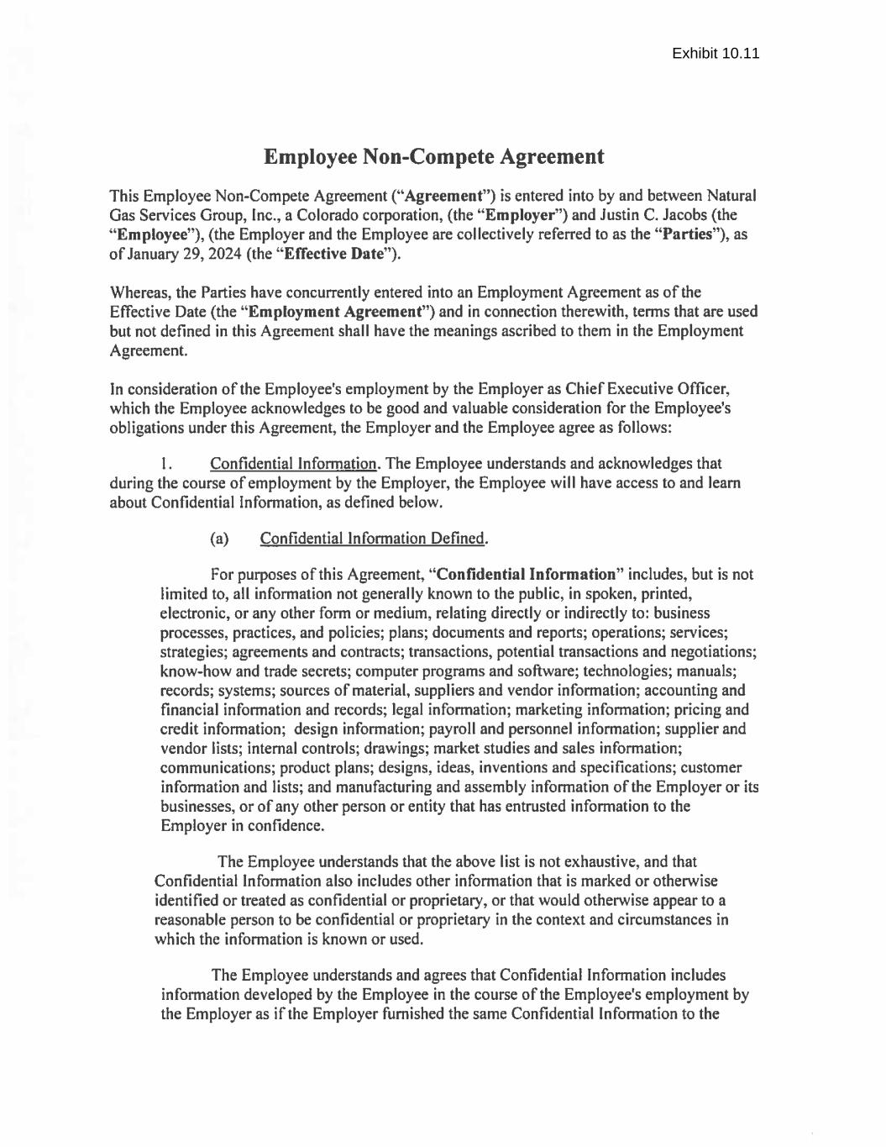

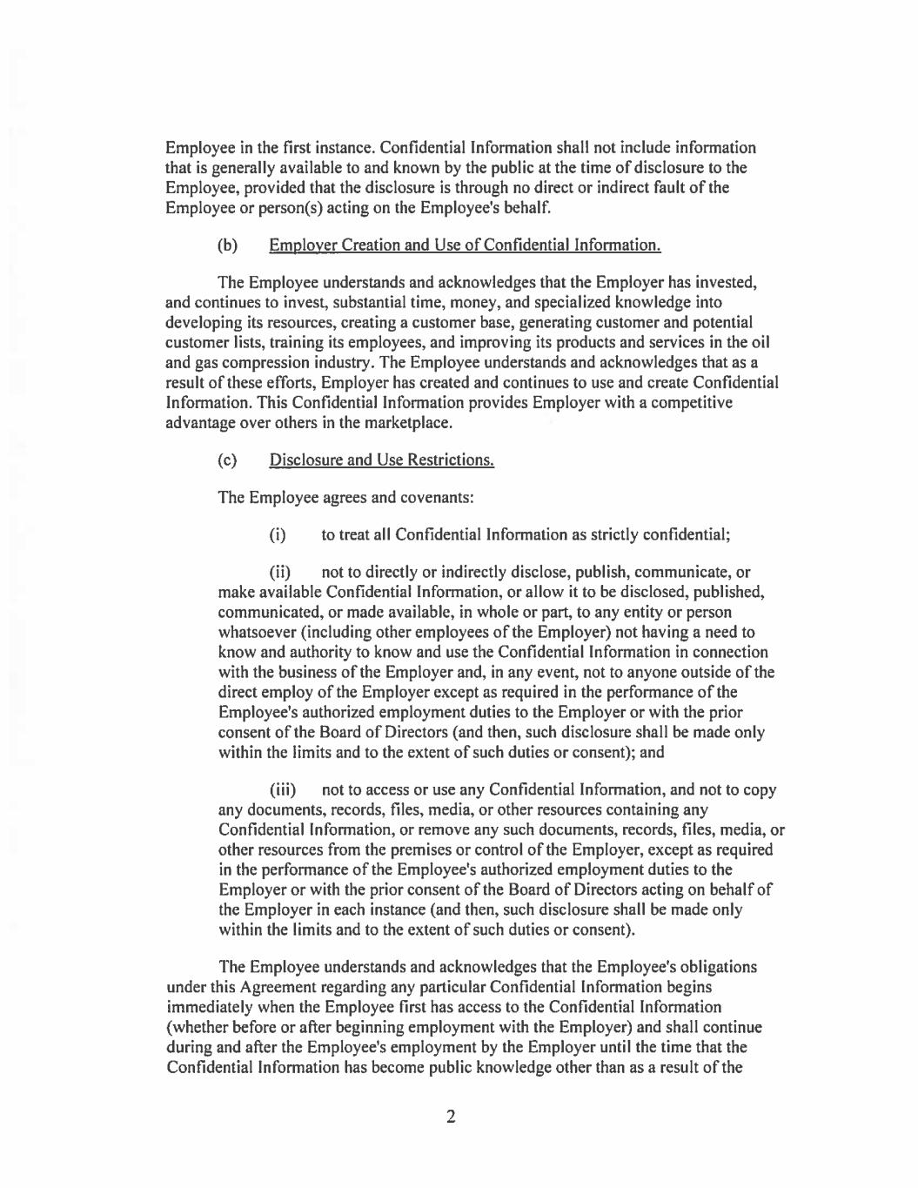

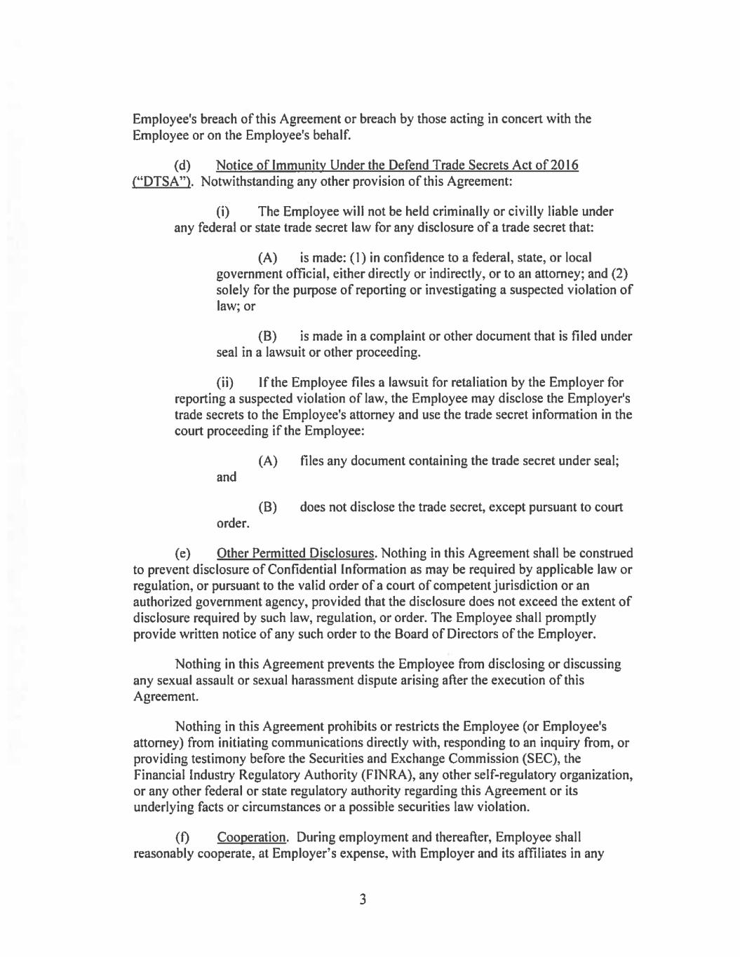

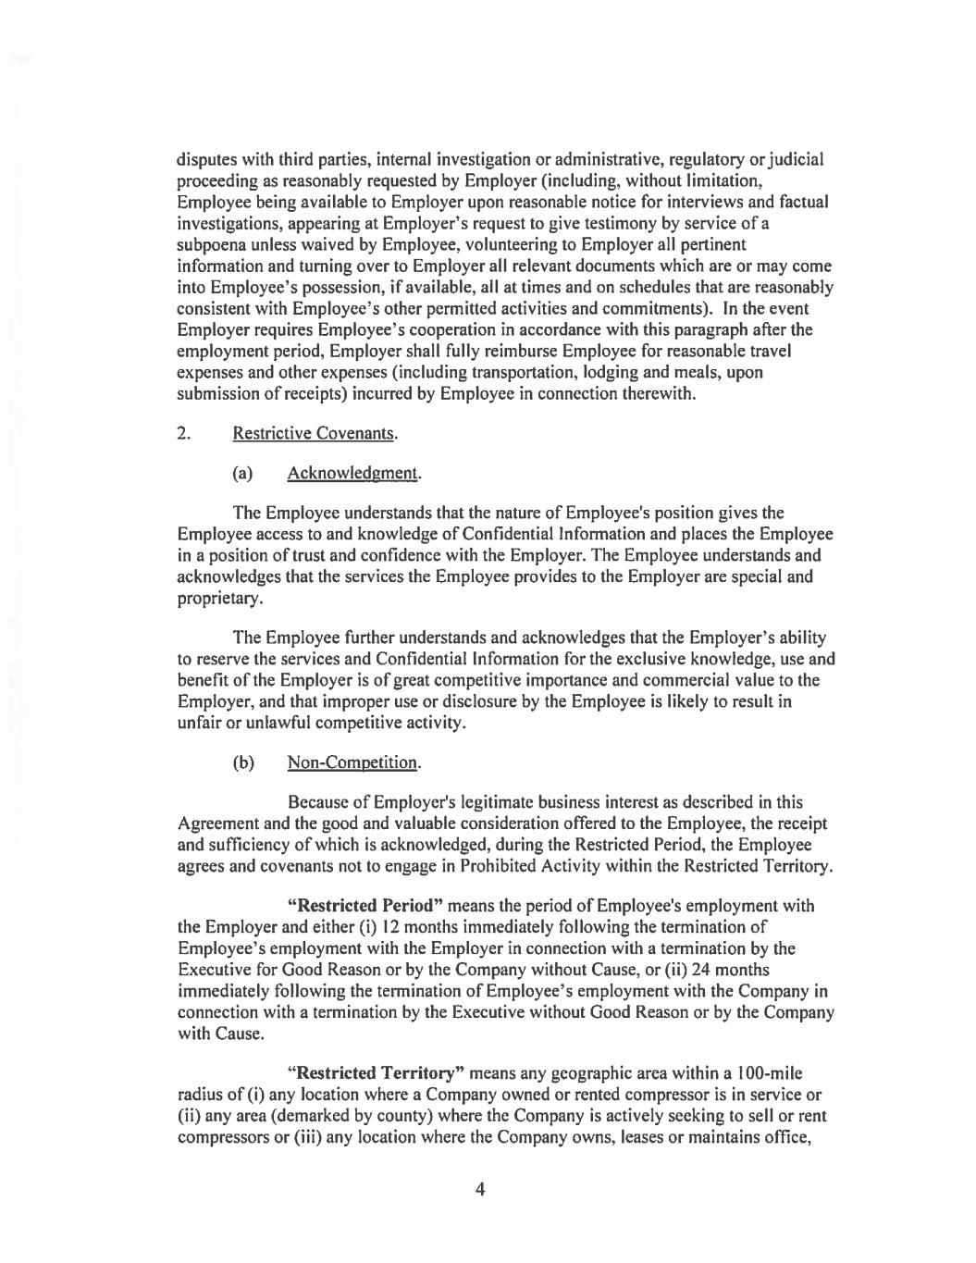

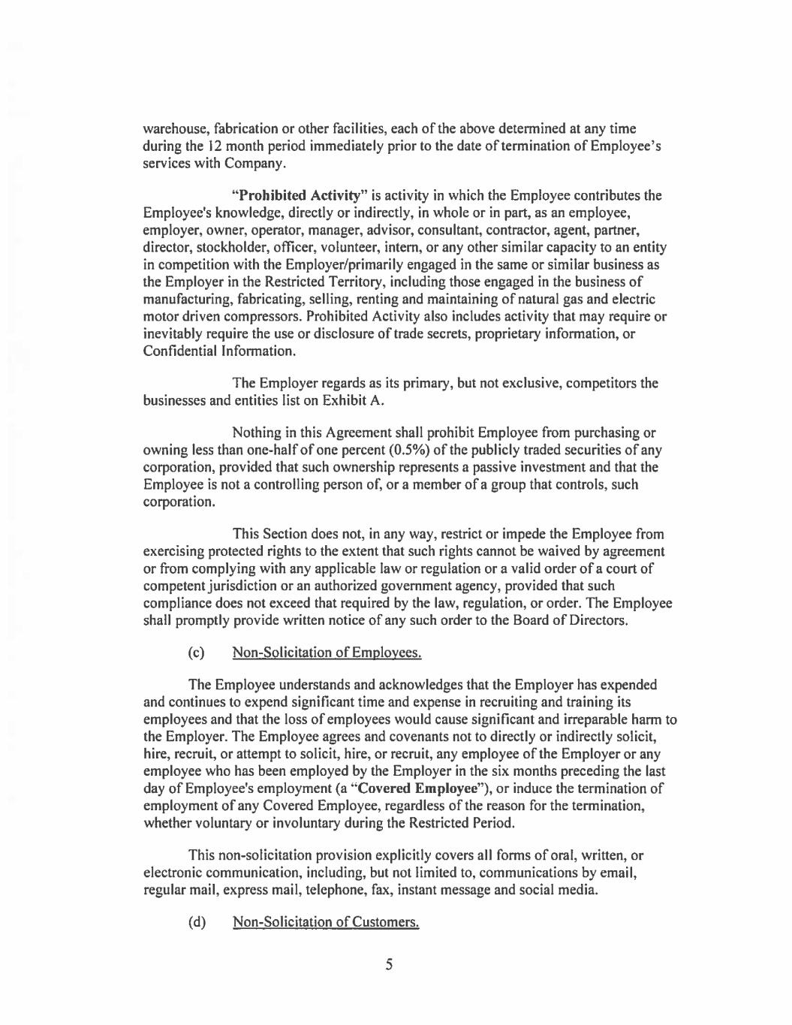

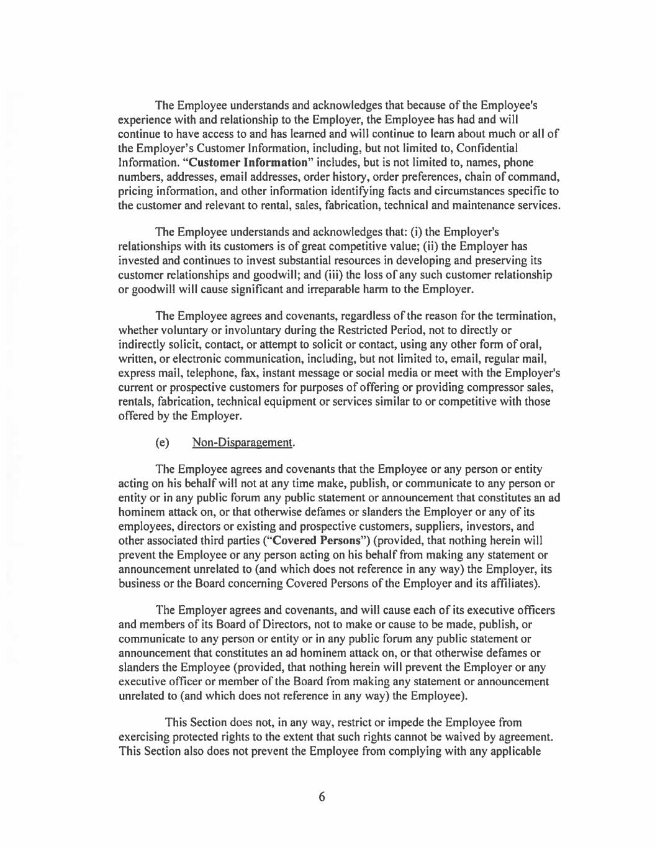

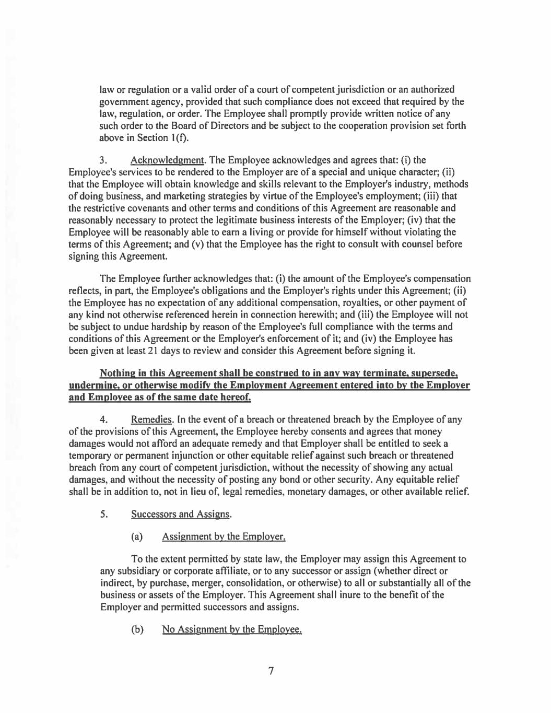

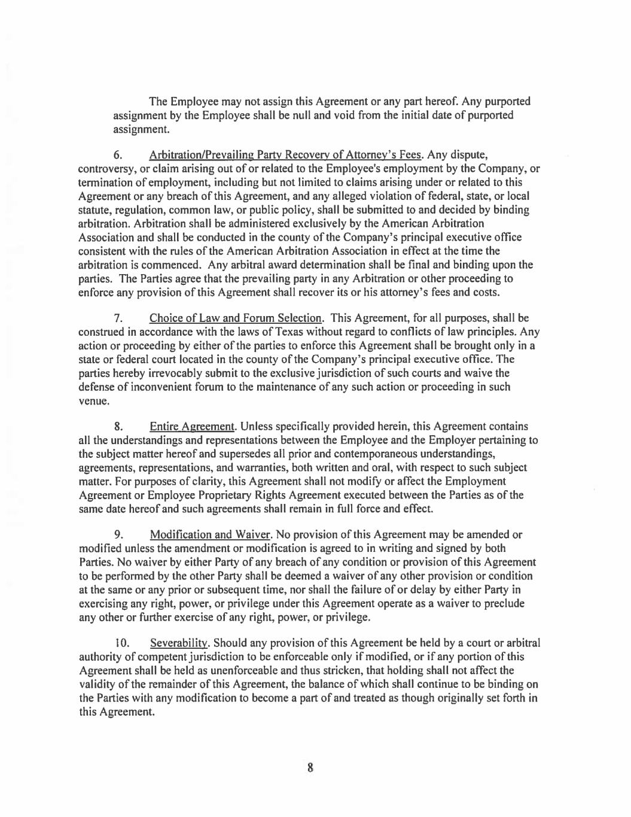

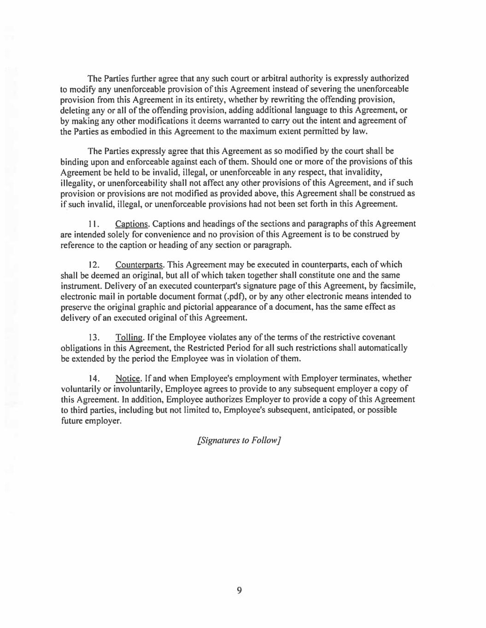

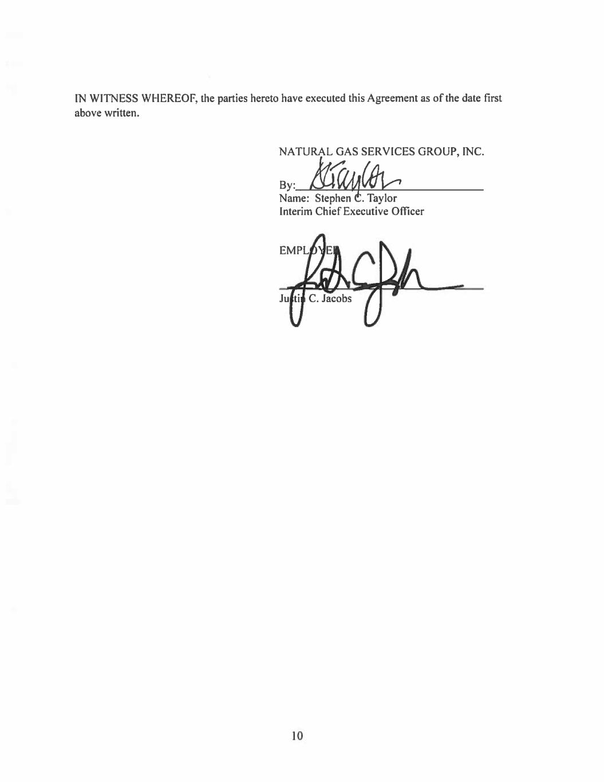

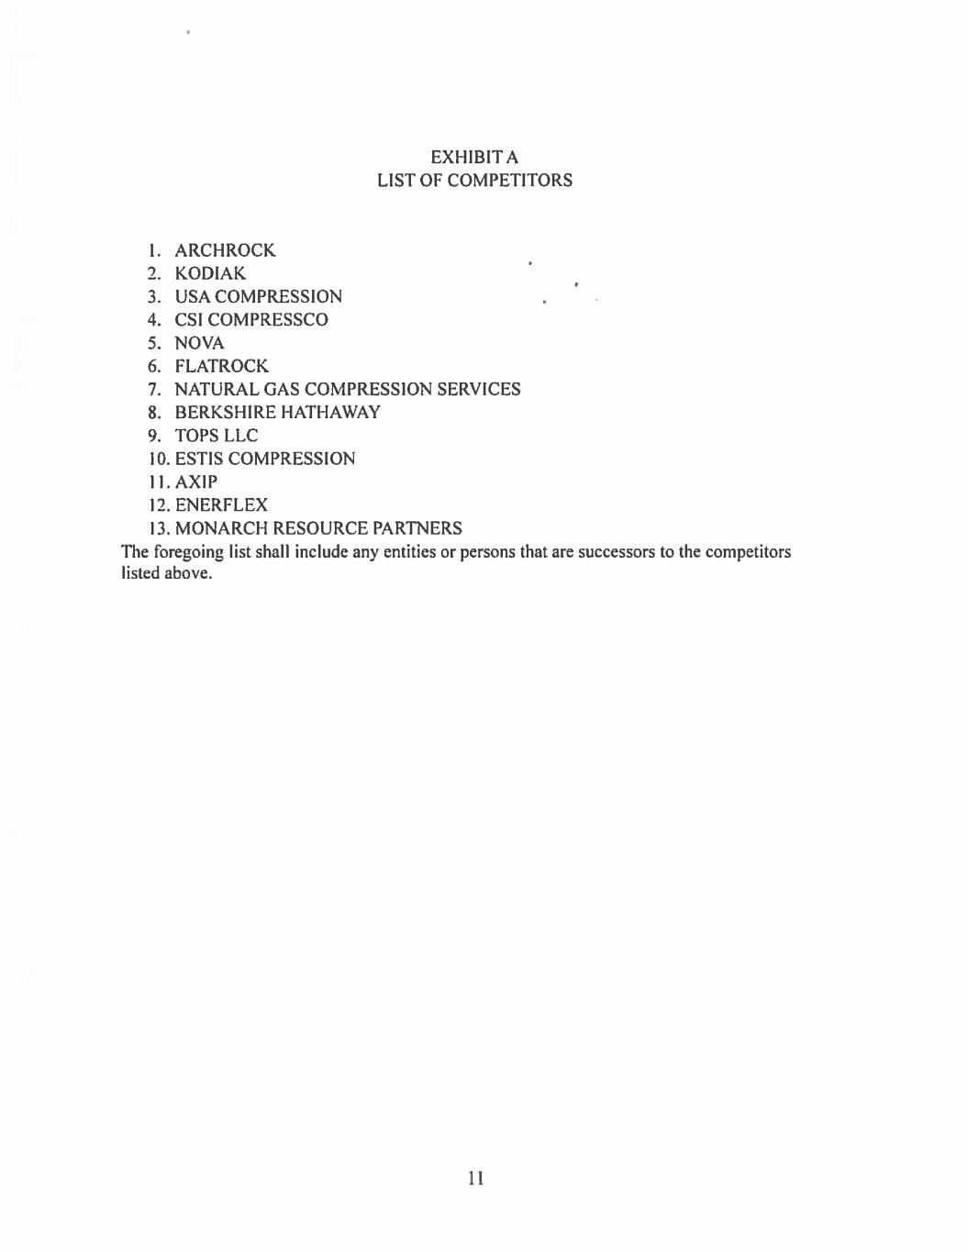

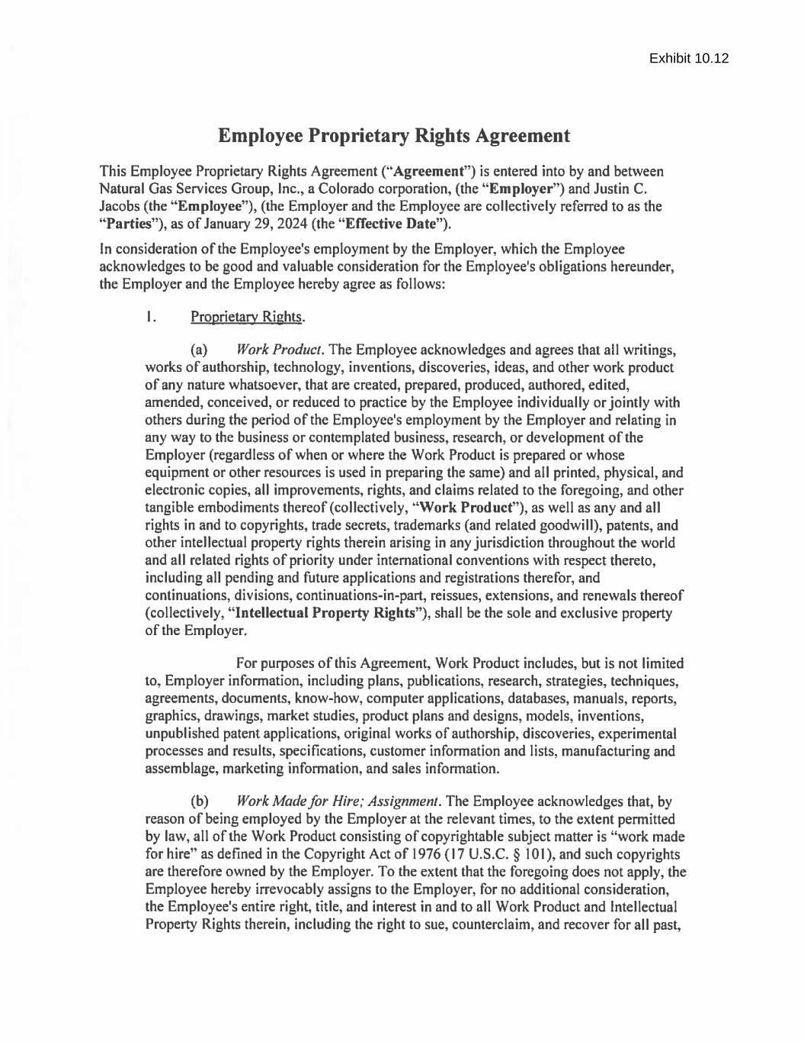
Exhibit 10.12

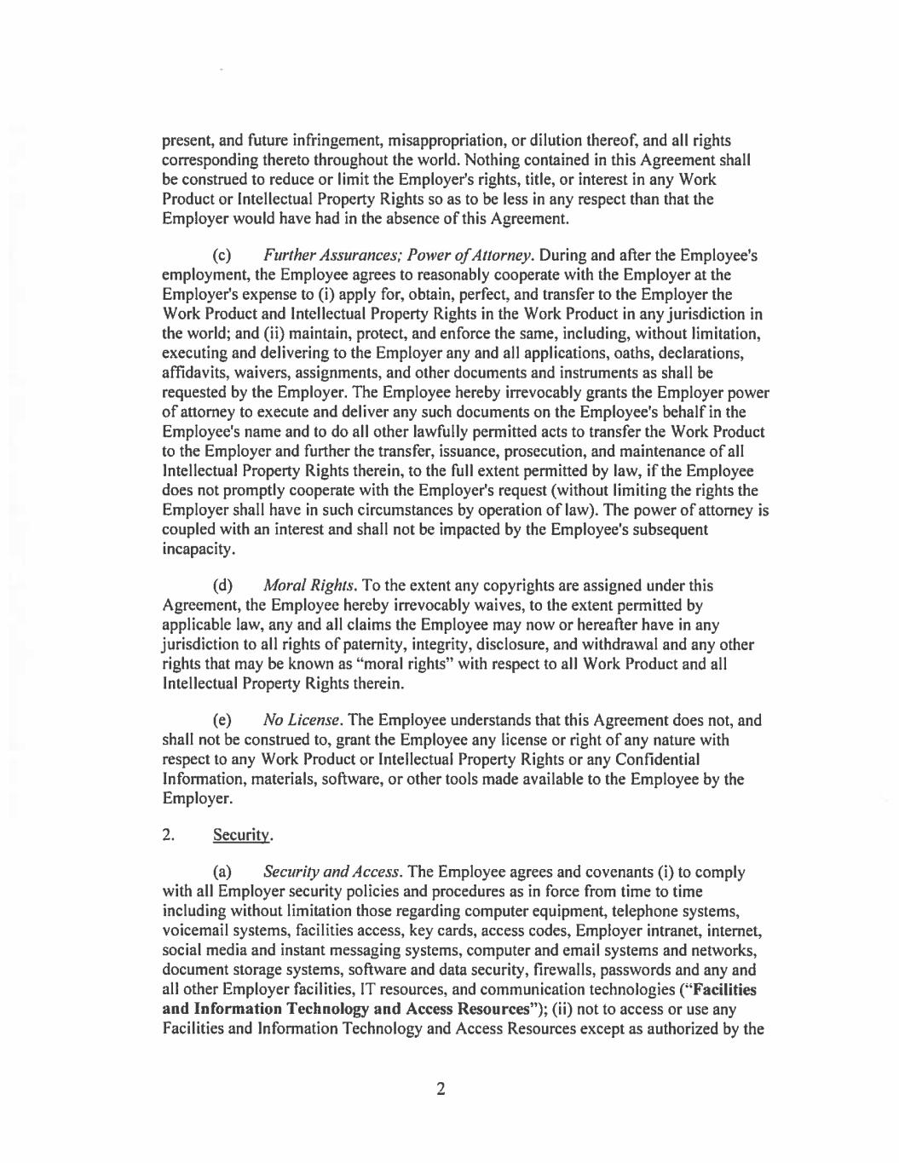

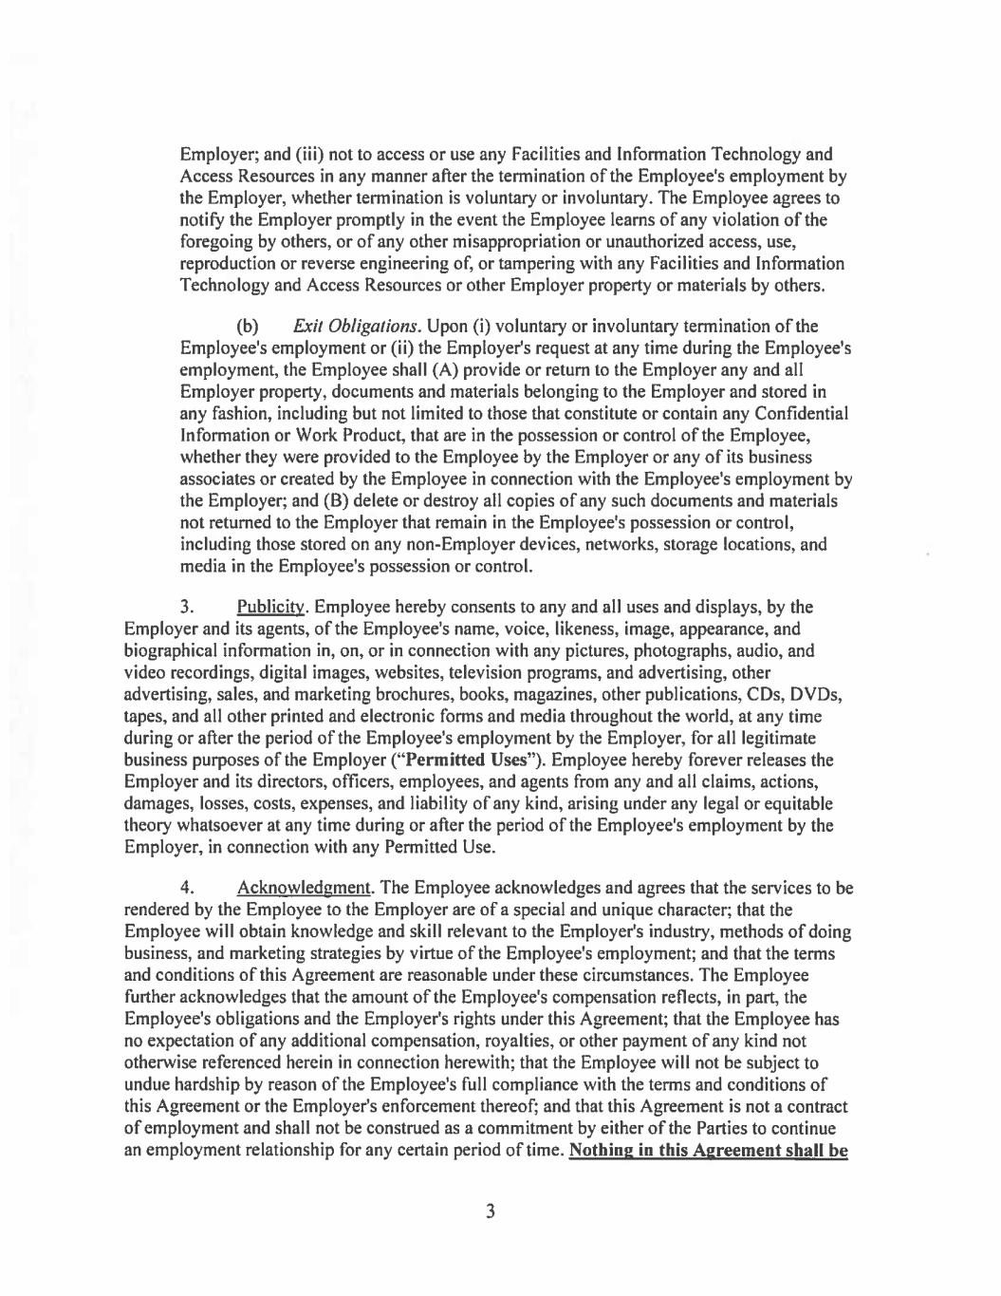

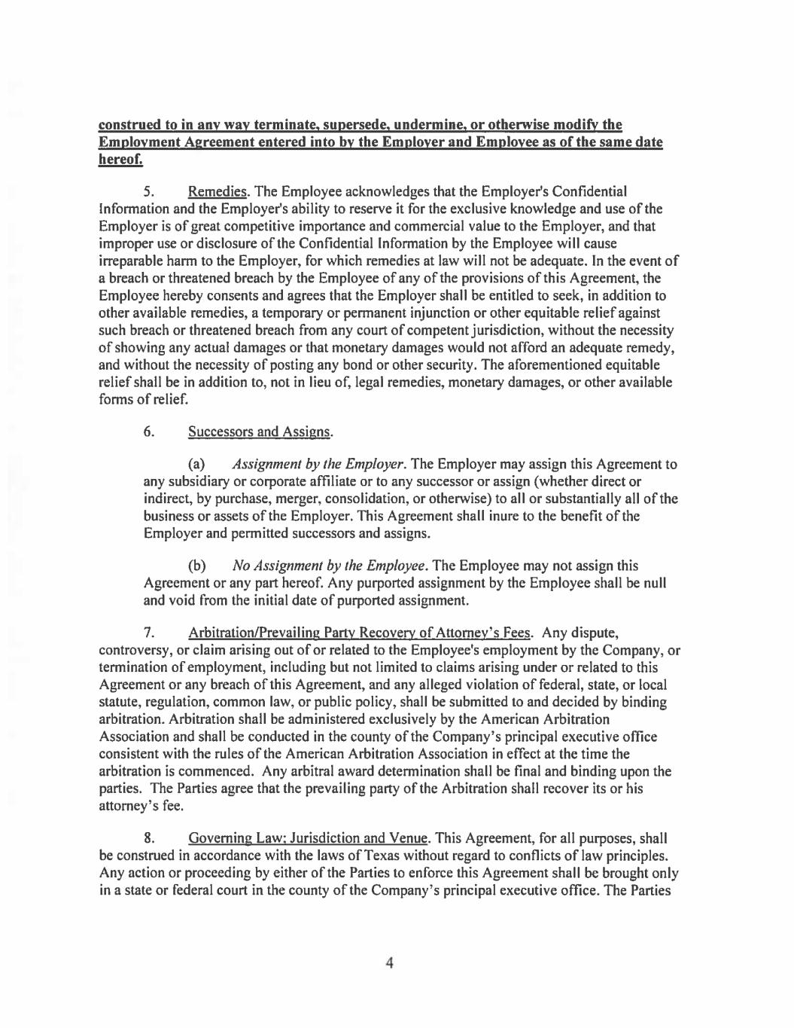

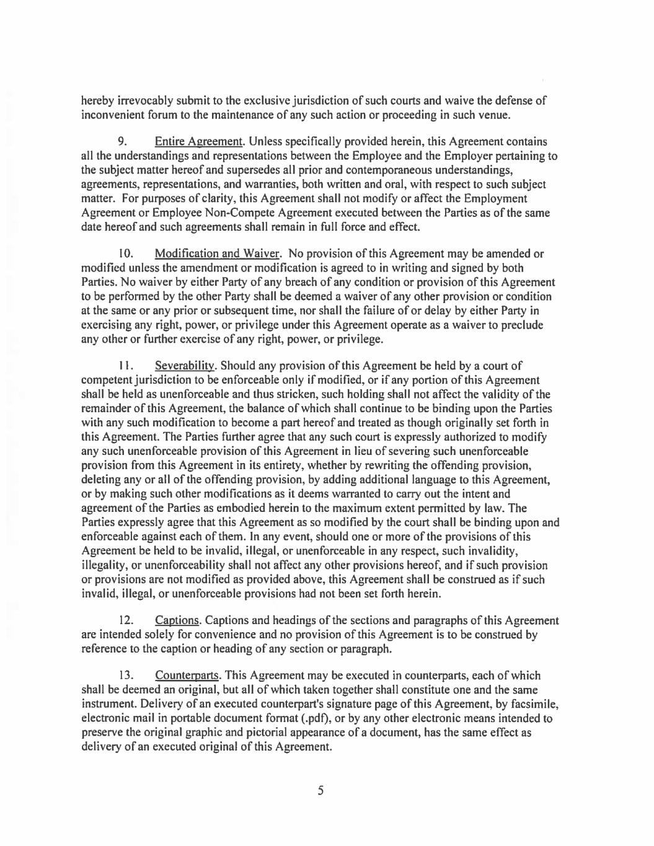

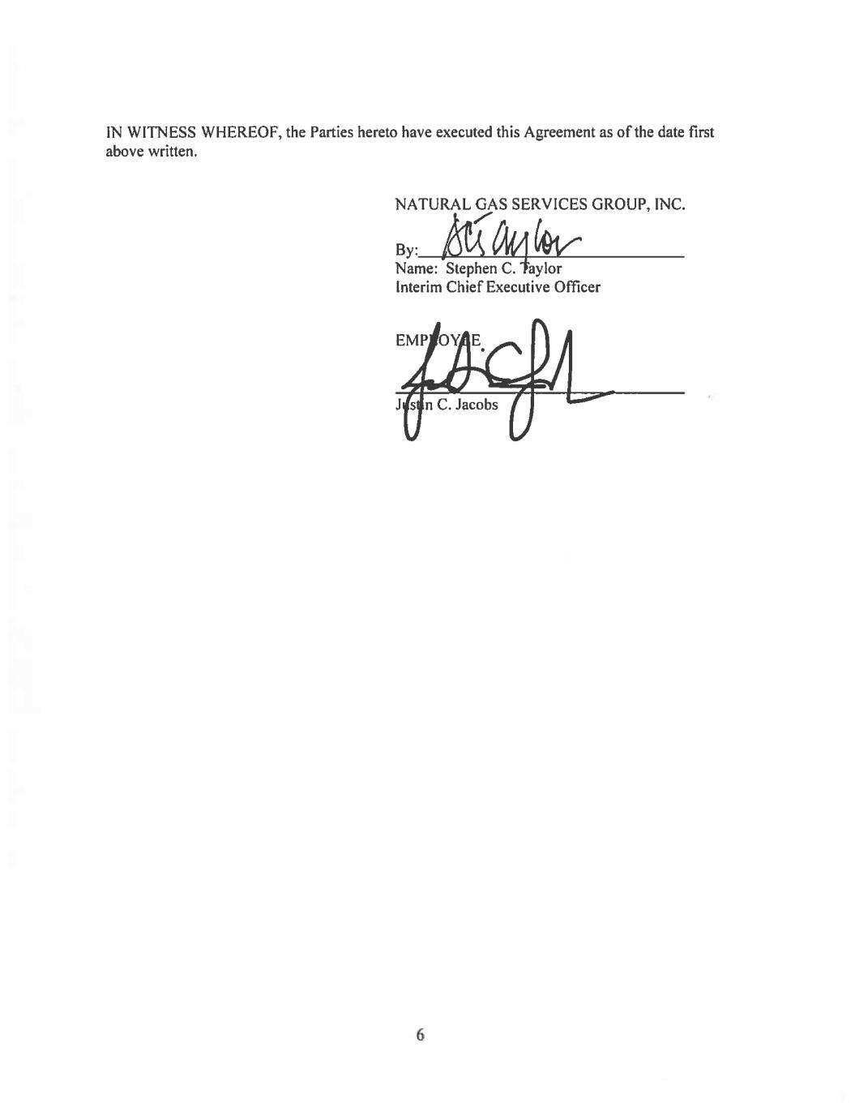

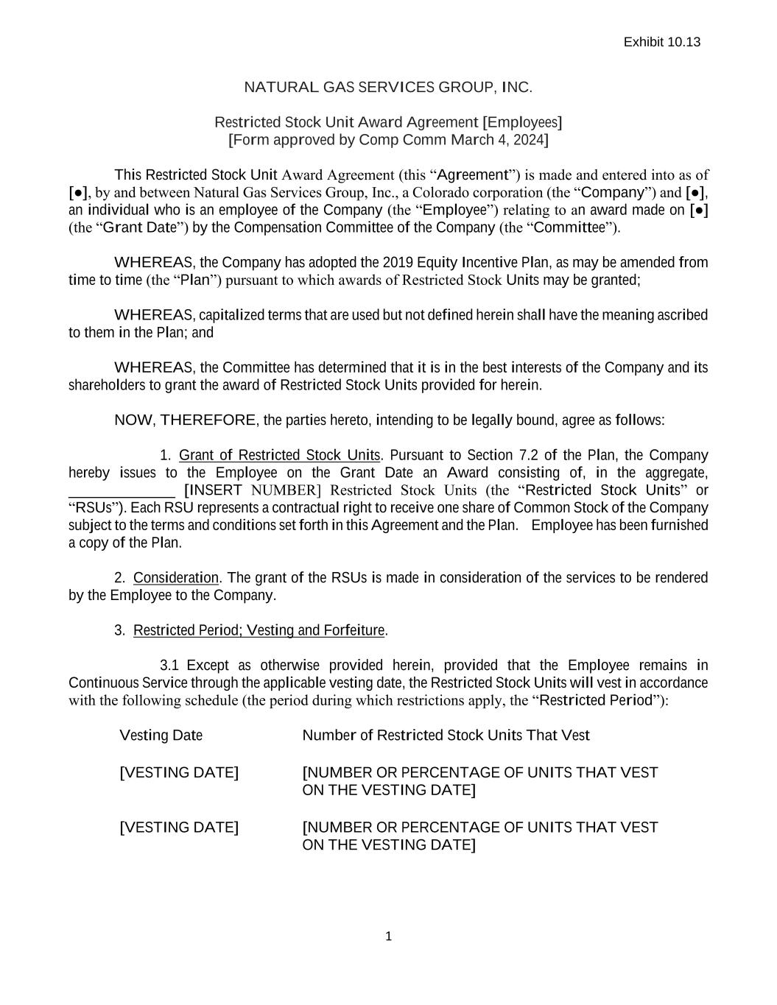
1 NATURAL GAS SERVICES GROUP, INC. Restricted Stock Unit Award Agreement [Employees] [Form approved by Comp Comm March 4, 2024] This Restricted Stock Unit Award Agreement (this “Agreement”) is made and entered into as of [●], by and between Natural Gas Services Group, Inc., a Colorado corporation (the “Company”) and [●], an individual who is an employee of the Company (the “Employee”) relating to an award made on [●] (the “Grant Date”) by the Compensation Committee of the Company (the “Committee”). WHEREAS, the Company has adopted the 2019 Equity Incentive Plan, as may be amended from time to time (the “Plan”) pursuant to which awards of Restricted Stock Units may be granted; WHEREAS, capitalized terms that are used but not defined herein shall have the meaning ascribed to them in the Plan; and WHEREAS, the Committee has determined that it is in the best interests of the Company and its shareholders to grant the award of Restricted Stock Units provided for herein. NOW, THEREFORE, the parties hereto, intending to be legally bound, agree as follows: 1. Grant of Restricted Stock Units. Pursuant to Section 7.2 of the Plan, the Company hereby issues to the Employee on the Grant Date an Award consisting of, in the aggregate, ______________ [INSERT NUMBER] Restricted Stock Units (the “Restricted Stock Units” or “RSUs”). Each RSU represents a contractual right to receive one share of Common Stock of the Company subject to the terms and conditions set forth in this Agreement and the Plan. Employee has been furnished a copy of the Plan. 2. Consideration. The grant of the RSUs is made in consideration of the services to be rendered by the Employee to the Company. 3. Restricted Period; Vesting and Forfeiture. 3.1 Except as otherwise provided herein, provided that the Employee remains in Continuous Service through the applicable vesting date, the Restricted Stock Units will vest in accordance with the following schedule (the period during which restrictions apply, the “Restricted Period”): Vesting Date Number of Restricted Stock Units That Vest [VESTING DATE] [NUMBER OR PERCENTAGE OF UNITS THAT VEST ON THE VESTING DATE] [VESTING DATE] [NUMBER OR PERCENTAGE OF UNITS THAT VEST ON THE VESTING DATE] Exhibit 10.13

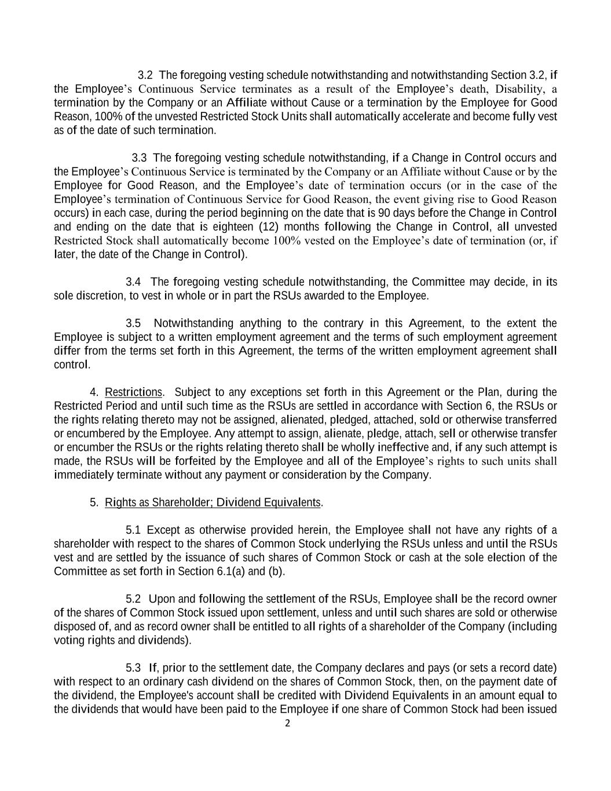
2 3.2 The foregoing vesting schedule notwithstanding and notwithstanding Section 3.2, if the Employee’s Continuous Service terminates as a result of the Employee’s death, Disability, a termination by the Company or an Affiliate without Cause or a termination by the Employee for Good Reason, 100% of the unvested Restricted Stock Units shall automatically accelerate and become fully vest as of the date of such termination. 3.3 The foregoing vesting schedule notwithstanding, if a Change in Control occurs and the Employee’s Continuous Service is terminated by the Company or an Affiliate without Cause or by the Employee for Good Reason, and the Employee’s date of termination occurs (or in the case of the Employee’s termination of Continuous Service for Good Reason, the event giving rise to Good Reason occurs) in each case, during the period beginning on the date that is 90 days before the Change in Control and ending on the date that is eighteen (12) months following the Change in Control, all unvested Restricted Stock shall automatically become 100% vested on the Employee’s date of termination (or, if later, the date of the Change in Control). 3.4 The foregoing vesting schedule notwithstanding, the Committee may decide, in its sole discretion, to vest in whole or in part the RSUs awarded to the Employee. 3.5 Notwithstanding anything to the contrary in this Agreement, to the extent the Employee is subject to a written employment agreement and the terms of such employment agreement differ from the terms set forth in this Agreement, the terms of the written employment agreement shall control. 4. Restrictions. Subject to any exceptions set forth in this Agreement or the Plan, during the Restricted Period and until such time as the RSUs are settled in accordance with Section 6, the RSUs or the rights relating thereto may not be assigned, alienated, pledged, attached, sold or otherwise transferred or encumbered by the Employee. Any attempt to assign, alienate, pledge, attach, sell or otherwise transfer or encumber the RSUs or the rights relating thereto shall be wholly ineffective and, if any such attempt is made, the RSUs will be forfeited by the Employee and all of the Employee’s rights to such units shall immediately terminate without any payment or consideration by the Company. 5. Rights as Shareholder; Dividend Equivalents. 5.1 Except as otherwise provided herein, the Employee shall not have any rights of a shareholder with respect to the shares of Common Stock underlying the RSUs unless and until the RSUs vest and are settled by the issuance of such shares of Common Stock or cash at the sole election of the Committee as set forth in Section 6.1(a) and (b). 5.2 Upon and following the settlement of the RSUs, Employee shall be the record owner of the shares of Common Stock issued upon settlement, unless and until such shares are sold or otherwise disposed of, and as record owner shall be entitled to all rights of a shareholder of the Company (including voting rights and dividends). 5.3 If, prior to the settlement date, the Company declares and pays (or sets a record date) with respect to an ordinary cash dividend on the shares of Common Stock, then, on the payment date of the dividend, the Employee's account shall be credited with Dividend Equivalents in an amount equal to the dividends that would have been paid to the Employee if one share of Common Stock had been issued

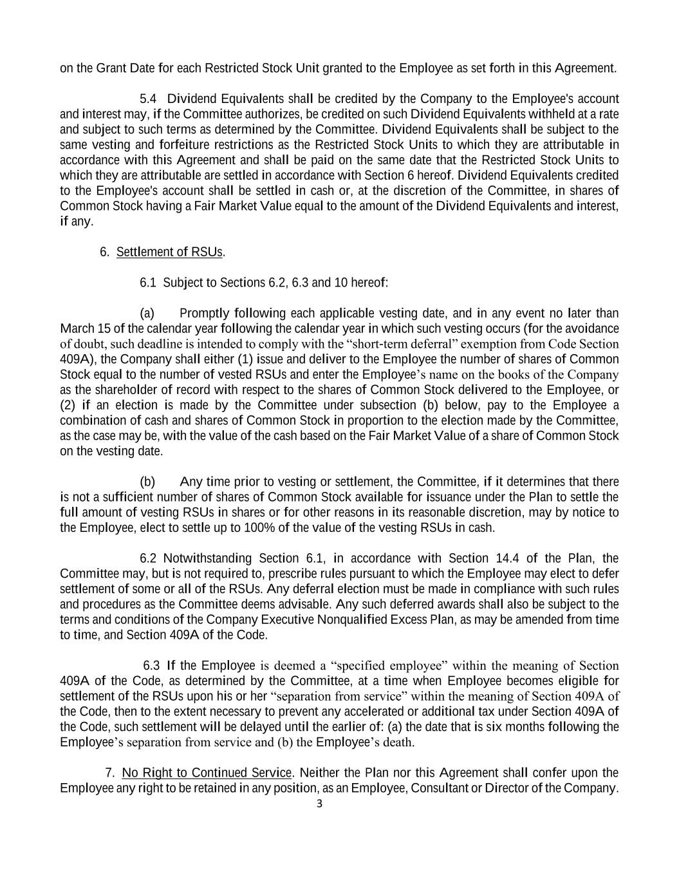
3 on the Grant Date for each Restricted Stock Unit granted to the Employee as set forth in this Agreement. 5.4 Dividend Equivalents shall be credited by the Company to the Employee's account and interest may, if the Committee authorizes, be credited on such Dividend Equivalents withheld at a rate and subject to such terms as determined by the Committee. Dividend Equivalents shall be subject to the same vesting and forfeiture restrictions as the Restricted Stock Units to which they are attributable in accordance with this Agreement and shall be paid on the same date that the Restricted Stock Units to which they are attributable are settled in accordance with Section 6 hereof. Dividend Equivalents credited to the Employee's account shall be settled in cash or, at the discretion of the Committee, in shares of Common Stock having a Fair Market Value equal to the amount of the Dividend Equivalents and interest, if any. 6. Settlement of RSUs. 6.1 Subject to Sections 6.2, 6.3 and 10 hereof: (a) Promptly following each applicable vesting date, and in any event no later than March 15 of the calendar year following the calendar year in which such vesting occurs (for the avoidance of doubt, such deadline is intended to comply with the “short-term deferral” exemption from Code Section 409A), the Company shall either (1) issue and deliver to the Employee the number of shares of Common Stock equal to the number of vested RSUs and enter the Employee’s name on the books of the Company as the shareholder of record with respect to the shares of Common Stock delivered to the Employee, or (2) if an election is made by the Committee under subsection (b) below, pay to the Employee a combination of cash and shares of Common Stock in proportion to the election made by the Committee, as the case may be, with the value of the cash based on the Fair Market Value of a share of Common Stock on the vesting date. (b) Any time prior to vesting or settlement, the Committee, if it determines that there is not a sufficient number of shares of Common Stock available for issuance under the Plan to settle the full amount of vesting RSUs in shares or for other reasons in its reasonable discretion, may by notice to the Employee, elect to settle up to 100% of the value of the vesting RSUs in cash. 6.2 Notwithstanding Section 6.1, in accordance with Section 14.4 of the Plan, the Committee may, but is not required to, prescribe rules pursuant to which the Employee may elect to defer settlement of some or all of the RSUs. Any deferral election must be made in compliance with such rules and procedures as the Committee deems advisable. Any such deferred awards shall also be subject to the terms and conditions of the Company Executive Nonqualified Excess Plan, as may be amended from time to time, and Section 409A of the Code. 6.3 If the Employee is deemed a “specified employee” within the meaning of Section 409A of the Code, as determined by the Committee, at a time when Employee becomes eligible for settlement of the RSUs upon his or her “separation from service” within the meaning of Section 409A of the Code, then to the extent necessary to prevent any accelerated or additional tax under Section 409A of the Code, such settlement will be delayed until the earlier of: (a) the date that is six months following the Employee’s separation from service and (b) the Employee’s death. 7. No Right to Continued Service. Neither the Plan nor this Agreement shall confer upon the Employee any right to be retained in any position, as an Employee, Consultant or Director of the Company.


4 Further, nothing in the Plan or this Agreement shall be construed to limit the discretion of the Company to terminate the Employee’s Continuous Service at any time, with or without Cause. 8. Adjustments. If any change is made to the outstanding Common Stock or the capital structure of the Company, if required, the shares of Common Stock shall be adjusted or terminated in any manner as contemplated by Section 11 of the Plan. 9. Tax Liability and Withholding. 9.1 The Employee shall be required to pay to the Company, and the Company shall have the right to deduct and/or withhold from any compensation paid to the Employee pursuant to the Plan, an applicable employment agreement or any other employment arrangement with the Employee, the amount of any required withholding taxes in respect of the Restricted Stock Units upon the occurrence of an event triggering the requirement, whether upon its grant, vesting, settlement, and/or otherwise, and to take all such other action as the Committee deems necessary to satisfy all obligations for the payment of such withholding taxes. The Committee may, in its sole discretion and subject to compliance with all applicable laws, permit the Employee to satisfy any federal, state or local tax withholding obligation by any of the following means, or by a combination of such means: (a) tendering a cash payment or withholding cash otherwise payable hereunder. (b) authorizing the Company to withhold shares of Common Stock from the shares of Common Stock otherwise issuable or deliverable to the Employee as a result of the vesting of the Restricted Stock Units; provided, however, that no shares of Common Stock shall be withheld with a value exceeding the maximum amount of tax required to be withheld by law. (c) delivering to the Company previously owned and unencumbered shares of Common Stock. 9.2 Notwithstanding any action the Company takes with respect to any or all income tax, social insurance, payroll tax, or other tax-related withholding (”Tax-Related Items”), the ultimate liability for all Tax-Related Items is and remains the Employee’s responsibility and the Company (a) makes no representation or undertakings regarding the treatment of any Tax-Related Items in connection with the grant, vesting or settlement of the Restricted Stock Units or the subsequent sale of any shares; and (b) does not commit to structure the Restricted Stock Units to reduce or eliminate the Employee’s liability for Tax-Related Items. 10. Compliance with Law. The issuance and transfer of shares of Common Stock shall be subject to compliance by the Company and Employee with all applicable requirements of federal and state securities laws and with all applicable requirements of any stock exchange on which the Company’s shares of Common Stock may be listed. No shares of Common Stock shall be issued or transferred unless and until any then applicable requirements of state and federal laws and regulatory agencies have been fully complied with to the satisfaction of the Company and its counsel. 11. Section 409A. It is the intention of the Company and the Employee that the payments, benefits and rights to which the Employee could be entitled pursuant to this Agreement comply with or be exempt from Section 409A of the Code and the treasury regulations promulgated thereunder (together “Section 409A”) (to the extent that the requirements of Section 409A are applicable thereto), after application of all available exemptions (including without limitation the short-term deferral rule). The provisions of this

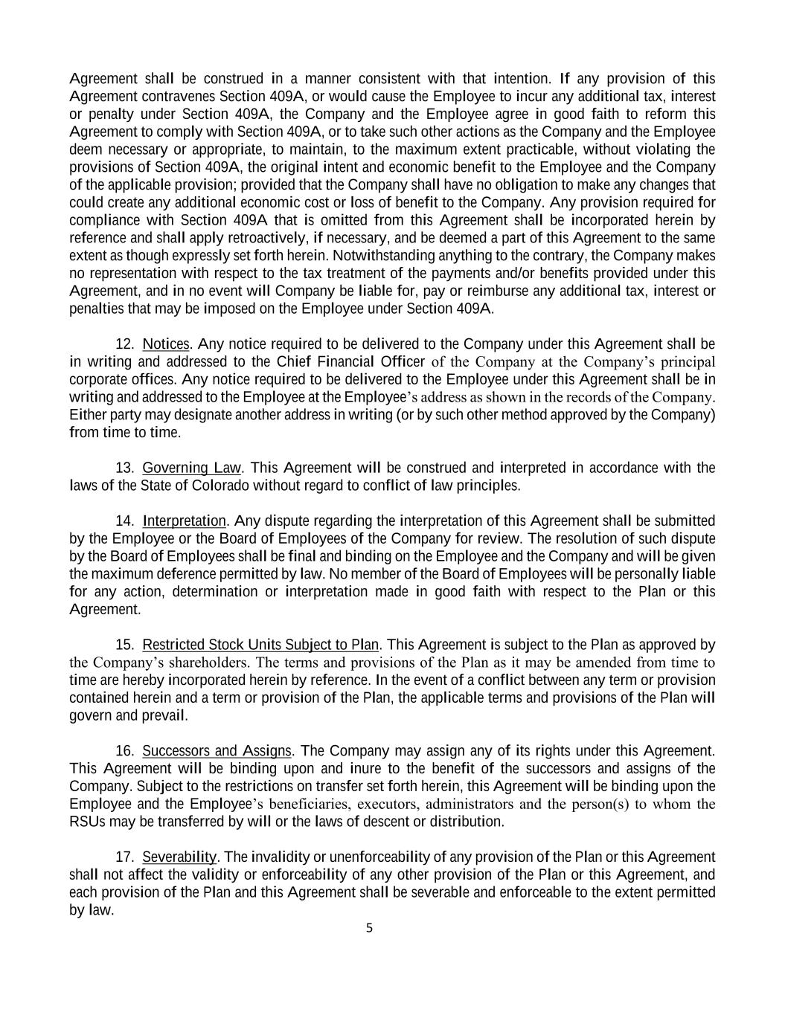
5 Agreement shall be construed in a manner consistent with that intention. If any provision of this Agreement contravenes Section 409A, or would cause the Employee to incur any additional tax, interest or penalty under Section 409A, the Company and the Employee agree in good faith to reform this Agreement to comply with Section 409A, or to take such other actions as the Company and the Employee deem necessary or appropriate, to maintain, to the maximum extent practicable, without violating the provisions of Section 409A, the original intent and economic benefit to the Employee and the Company of the applicable provision; provided that the Company shall have no obligation to make any changes that could create any additional economic cost or loss of benefit to the Company. Any provision required for compliance with Section 409A that is omitted from this Agreement shall be incorporated herein by reference and shall apply retroactively, if necessary, and be deemed a part of this Agreement to the same extent as though expressly set forth herein. Notwithstanding anything to the contrary, the Company makes no representation with respect to the tax treatment of the payments and/or benefits provided under this Agreement, and in no event will Company be liable for, pay or reimburse any additional tax, interest or penalties that may be imposed on the Employee under Section 409A. 12. Notices. Any notice required to be delivered to the Company under this Agreement shall be in writing and addressed to the Chief Financial Officer of the Company at the Company’s principal corporate offices. Any notice required to be delivered to the Employee under this Agreement shall be in writing and addressed to the Employee at the Employee’s address as shown in the records of the Company. Either party may designate another address in writing (or by such other method approved by the Company) from time to time. 13. Governing Law. This Agreement will be construed and interpreted in accordance with the laws of the State of Colorado without regard to conflict of law principles. 14. Interpretation. Any dispute regarding the interpretation of this Agreement shall be submitted by the Employee or the Board of Employees of the Company for review. The resolution of such dispute by the Board of Employees shall be final and binding on the Employee and the Company and will be given the maximum deference permitted by law. No member of the Board of Employees will be personally liable for any action, determination or interpretation made in good faith with respect to the Plan or this Agreement. 15. Restricted Stock Units Subject to Plan. This Agreement is subject to the Plan as approved by the Company’s shareholders. The terms and provisions of the Plan as it may be amended from time to time are hereby incorporated herein by reference. In the event of a conflict between any term or provision contained herein and a term or provision of the Plan, the applicable terms and provisions of the Plan will govern and prevail. 16. Successors and Assigns. The Company may assign any of its rights under this Agreement. This Agreement will be binding upon and inure to the benefit of the successors and assigns of the Company. Subject to the restrictions on transfer set forth herein, this Agreement will be binding upon the Employee and the Employee’s beneficiaries, executors, administrators and the person(s) to whom the RSUs may be transferred by will or the laws of descent or distribution. 17. Severability. The invalidity or unenforceability of any provision of the Plan or this Agreement shall not affect the validity or enforceability of any other provision of the Plan or this Agreement, and each provision of the Plan and this Agreement shall be severable and enforceable to the extent permitted by law.

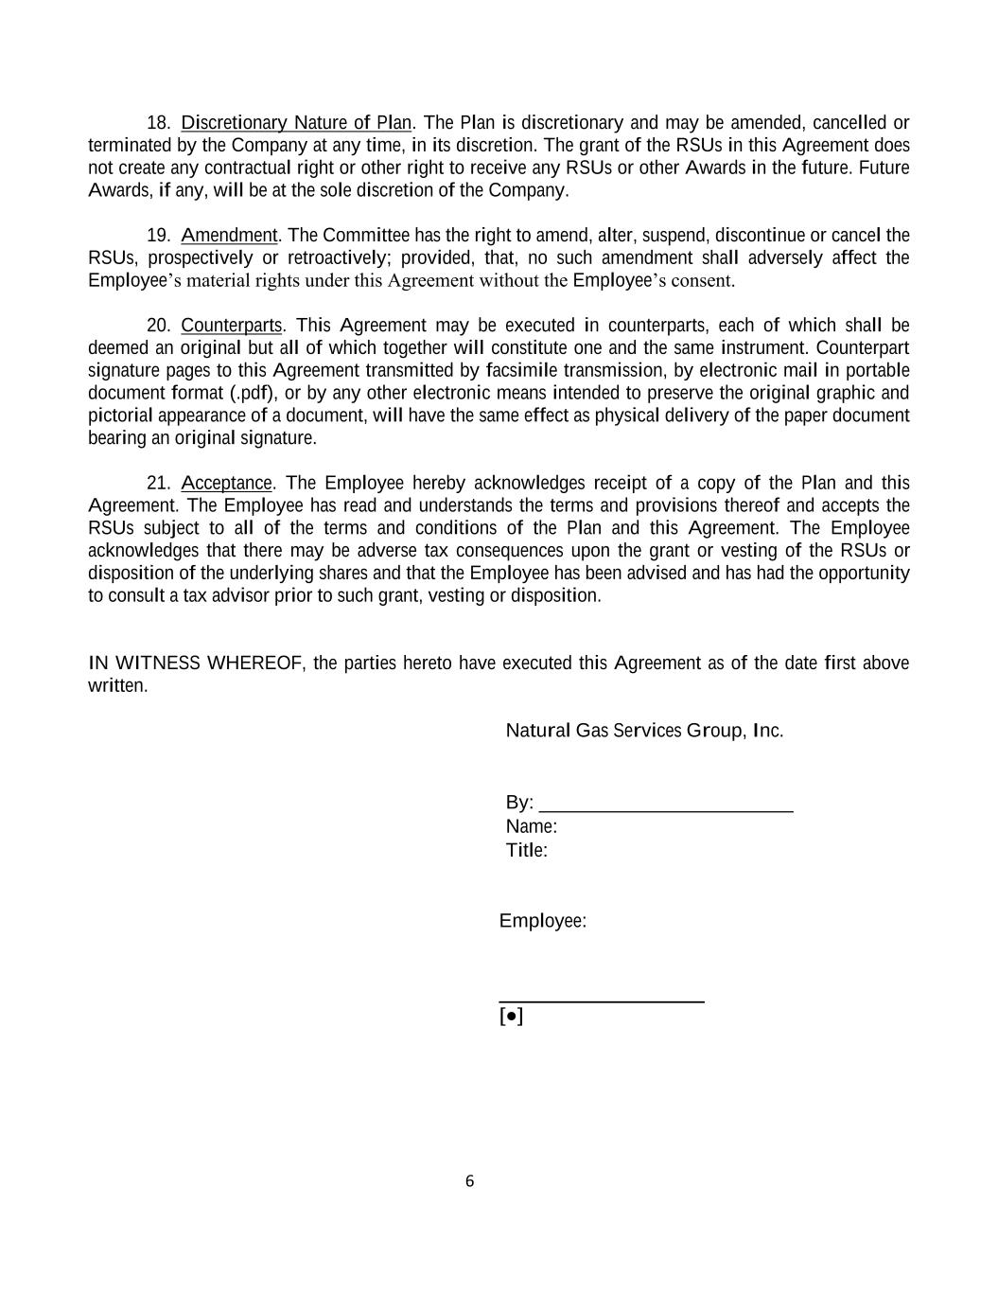
6 18. Discretionary Nature of Plan. The Plan is discretionary and may be amended, cancelled or terminated by the Company at any time, in its discretion. The grant of the RSUs in this Agreement does not create any contractual right or other right to receive any RSUs or other Awards in the future. Future Awards, if any, will be at the sole discretion of the Company. 19. Amendment. The Committee has the right to amend, alter, suspend, discontinue or cancel the RSUs, prospectively or retroactively; provided, that, no such amendment shall adversely affect the Employee’s material rights under this Agreement without the Employee’s consent. 20. Counterparts. This Agreement may be executed in counterparts, each of which shall be deemed an original but all of which together will constitute one and the same instrument. Counterpart signature pages to this Agreement transmitted by facsimile transmission, by electronic mail in portable document format (.pdf), or by any other electronic means intended to preserve the original graphic and pictorial appearance of a document, will have the same effect as physical delivery of the paper document bearing an original signature. 21. Acceptance. The Employee hereby acknowledges receipt of a copy of the Plan and this Agreement. The Employee has read and understands the terms and provisions thereof and accepts the RSUs subject to all of the terms and conditions of the Plan and this Agreement. The Employee acknowledges that there may be adverse tax consequences upon the grant or vesting of the RSUs or disposition of the underlying shares and that the Employee has been advised and has had the opportunity to consult a tax advisor prior to such grant, vesting or disposition. IN WITNESS WHEREOF, the parties hereto have executed this Agreement as of the date first above written. Natural Gas Services Group, Inc. By: __________________________ Name: Title: Employee: _____________________ [●]

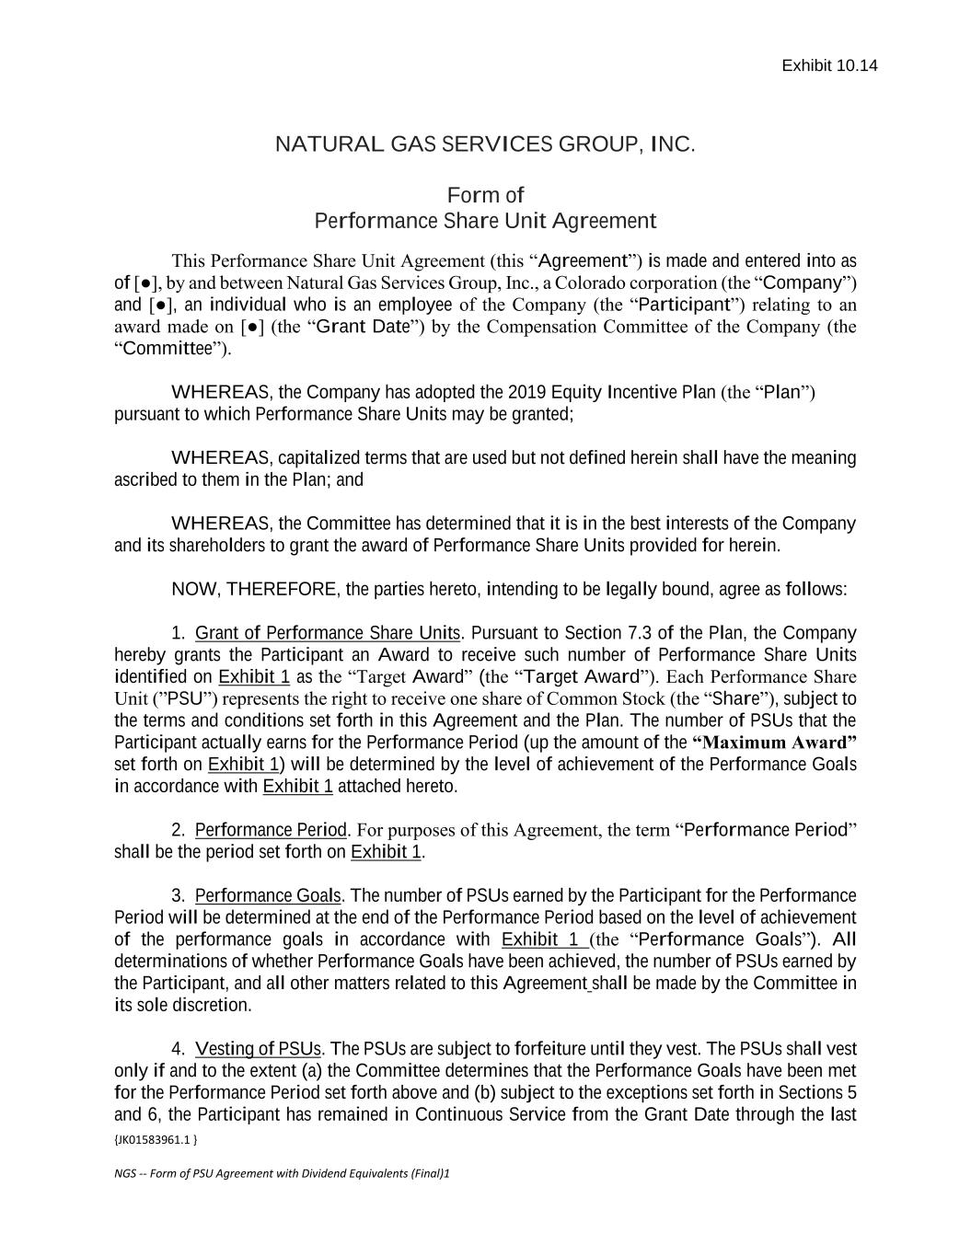
{JK01583961.1 } NGS -- Form of PSU Agreement with Dividend Equivalents (Final)1 NATURAL GAS SERVICES GROUP, INC. Form of Performance Share Unit Agreement This Performance Share Unit Agreement (this “Agreement”) is made and entered into as of [●], by and between Natural Gas Services Group, Inc., a Colorado corporation (the “Company”) and [●], an individual who is an employee of the Company (the “Participant”) relating to an award made on [●] (the “Grant Date”) by the Compensation Committee of the Company (the “Committee”). WHEREAS, the Company has adopted the 2019 Equity Incentive Plan (the “Plan”) pursuant to which Performance Share Units may be granted; WHEREAS, capitalized terms that are used but not defined herein shall have the meaning ascribed to them in the Plan; and WHEREAS, the Committee has determined that it is in the best interests of the Company and its shareholders to grant the award of Performance Share Units provided for herein. NOW, THEREFORE, the parties hereto, intending to be legally bound, agree as follows: 1. Grant of Performance Share Units. Pursuant to Section 7.3 of the Plan, the Company hereby grants the Participant an Award to receive such number of Performance Share Units identified on Exhibit 1 as the “Target Award” (the “Target Award”). Each Performance Share Unit (”PSU”) represents the right to receive one share of Common Stock (the “Share”), subject to the terms and conditions set forth in this Agreement and the Plan. The number of PSUs that the Participant actually earns for the Performance Period (up the amount of the “Maximum Award” set forth on Exhibit 1) will be determined by the level of achievement of the Performance Goals in accordance with Exhibit 1 attached hereto. 2. Performance Period. For purposes of this Agreement, the term “Performance Period” shall be the period set forth on Exhibit 1. 3. Performance Goals. The number of PSUs earned by the Participant for the Performance Period will be determined at the end of the Performance Period based on the level of achievement of the performance goals in accordance with Exhibit 1 (the “Performance Goals”). All determinations of whether Performance Goals have been achieved, the number of PSUs earned by the Participant, and all other matters related to this Agreement shall be made by the Committee in its sole discretion. 4. Vesting of PSUs. The PSUs are subject to forfeiture until they vest. The PSUs shall vest only if and to the extent (a) the Committee determines that the Performance Goals have been met for the Performance Period set forth above and (b) subject to the exceptions set forth in Sections 5 and 6, the Participant has remained in Continuous Service from the Grant Date through the last Exhibit 10.14

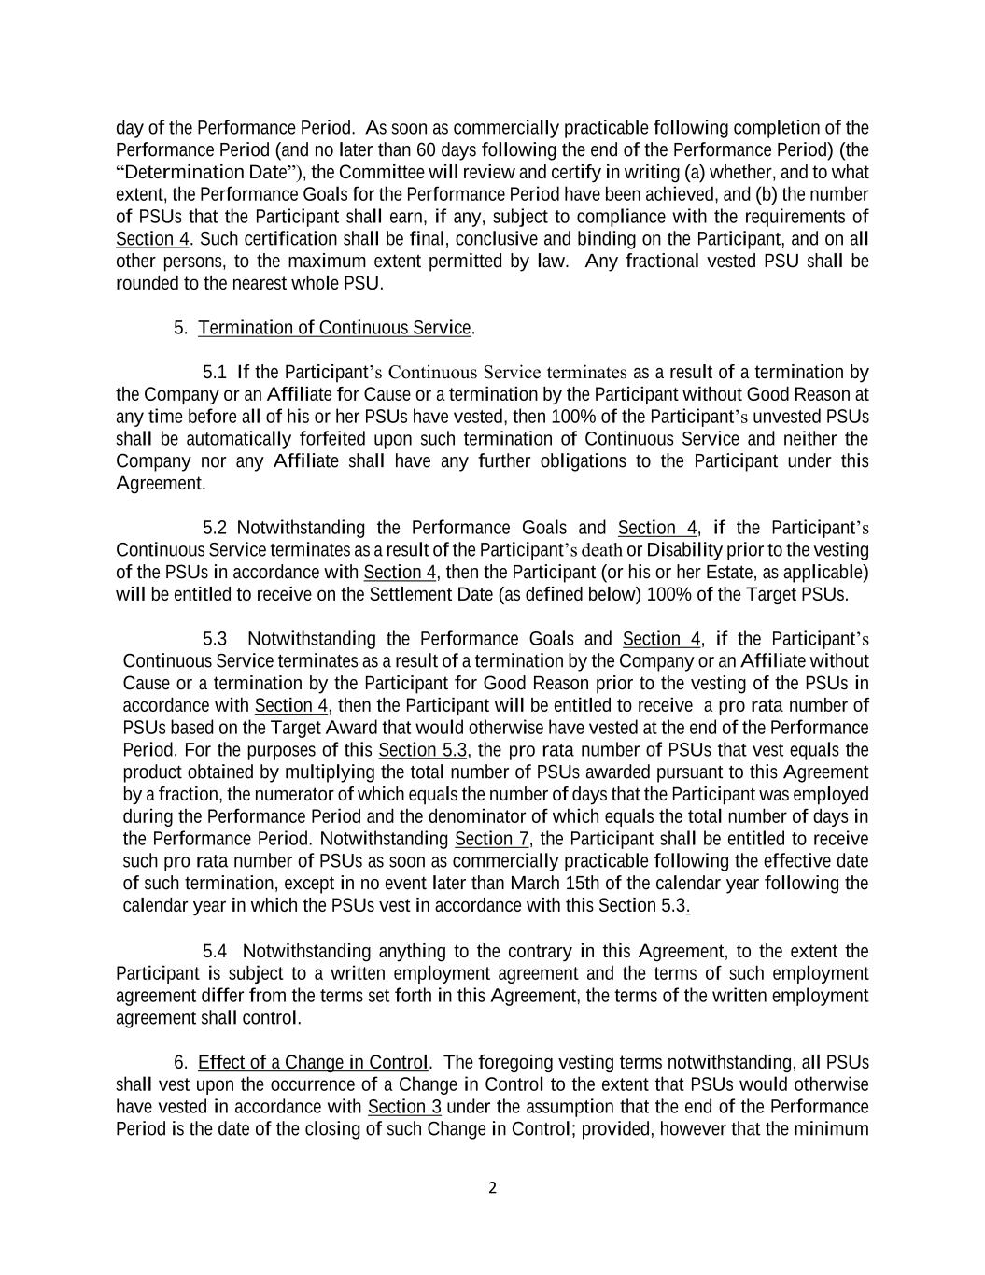
2 day of the Performance Period. As soon as commercially practicable following completion of the Performance Period (and no later than 60 days following the end of the Performance Period) (the “Determination Date”), the Committee will review and certify in writing (a) whether, and to what extent, the Performance Goals for the Performance Period have been achieved, and (b) the number of PSUs that the Participant shall earn, if any, subject to compliance with the requirements of Section 4. Such certification shall be final, conclusive and binding on the Participant, and on all other persons, to the maximum extent permitted by law. Any fractional vested PSU shall be rounded to the nearest whole PSU. 5. Termination of Continuous Service. 5.1 If the Participant’s Continuous Service terminates as a result of a termination by the Company or an Affiliate for Cause or a termination by the Participant without Good Reason at any time before all of his or her PSUs have vested, then 100% of the Participant’s unvested PSUs shall be automatically forfeited upon such termination of Continuous Service and neither the Company nor any Affiliate shall have any further obligations to the Participant under this Agreement. 5.2 Notwithstanding the Performance Goals and Section 4, if the Participant’s Continuous Service terminates as a result of the Participant’s death or Disability prior to the vesting of the PSUs in accordance with Section 4, then the Participant (or his or her Estate, as applicable) will be entitled to receive on the Settlement Date (as defined below) 100% of the Target PSUs. 5.3 Notwithstanding the Performance Goals and Section 4, if the Participant’s Continuous Service terminates as a result of a termination by the Company or an Affiliate without Cause or a termination by the Participant for Good Reason prior to the vesting of the PSUs in accordance with Section 4, then the Participant will be entitled to receive a pro rata number of PSUs based on the Target Award that would otherwise have vested at the end of the Performance Period. For the purposes of this Section 5.3, the pro rata number of PSUs that vest equals the product obtained by multiplying the total number of PSUs awarded pursuant to this Agreement by a fraction, the numerator of which equals the number of days that the Participant was employed during the Performance Period and the denominator of which equals the total number of days in the Performance Period. Notwithstanding Section 7, the Participant shall be entitled to receive such pro rata number of PSUs as soon as commercially practicable following the effective date of such termination, except in no event later than March 15th of the calendar year following the calendar year in which the PSUs vest in accordance with this Section 5.3. 5.4 Notwithstanding anything to the contrary in this Agreement, to the extent the Participant is subject to a written employment agreement and the terms of such employment agreement differ from the terms set forth in this Agreement, the terms of the written employment agreement shall control. 6. Effect of a Change in Control. The foregoing vesting terms notwithstanding, all PSUs shall vest upon the occurrence of a Change in Control to the extent that PSUs would otherwise have vested in accordance with Section 3 under the assumption that the end of the Performance Period is the date of the closing of such Change in Control; provided, however that the minimum

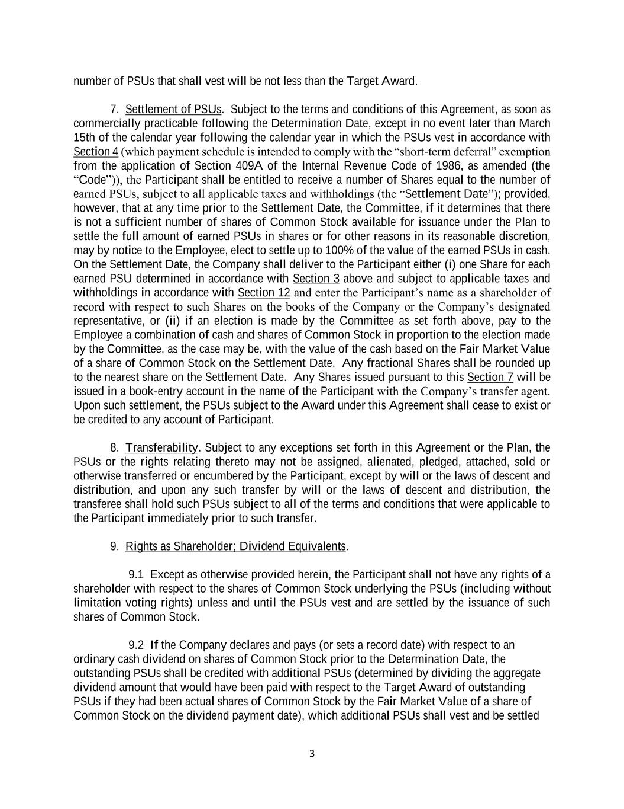
3 number of PSUs that shall vest will be not less than the Target Award. 7. Settlement of PSUs. Subject to the terms and conditions of this Agreement, as soon as commercially practicable following the Determination Date, except in no event later than March 15th of the calendar year following the calendar year in which the PSUs vest in accordance with Section 4 (which payment schedule is intended to comply with the “short-term deferral” exemption from the application of Section 409A of the Internal Revenue Code of 1986, as amended (the “Code”)), the Participant shall be entitled to receive a number of Shares equal to the number of earned PSUs, subject to all applicable taxes and withholdings (the “Settlement Date”); provided, however, that at any time prior to the Settlement Date, the Committee, if it determines that there is not a sufficient number of shares of Common Stock available for issuance under the Plan to settle the full amount of earned PSUs in shares or for other reasons in its reasonable discretion, may by notice to the Employee, elect to settle up to 100% of the value of the earned PSUs in cash. On the Settlement Date, the Company shall deliver to the Participant either (i) one Share for each earned PSU determined in accordance with Section 3 above and subject to applicable taxes and withholdings in accordance with Section 12 and enter the Participant’s name as a shareholder of record with respect to such Shares on the books of the Company or the Company’s designated representative, or (ii) if an election is made by the Committee as set forth above, pay to the Employee a combination of cash and shares of Common Stock in proportion to the election made by the Committee, as the case may be, with the value of the cash based on the Fair Market Value of a share of Common Stock on the Settlement Date. Any fractional Shares shall be rounded up to the nearest share on the Settlement Date. Any Shares issued pursuant to this Section 7 will be issued in a book-entry account in the name of the Participant with the Company’s transfer agent. Upon such settlement, the PSUs subject to the Award under this Agreement shall cease to exist or be credited to any account of Participant. 8. Transferability. Subject to any exceptions set forth in this Agreement or the Plan, the PSUs or the rights relating thereto may not be assigned, alienated, pledged, attached, sold or otherwise transferred or encumbered by the Participant, except by will or the laws of descent and distribution, and upon any such transfer by will or the laws of descent and distribution, the transferee shall hold such PSUs subject to all of the terms and conditions that were applicable to the Participant immediately prior to such transfer. 9. Rights as Shareholder; Dividend Equivalents. 9.1 Except as otherwise provided herein, the Participant shall not have any rights of a shareholder with respect to the shares of Common Stock underlying the PSUs (including without limitation voting rights) unless and until the PSUs vest and are settled by the issuance of such shares of Common Stock. 9.2 If the Company declares and pays (or sets a record date) with respect to an ordinary cash dividend on shares of Common Stock prior to the Determination Date, the outstanding PSUs shall be credited with additional PSUs (determined by dividing the aggregate dividend amount that would have been paid with respect to the Target Award of outstanding PSUs if they had been actual shares of Common Stock by the Fair Market Value of a share of Common Stock on the dividend payment date), which additional PSUs shall vest and be settled

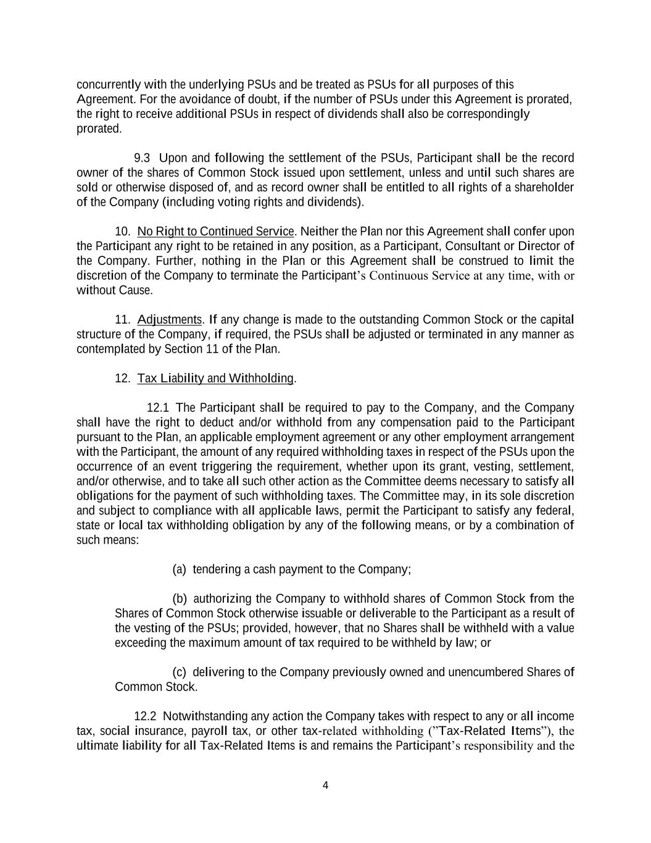
4 concurrently with the underlying PSUs and be treated as PSUs for all purposes of this Agreement. For the avoidance of doubt, if the number of PSUs under this Agreement is prorated, the right to receive additional PSUs in respect of dividends shall also be correspondingly prorated. 9.3 Upon and following the settlement of the PSUs, Participant shall be the record owner of the shares of Common Stock issued upon settlement, unless and until such shares are sold or otherwise disposed of, and as record owner shall be entitled to all rights of a shareholder of the Company (including voting rights and dividends). 10. No Right to Continued Service. Neither the Plan nor this Agreement shall confer upon the Participant any right to be retained in any position, as a Participant, Consultant or Director of the Company. Further, nothing in the Plan or this Agreement shall be construed to limit the discretion of the Company to terminate the Participant’s Continuous Service at any time, with or without Cause. 11. Adjustments. If any change is made to the outstanding Common Stock or the capital structure of the Company, if required, the PSUs shall be adjusted or terminated in any manner as contemplated by Section 11 of the Plan. 12. Tax Liability and Withholding. 12.1 The Participant shall be required to pay to the Company, and the Company shall have the right to deduct and/or withhold from any compensation paid to the Participant pursuant to the Plan, an applicable employment agreement or any other employment arrangement with the Participant, the amount of any required withholding taxes in respect of the PSUs upon the occurrence of an event triggering the requirement, whether upon its grant, vesting, settlement, and/or otherwise, and to take all such other action as the Committee deems necessary to satisfy all obligations for the payment of such withholding taxes. The Committee may, in its sole discretion and subject to compliance with all applicable laws, permit the Participant to satisfy any federal, state or local tax withholding obligation by any of the following means, or by a combination of such means: (a) tendering a cash payment to the Company; (b) authorizing the Company to withhold shares of Common Stock from the Shares of Common Stock otherwise issuable or deliverable to the Participant as a result of the vesting of the PSUs; provided, however, that no Shares shall be withheld with a value exceeding the maximum amount of tax required to be withheld by law; or (c) delivering to the Company previously owned and unencumbered Shares of Common Stock. 12.2 Notwithstanding any action the Company takes with respect to any or all income tax, social insurance, payroll tax, or other tax-related withholding (”Tax-Related Items”), the ultimate liability for all Tax-Related Items is and remains the Participant’s responsibility and the

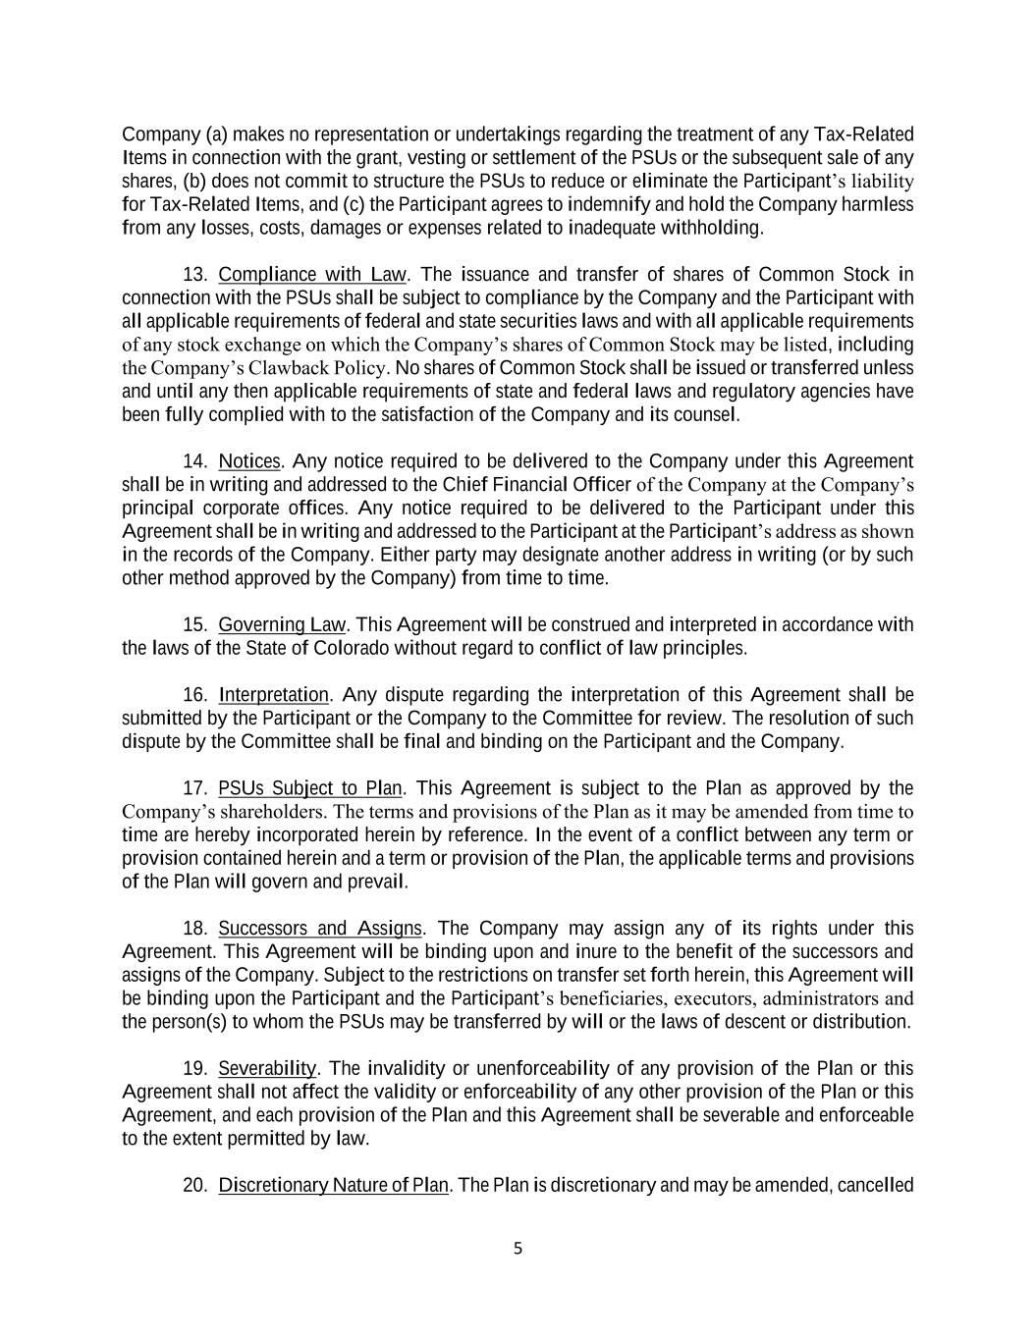
5 Company (a) makes no representation or undertakings regarding the treatment of any Tax-Related Items in connection with the grant, vesting or settlement of the PSUs or the subsequent sale of any shares, (b) does not commit to structure the PSUs to reduce or eliminate the Participant’s liability for Tax-Related Items, and (c) the Participant agrees to indemnify and hold the Company harmless from any losses, costs, damages or expenses related to inadequate withholding. 13. Compliance with Law. The issuance and transfer of shares of Common Stock in connection with the PSUs shall be subject to compliance by the Company and the Participant with all applicable requirements of federal and state securities laws and with all applicable requirements of any stock exchange on which the Company’s shares of Common Stock may be listed, including the Company’s Clawback Policy. No shares of Common Stock shall be issued or transferred unless and until any then applicable requirements of state and federal laws and regulatory agencies have been fully complied with to the satisfaction of the Company and its counsel. 14. Notices. Any notice required to be delivered to the Company under this Agreement shall be in writing and addressed to the Chief Financial Officer of the Company at the Company’s principal corporate offices. Any notice required to be delivered to the Participant under this Agreement shall be in writing and addressed to the Participant at the Participant’s address as shown in the records of the Company. Either party may designate another address in writing (or by such other method approved by the Company) from time to time. 15. Governing Law. This Agreement will be construed and interpreted in accordance with the laws of the State of Colorado without regard to conflict of law principles. 16. Interpretation. Any dispute regarding the interpretation of this Agreement shall be submitted by the Participant or the Company to the Committee for review. The resolution of such dispute by the Committee shall be final and binding on the Participant and the Company. 17. PSUs Subject to Plan. This Agreement is subject to the Plan as approved by the Company’s shareholders. The terms and provisions of the Plan as it may be amended from time to time are hereby incorporated herein by reference. In the event of a conflict between any term or provision contained herein and a term or provision of the Plan, the applicable terms and provisions of the Plan will govern and prevail. 18. Successors and Assigns. The Company may assign any of its rights under this Agreement. This Agreement will be binding upon and inure to the benefit of the successors and assigns of the Company. Subject to the restrictions on transfer set forth herein, this Agreement will be binding upon the Participant and the Participant’s beneficiaries, executors, administrators and the person(s) to whom the PSUs may be transferred by will or the laws of descent or distribution. 19. Severability. The invalidity or unenforceability of any provision of the Plan or this Agreement shall not affect the validity or enforceability of any other provision of the Plan or this Agreement, and each provision of the Plan and this Agreement shall be severable and enforceable to the extent permitted by law. 20. Discretionary Nature of Plan. The Plan is discretionary and may be amended, cancelled

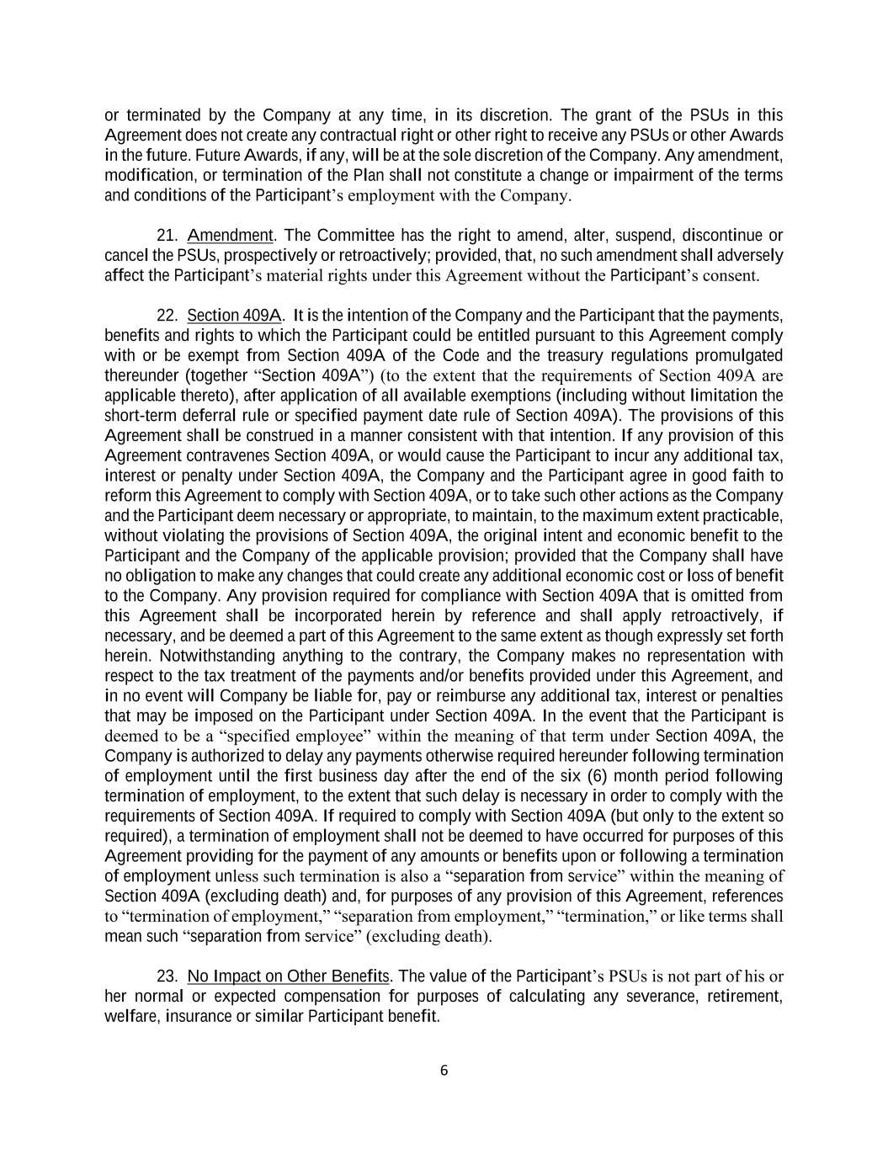
6 or terminated by the Company at any time, in its discretion. The grant of the PSUs in this Agreement does not create any contractual right or other right to receive any PSUs or other Awards in the future. Future Awards, if any, will be at the sole discretion of the Company. Any amendment, modification, or termination of the Plan shall not constitute a change or impairment of the terms and conditions of the Participant’s employment with the Company. 21. Amendment. The Committee has the right to amend, alter, suspend, discontinue or cancel the PSUs, prospectively or retroactively; provided, that, no such amendment shall adversely affect the Participant’s material rights under this Agreement without the Participant’s consent. 22. Section 409A. It is the intention of the Company and the Participant that the payments, benefits and rights to which the Participant could be entitled pursuant to this Agreement comply with or be exempt from Section 409A of the Code and the treasury regulations promulgated thereunder (together “Section 409A”) (to the extent that the requirements of Section 409A are applicable thereto), after application of all available exemptions (including without limitation the short-term deferral rule or specified payment date rule of Section 409A). The provisions of this Agreement shall be construed in a manner consistent with that intention. If any provision of this Agreement contravenes Section 409A, or would cause the Participant to incur any additional tax, interest or penalty under Section 409A, the Company and the Participant agree in good faith to reform this Agreement to comply with Section 409A, or to take such other actions as the Company and the Participant deem necessary or appropriate, to maintain, to the maximum extent practicable, without violating the provisions of Section 409A, the original intent and economic benefit to the Participant and the Company of the applicable provision; provided that the Company shall have no obligation to make any changes that could create any additional economic cost or loss of benefit to the Company. Any provision required for compliance with Section 409A that is omitted from this Agreement shall be incorporated herein by reference and shall apply retroactively, if necessary, and be deemed a part of this Agreement to the same extent as though expressly set forth herein. Notwithstanding anything to the contrary, the Company makes no representation with respect to the tax treatment of the payments and/or benefits provided under this Agreement, and in no event will Company be liable for, pay or reimburse any additional tax, interest or penalties that may be imposed on the Participant under Section 409A. In the event that the Participant is deemed to be a “specified employee” within the meaning of that term under Section 409A, the Company is authorized to delay any payments otherwise required hereunder following termination of employment until the first business day after the end of the six (6) month period following termination of employment, to the extent that such delay is necessary in order to comply with the requirements of Section 409A. If required to comply with Section 409A (but only to the extent so required), a termination of employment shall not be deemed to have occurred for purposes of this Agreement providing for the payment of any amounts or benefits upon or following a termination of employment unless such termination is also a “separation from service” within the meaning of Section 409A (excluding death) and, for purposes of any provision of this Agreement, references to “termination of employment,” “separation from employment,” “termination,” or like terms shall mean such “separation from service” (excluding death). 23. No Impact on Other Benefits. The value of the Participant’s PSUs is not part of his or her normal or expected compensation for purposes of calculating any severance, retirement, welfare, insurance or similar Participant benefit.

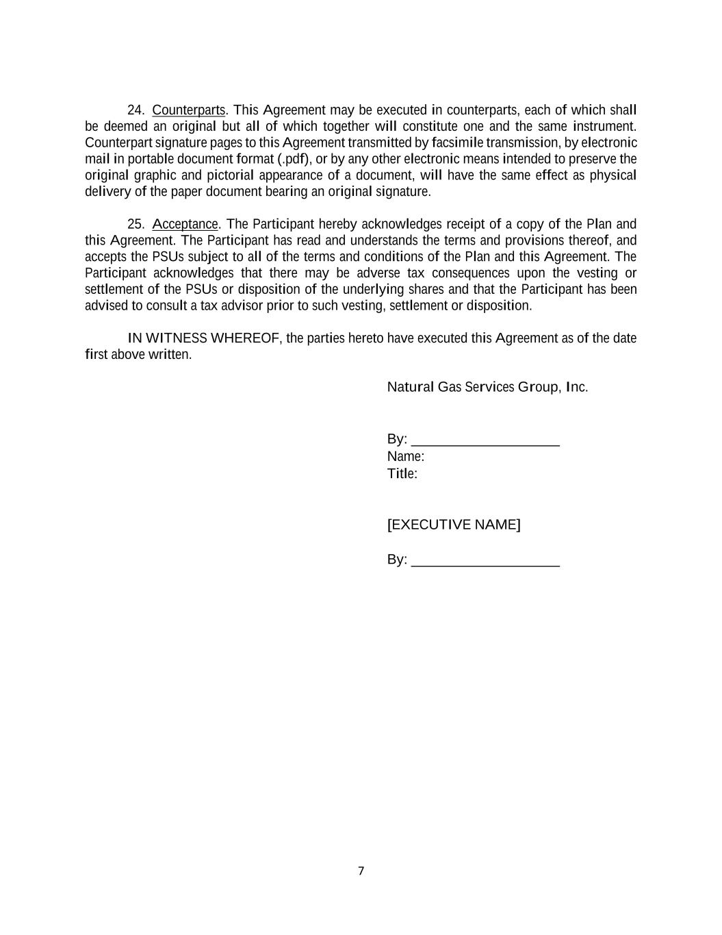
7 24. Counterparts. This Agreement may be executed in counterparts, each of which shall be deemed an original but all of which together will constitute one and the same instrument. Counterpart signature pages to this Agreement transmitted by facsimile transmission, by electronic mail in portable document format (.pdf), or by any other electronic means intended to preserve the original graphic and pictorial appearance of a document, will have the same effect as physical delivery of the paper document bearing an original signature. 25. Acceptance. The Participant hereby acknowledges receipt of a copy of the Plan and this Agreement. The Participant has read and understands the terms and provisions thereof, and accepts the PSUs subject to all of the terms and conditions of the Plan and this Agreement. The Participant acknowledges that there may be adverse tax consequences upon the vesting or settlement of the PSUs or disposition of the underlying shares and that the Participant has been advised to consult a tax advisor prior to such vesting, settlement or disposition. IN WITNESS WHEREOF, the parties hereto have executed this Agreement as of the date first above written. Natural Gas Services Group, Inc. By: _____________________ Name: Title: [EXECUTIVE NAME] By: _____________________

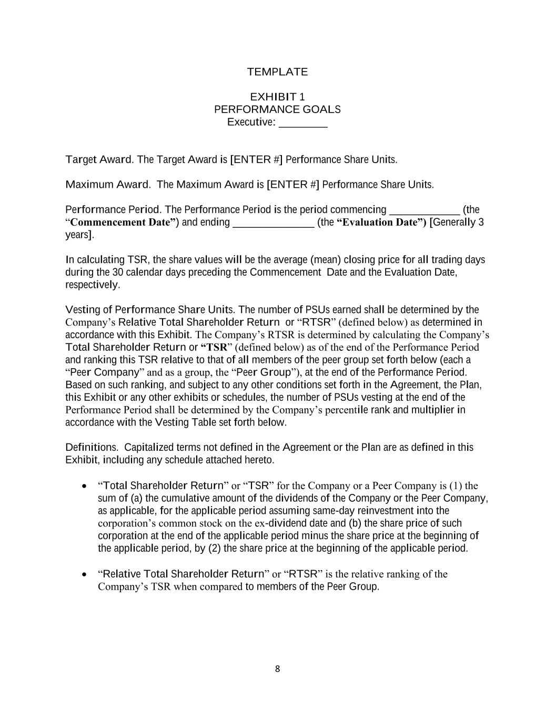
8 TEMPLATE EXHIBIT 1 PERFORMANCE GOALS Executive: _________ Target Award. The Target Award is [ENTER #] Performance Share Units. Maximum Award. The Maximum Award is [ENTER #] Performance Share Units. Performance Period. The Performance Period is the period commencing _____________ (the “Commencement Date”) and ending _______________ (the “Evaluation Date”) [Generally 3 years]. In calculating TSR, the share values will be the average (mean) closing price for all trading days during the 30 calendar days preceding the Commencement Date and the Evaluation Date, respectively. Vesting of Performance Share Units. The number of PSUs earned shall be determined by the Company’s Relative Total Shareholder Return or “RTSR” (defined below) as determined in accordance with this Exhibit. The Company’s RTSR is determined by calculating the Company’s Total Shareholder Return or “TSR” (defined below) as of the end of the Performance Period and ranking this TSR relative to that of all members of the peer group set forth below (each a “Peer Company” and as a group, the “Peer Group”), at the end of the Performance Period. Based on such ranking, and subject to any other conditions set forth in the Agreement, the Plan, this Exhibit or any other exhibits or schedules, the number of PSUs vesting at the end of the Performance Period shall be determined by the Company’s percentile rank and multiplier in accordance with the Vesting Table set forth below. Definitions. Capitalized terms not defined in the Agreement or the Plan are as defined in this Exhibit, including any schedule attached hereto. • “Total Shareholder Return” or “TSR” for the Company or a Peer Company is (1) the sum of (a) the cumulative amount of the dividends of the Company or the Peer Company, as applicable, for the applicable period assuming same-day reinvestment into the corporation’s common stock on the ex-dividend date and (b) the share price of such corporation at the end of the applicable period minus the share price at the beginning of the applicable period, by (2) the share price at the beginning of the applicable period. • “Relative Total Shareholder Return” or “RTSR” is the relative ranking of the Company’s TSR when compared to members of the Peer Group.

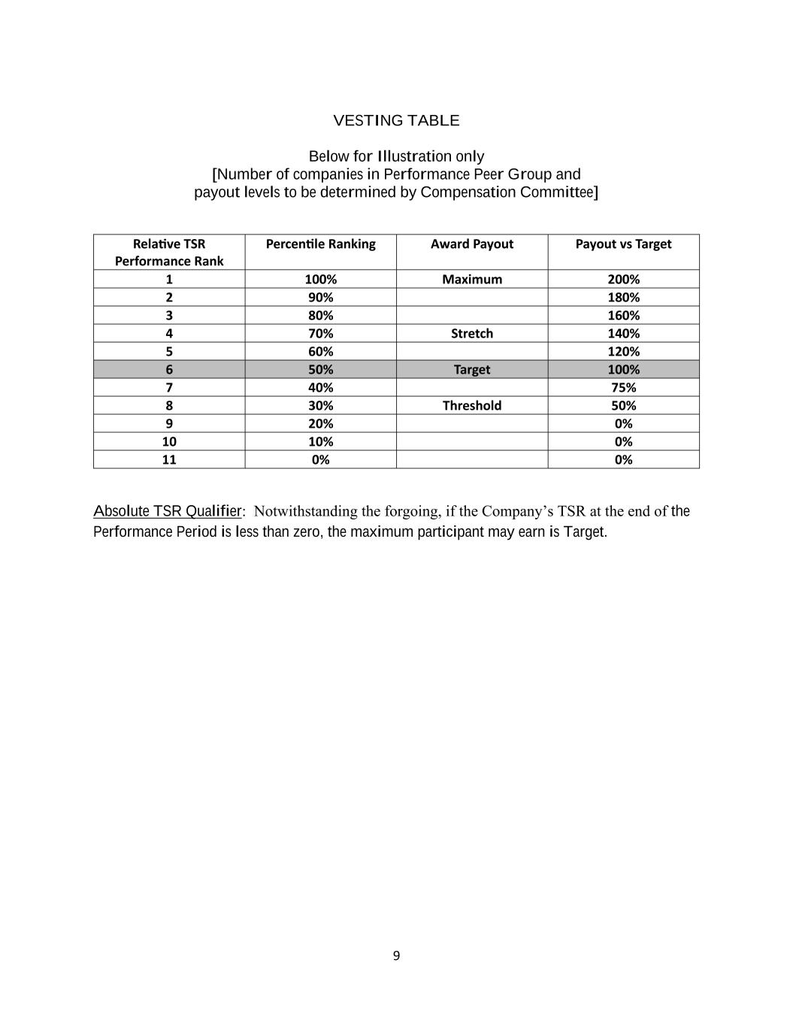
9 VESTING TABLE Below for Illustration only [Number of companies in Performance Peer Group and payout levels to be determined by Compensation Committee] Relative TSR Performance Rank Percentile Ranking Award Payout Payout vs Target 1 100% Maximum 200% 2 90% 180% 3 80% 160% 4 70% Stretch 140% 5 60% 120% 6 50% Target 100% 7 40% 75% 8 30% Threshold 50% 9 20% 0% 10 10% 0% 11 0% 0% Absolute TSR Qualifier: Notwithstanding the forgoing, if the Company’s TSR at the end of the Performance Period is less than zero, the maximum participant may earn is Target.

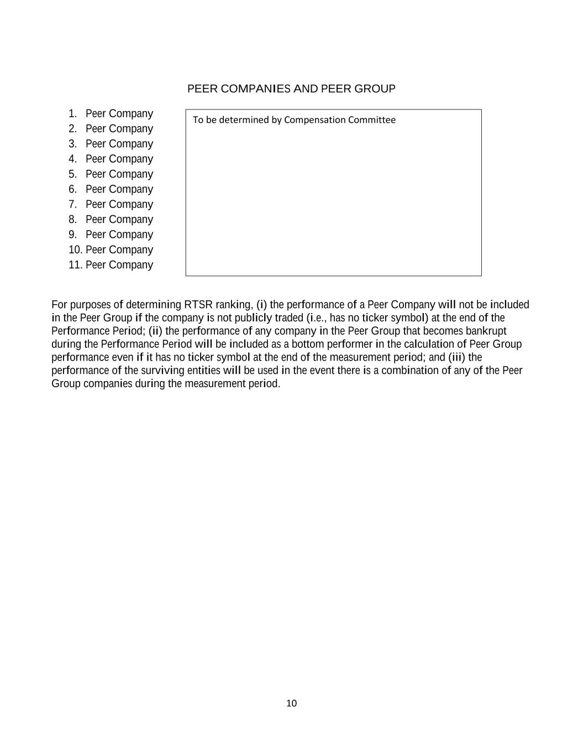
10 PEER COMPANIES AND PEER GROUP 1. Peer Company 2. Peer Company 3. Peer Company 4. Peer Company 5. Peer Company 6. Peer Company 7. Peer Company 8. Peer Company 9. Peer Company 10. Peer Company 11. Peer Company For purposes of determining RTSR ranking, (i) the performance of a Peer Company will not be included in the Peer Group if the company is not publicly traded (i.e., has no ticker symbol) at the end of the Performance Period; (ii) the performance of any company in the Peer Group that becomes bankrupt during the Performance Period will be included as a bottom performer in the calculation of Peer Group performance even if it has no ticker symbol at the end of the measurement period; and (iii) the performance of the surviving entities will be used in the event there is a combination of any of the Peer Group companies during the measurement period. To be determined by Compensation Committee

Exhibit 31.1

Certifications

I, Justin C. Jacobs, certify that:
1.I have reviewed this Quarterly Report on Form 10-Q of Natural Gas Services Group, Inc;
2.Based on my knowledge, this report does not contain any untrue statement of a material fact or omit to state a material fact necessary to make the statements made, in light of the circumstances under which such statements were made, not misleading with respect to the period covered by this report;
3.Based on my knowledge, the financial statements, and other financial information included in this report, fairly present in all material respects the financial condition, results of operations and cash flows of the registrant as of, and for, the periods presented in this report;
4.The registrant's other certifying officer(s) and I are responsible for establishing and maintaining disclosure controls and procedures (as defined in Exchange Act Rules 13a-15(e) and 15d-15(e)) and internal control over financial reporting (as defined in Exchange Act Rules 13a-15(f) and 15d-15(f) for the registrant and have:
a.Designed such disclosure controls and procedures, or caused such disclosure controls and procedures to be designed under our supervision, to ensure that material information relating to the registrant, including its consolidated subsidiaries, is made known to us by others within those entities, particularly during the period in which this report is being prepared;
b.Designed such internal control over financial reporting, or caused such internal control over financial reporting to be designed under our supervision, to provide reasonable assurance regarding the reliability of financial reporting and the preparation of financial statements for external purposes in accordance with generally accepted accounting principles;
c.Evaluated the effectiveness of the registrant's disclosure controls and procedures and presented in this report our conclusions about the effectiveness of the disclosure controls and procedures, as of the end of the period covered by this report based on such evaluation; and
d.Disclosed in this report any change in the registrant's internal control over financial reporting that occurred during the registrant's most recent fiscal quarter (the registrant's fourth fiscal quarter in the case of an annual report) that has materially affected, or is reasonably likely to materially affect, the registrant's internal control over financial reporting; and
1.The registrant's other certifying officer(s) and I have disclosed, based on our most recent evaluation of internal control over financial reporting, to the registrant's auditors and the audit committee of the registrant's board of directors (or persons performing the equivalent functions):
a.All significant deficiencies and material weaknesses in the design or operation of internal control over financial reporting which are reasonably likely to adversely affect the registrant's ability to record, process, summarize and report financial information; and
b.Any fraud, whether or not material, that involves management or other employees who have a significant role in the registrant's internal control over financial reporting.
Dated: |  |  | May 15, 2024 |  |  |  |  |  | Natural Gas Services Group, Inc.
 |  |  |  |  |  | By: |  |  | /s/ Justin C. Jacobs
 |  |  |  |  |  |  |  |  | Justin C. Jacobs
 |  |  |  |  |  |  |  |  | Director and Chief Executive Officer
 |  |  |  |  |  |  |  |  | (Principal Executive Officer)

Exhibit 31.2
Certifications
I, John Bittner, certify that:
1. I have reviewed this Quarterly Report on Form 10-Q of Natural Gas Services Group, Inc;
2. Based on my knowledge, this report does not contain any untrue statement of a material fact or omit to state a material fact necessary to make the statements made, in light of the circumstances under which such statements were made, not misleading with respect to the period covered by this report;
3. Based on my knowledge, the financial statements, and other financial information included in this report, fairly present in all material respects the financial condition, results of operations and cash flows of the registrant as of, and for, the periods presented in this report;
4. The registrant's other certifying officer(s) and I are responsible for establishing and maintaining disclosure controls and procedures (as defined in Exchange Act Rules 13a-15(e) and 15d-15(e)) and internal control over financial reporting (as defined in Exchange Act Rules 13a-15(f) and 15d-15(f) for the registrant and have:
(a) Designed such disclosure controls and procedures, or caused such disclosure controls and procedures to be designed under our supervision, to ensure that material information relating to the registrant, including its consolidated subsidiaries, is made known to us by others within those entities, particularly during the period in which this report is being prepared;
(b) Designed such internal control over financial reporting, or caused such internal control over financial reporting to be designed under our supervision, to provide reasonable assurance regarding the reliability of financial reporting and the preparation of financial statements for external purposes in accordance with generally accepted accounting principles;
(c) Evaluated the effectiveness of the registrant's disclosure controls and procedures and presented in this report our conclusions about the effectiveness of the disclosure controls and procedures, as of the end of the period covered by this report based on such evaluation; and
(d) Disclosed in this report any change in the registrant's internal control over financial reporting that occurred during the registrant's most recent fiscal quarter (the registrant's fourth fiscal quarter in the case of an annual report) that has materially affected, or is reasonably likely to materially affect, the registrant's internal control over financial reporting; and
5. The registrant's other certifying officer(s) and I have disclosed, based on our most recent evaluation of internal control over financial reporting, to the registrant's auditors and the audit committee of the registrant's board of directors (or persons performing the equivalent functions):
(a) All significant deficiencies and material weaknesses in the design or operation of internal control over financial reporting which are reasonably likely to adversely affect the registrant's ability to record, process, summarize and report financial information; and
(b) Any fraud, whether or not material, that involves management or other employees who have a significant role in the registrant's internal control over financial reporting.
Dated: |  |  | May 15, 2024 |  |  |  |  |  | Natural Gas Services Group, Inc.
 |  |  |  |  |  | By: |  |  | /s/John Bittner
 |  |  |  |  |  |  |  |  | John Bittner
 |  |  |  |  |  |  |  |  | Interim Chief Financial Officer
 |  |  |  |  |  |  |  |  | (Principal Accounting Officer)

Exhibit 32.1

CERTIFICATION PURSUANT TO
18 U.S.C. §1350,
AS ADOPTED PURSUANT TO
SECTION 906 OF THE SARBANES-OXLEY ACT OF 2002

In connection with the Quarterly Report of Natural Gas Services Group, Inc. (the “Company”) on Form 10-Q for the period ended March 31, 2024 as filed with the Securities and Exchange Commission on the date hereof (the “Report”), I, Justin C. Jacobs, Interim Chief Executive Officer of the Company, certify, pursuant to 18 U.S.C. §1350, as adopted pursuant to Section 906 of the Sarbanes-Oxley Act of 2002, that:
1. The Report fully complies with the requirements of Section 13(a) or 15(d) of the Securities Exchange Act of 1934, as amended; and
2. The information contained in the Report fairly presents, in all material respects, the financial condition and results of operations of the Company.
Dated: |  |  | May 15, 2024 |  |  |  |  |  | Natural Gas Services Group, Inc.
 |  |  |  |  |  | By: |  |  | /s/ Justin C. Jacobs
 |  |  |  |  |  |  |  |  | Justin C. Jacobs
 |  |  |  |  |  |  |  |  | Director and Chief Executive Officer
 |  |  |  |  |  |  |  |  | (Principal Executive Officer)

The foregoing certification is being furnished solely to accompany the Report pursuant to 18 U.S.C. § 1350, and is not being filed for purposes of Section 18 of the Securities Exchange Act of 1934, as amended, and is not to be incorporated by reference into any filing of the Company, whether made before or after the date hereof, regardless of any general incorporation language in such filing.

Exhibit 32.2

CERTIFICATION PURSUANT TO
18 U.S.C. §1350,
AS ADOPTED PURSUANT TO
SECTION 906 OF THE SARBANES-OXLEY ACT OF 2002

In connection with the Quarterly Report of Natural Gas Services Group, Inc. (the “Company”) on Form 10-Q for the period ended March 31, 2024 as filed with the Securities and Exchange Commission on the date hereof (the “Report”), I, John Bittner, Interim Chief Financial Officer of the Company, certify, pursuant to 18 U.S.C. §1350, as adopted pursuant to Section 906 of the Sarbanes-Oxley Act of 2002, that:
1. The Report fully complies with the requirements of Section 13(a) or 15(d) of the Securities Exchange Act of 1934, as amended; and
2. The information contained in the Report fairly presents, in all material respects, the financial condition and results of operations of the Company.
Dated: |  |  | May 15, 2024 |  |  |  |  |  | Natural Gas Services Group, Inc.
 |  |  |  |  |  | By: |  |  | /s/ John Bittner
 |  |  |  |  |  |  |  |  | John Bittner
 |  |  |  |  |  |  |  |  | Interim Chief Financial Officer
 |  |  |  |  |  |  |  |  | (Principal Accounting Officer)

The foregoing certification is being furnished solely to accompany the Report pursuant to 18 U.S.C. § 1350, and is not being filed for purposes of Section 18 of the Securities Exchange Act of 1934, as amended, and is not to be incorporated by reference into any filing of the Company, whether made before or after the date hereof, regardless of any general incorporation language in such filing.

