UNITED STATES
SECURITIES AND EXCHANGE COMMISSION
WASHINGTON, D.C. 20549
FORM 8-K
CURRENT REPORT
Pursuant to Section 13 or 15(d) of the Securities Exchange Act of 1934
Date of Report (Date of Earliest Event Reported): August 11, 2026
NATURAL GAS SERVICES GROUP, INC.
(Exact Name of Registrant as Specified in Charter)
Texas |  |  |  |  |  | 1-31398 |  |  |  |  |  | 75-2811855
(State or Other Jurisdiction  of Incorporation) |  |  |  |  |  | (Commission File Number) |  |  |  |  |  | (IRS Employer Identification No.)
601 State Street, Suite 400
Southlake, TX 76092
(Address of Principal Executive Offices)
(432) 262-2700
(Registrant's Telephone Number, Including Area Code)
N/A
(Former Name or Former Address if Changed Since Last Report)

Check the appropriate box below if the Form 8-K filing is intended to simultaneously satisfy the filing obligation of the registrant under any of the following provisions (see General Instruction A.2. below):

☐ Written communications pursuant to Rule 425 under the Securities Act (17 CFR 230.425)

☐ Soliciting material pursuant to Rule 14a-12 under the Exchange Act (17 CFR 240.14a-12)

☐ Pre-commencement communications pursuant to Rule 14d-2(b) under the Exchange Act (17 CFR 240.14d-2(b)).

☐ Pre-commencement communications pursuant to Rule 13e-4(c) under the Exchange Act (17 CFR 240.13e-14(c)).
Securities registered pursuant to Section 12(b) of the Act:
Title of each class |  |  |  |  |  | Trading Symbol |  |  |  |  |  | Name of each exchange on which registered
Common Stock, Par Value $0.01 |  |  |  |  |  | NGS |  |  |  |  |  | NYSE

Indicate by check mark whether the registrant is an emerging growth company as defined in Rule 405 of the Securities Act of 1933 (§230.405 of this chapter) or Rule 12b-2 of the Securities Exchange Act of 1934 (§240.12b-2 of this chapter).

Emerging growth company ☐

If an emerging growth company, indicate by check mark if the registrant has elected not to use the extended transition period for complying with any new or revised financial accounting standards provided pursuant to Section 13(a) of the Exchange Act. o

Item 2.02 Results of Operations and Financial Condition.
On August 11, 2026, Natural Gas Services Group, Inc. (the “Company”) hosted an earnings call to announce the Company’s financial results for the second quarter ended June 30, 2026, and provide certain other financial and business information, along with forward guidance. A copy of the earnings call transcript is attached hereto as Exhibit 99.1 and incorporated herein by reference.
Item 7.01. |  |  | Regulation FD Disclosure.
The information set forth in Item 2.02 of this Current Report on Form 8-K is incorporated by reference into this Item 7.01.
The information in Item 2.02 and Item 7.01 of this Current Report on Form 8-K, including Exhibit 99.1, is being furnished and shall not be deemed “filed” for purposes of Section 18 of the Securities Exchange Act of 1934, as amended, or otherwise subject to the liabilities of that section, nor shall it be deemed incorporated by reference in any filing under the Securities Act of 1933, as amended, except as expressly set forth by specific reference in such filing.
The replay of the earnings call may also be found on our website at https://www.ngsgi.com under our “news and events” section of our website.
About Natural Gas Services Group, Inc.
Natural Gas Services Group is a leading provider of natural gas and electric compression equipment, technology and services to the energy industry. The Company rents, designs, installs, services and maintains natural gas and electric compressors and related equipment and parts for our customers’ oil and gas production and processing facilities, generally using equipment from third-party fabricators and OEM suppliers along with limited in-house assembly. The Company is headquartered in Southlake, Texas, with administrative offices in Midland, Texas an assembly facility located in Tulsa, Oklahoma, and service facilities located in major oil and natural gas producing basins in the continental U.S. Additional information can be found at www.ngsgi.com.

Forward-Looking Statements
Certain statements herein (and oral statements made regarding the subjects of this release) constitute “forward-looking statements” within the meaning of the federal securities laws. Words such as “may,” “will,” “expect,” “anticipate,” “estimate,” “guidance,” “forecast,” “believe,” “might,” “continue,” “should,” “intend” “plan,” “project,” “budget,” or similar expressions, or statements regarding intent, belief, or current expectations, are forward-looking statements. These forward-looking statements are based upon current estimates and assumptions.
These forward–looking statements rely on a number of assumptions concerning future events and are subject to a number of uncertainties and factors that could cause actual results to differ materially from such statements, many of which are outside the control of the Company. Forward– looking information includes, but is not limited to statements regarding: guidance or estimates related to Adjusted EBITDA growth, projected capital expenditures; returns on invested capital, fundamentals of the compression industry and related oil and gas industry, valuations, compressor demand assumptions and overall industry outlook, the anticipated benefits of the Flatrock Acquisition, expected synergies from the acquisition, the expectation that the acquisition will be immediately and meaningfully accretive, and the ability of the Company to capitalize on any potential opportunities.
While the Company believes that the assumptions concerning future events are reasonable, investors are cautioned that there are inherent difficulties in predicting certain important factors that could impact the future performance or results of its business. Some of these factors that could cause results to differ materially from those indicated by such forward-looking statements include, but are not limited to:
•conditions in the oil and gas industry, including the supply and demand for oil and gas and volatility in the prices of oil and gas;
•changes in general economic and financial conditions, inflationary pressures, the potential for economic recession in the U.S., tariffs and trade restrictions, including the imposition of new and higher tariffs on imported goods and retaliatory tariffs implemented by other countries on U.S. goods, and the potential effects on our financial condition, results of operations and cash flows;
•our reliance on major customers;
•failure of projected organic growth due to adverse changes in the oil and gas industry, including depressed oil and gas prices, oppressive environmental regulations and competition;
•integration of the Flatrock Acquisition with our business;
•our inability to achieve increased utilization of assets, including rental fleet utilization and monetizing other non-cash balance sheet assets;
•failure of our customers to continue to rent equipment after expiration of the primary rental term;
•our ability to economically develop and deploy new technologies and services, including technology to comply with health and environmental laws and regulations;
•failure to achieve accretive financial results in connection with any acquisitions we may make;
•fluctuations in interest rates;
•our ability to make dividends, distributions and share repurchases;
•changes in regulation or prohibition of new or current well completion techniques;
•competition among the various providers of compression services and products;
•changes in safety, health and environmental regulations;
•changes in economic or political conditions in the markets in which we operate;
•the inherent risks associated with our operations, such as equipment defects, malfunctions, natural disasters and adverse changes in customer, employee and supplier relationships;
•our inability to comply with covenants in our debt agreements and the decreased financial flexibility associated with our debt;
•inability to finance our future capital requirements and availability of financing;
•cybersecurity threats, including increased use of artificial intelligence and other emerging technologies;
•capacity availability, costs and performance of our outsourced compressor fabrication providers and overall inflationary pressures;
•impacts of world events, such as acts of terrorism, the conflicts in Iran, Ukraine, Venezuela and in the greater Middle East, and significant economic disruptions and adverse consequences resulting from possible long-term effects of potential pandemics and other public health crises; and
•general economic conditions.
In addition, these forward-looking statements are subject to other various risks and uncertainties, including without limitation those set forth in the Company’s filings with the Securities and Exchange Commission, including the Company's Annual Report on Form 10-K for the year ended December 31, 2025, and its Quarterly Report on Form 10-Q for the quarter ended June 30, 2026. Thus, actual results could be materially different. The Company expressly disclaims any obligation to update or alter statements whether as a result of new information, future events or otherwise, except as required by law.

Item 9.01 Financial Statements and Exhibits.
(d) Exhibits.
The following exhibits are included with this Current Report on Form 8-K:

Exhibit No. |  |  | Description
99.1 |  |  | Earnings Call Transcript for the First Quarter Ended June 30, 2026.
104 |  |  | Cover Page Interactive Data File (embedded within the Inline XBRL document).

SIGNATURES

Pursuant to the requirements of the Securities Exchange Act of 1934, the registrant has duly caused this report to be signed on its behalf by the undersigned hereunto duly authorized.

 |  |  |  |  |  |  |  |  | NATURAL GAS SERVICES GROUP, INC.
 |  |  | Dated: August 12, 2026 |  |  |  |  |  | By: |  |  |  |  |  | /s/ Justin C. Jacobs
 |  |  |  |  |  |  |  |  |  |  |  |  |  |  | Name: Justin C. Jacobs
 |  |  |  |  |  |  |  |  |  |  |  |  |  |  | Title: Chief Executive Officer

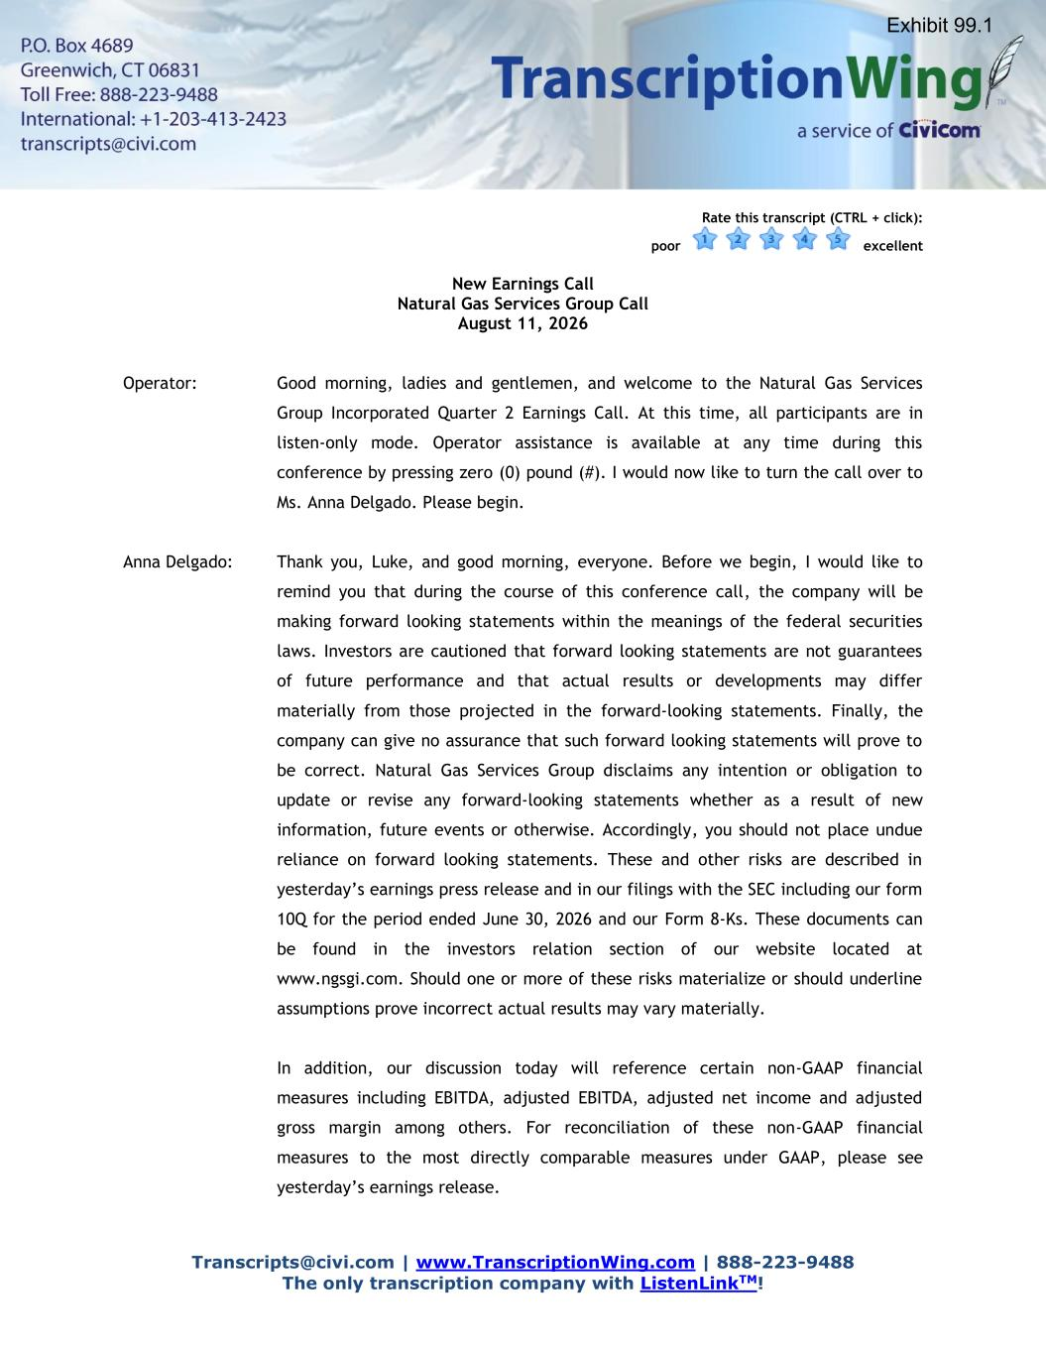

Transcripts@civi.com | www.TranscriptionWing.com | 888-223-9488 The only transcription company with ListenLinkTM! Rate this transcript (CTRL + click): poor excellent New Earnings Call Natural Gas Services Group Call August 11, 2026 Operator: Good morning, ladies and gentlemen, and welcome to the Natural Gas Services Group Incorporated Quarter 2 Earnings Call. At this time, all participants are in listen-only mode. Operator assistance is available at any time during this conference by pressing zero (0) pound (#). I would now like to turn the call over to Ms. Anna Delgado. Please begin. Anna Delgado: Thank you, Luke, and good morning, everyone. Before we begin, I would like to remind you that during the course of this conference call, the company will be making forward looking statements within the meanings of the federal securities laws. Investors are cautioned that forward looking statements are not guarantees of future performance and that actual results or developments may differ materially from those projected in the forward-looking statements. Finally, the company can give no assurance that such forward looking statements will prove to be correct. Natural Gas Services Group disclaims any intention or obligation to update or revise any forward-looking statements whether as a result of new information, future events or otherwise. Accordingly, you should not place undue reliance on forward looking statements. These and other risks are described in yesterday’s earnings press release and in our filings with the SEC including our form 10Q for the period ended June 30, 2026 and our Form 8-Ks. These documents can be found in the investors relation section of our website located at www.ngsgi.com. Should one or more of these risks materialize or should underline assumptions prove incorrect actual results may vary materially. In addition, our discussion today will reference certain non-GAAP financial measures including EBITDA, adjusted EBITDA, adjusted net income and adjusted gross margin among others. For reconciliation of these non-GAAP financial measures to the most directly comparable measures under GAAP, please see yesterday’s earnings release. Exhibit 99.1

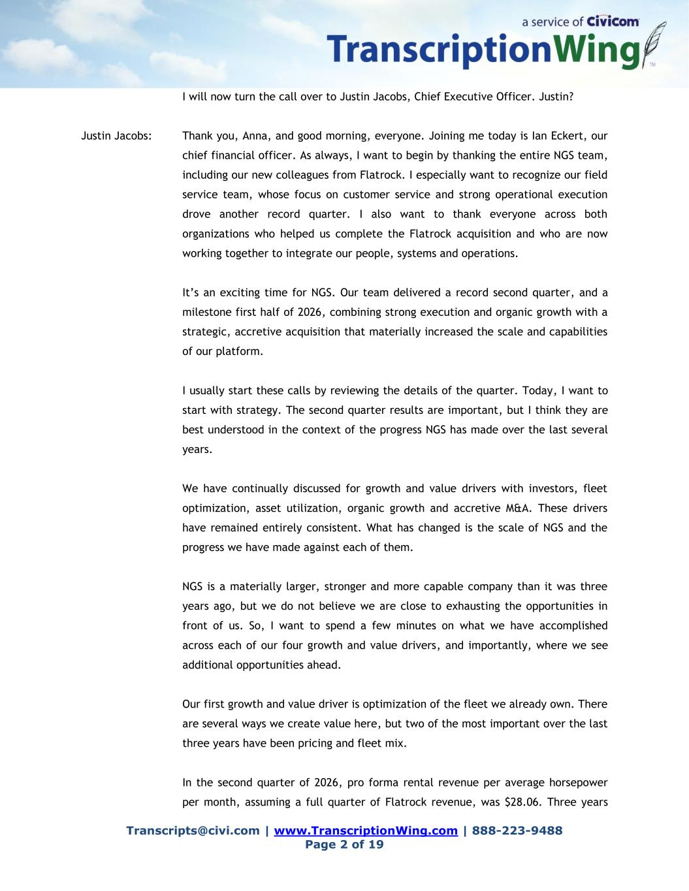
Transcripts@civi.com | www.TranscriptionWing.com | 888-223-9488 Page 2 of 19 I will now turn the call over to Justin Jacobs, Chief Executive Officer. Justin? Justin Jacobs: Thank you, Anna, and good morning, everyone. Joining me today is Ian Eckert, our chief financial officer. As always, I want to begin by thanking the entire NGS team, including our new colleagues from Flatrock. I especially want to recognize our field service team, whose focus on customer service and strong operational execution drove another record quarter. I also want to thank everyone across both organizations who helped us complete the Flatrock acquisition and who are now working together to integrate our people, systems and operations. It’s an exciting time for NGS. Our team delivered a record second quarter, and a milestone first half of 2026, combining strong execution and organic growth with a strategic, accretive acquisition that materially increased the scale and capabilities of our platform. I usually start these calls by reviewing the details of the quarter. Today, I want to start with strategy. The second quarter results are important, but I think they are best understood in the context of the progress NGS has made over the last several years. We have continually discussed for growth and value drivers with investors, fleet optimization, asset utilization, organic growth and accretive M&A. These drivers have remained entirely consistent. What has changed is the scale of NGS and the progress we have made against each of them. NGS is a materially larger, stronger and more capable company than it was three years ago, but we do not believe we are close to exhausting the opportunities in front of us. So, I want to spend a few minutes on what we have accomplished across each of our four growth and value drivers, and importantly, where we see additional opportunities ahead. Our first growth and value driver is optimization of the fleet we already own. There are several ways we create value here, but two of the most important over the last three years have been pricing and fleet mix. In the second quarter of 2026, pro forma rental revenue per average horsepower per month, assuming a full quarter of Flatrock revenue, was $28.06. Three years

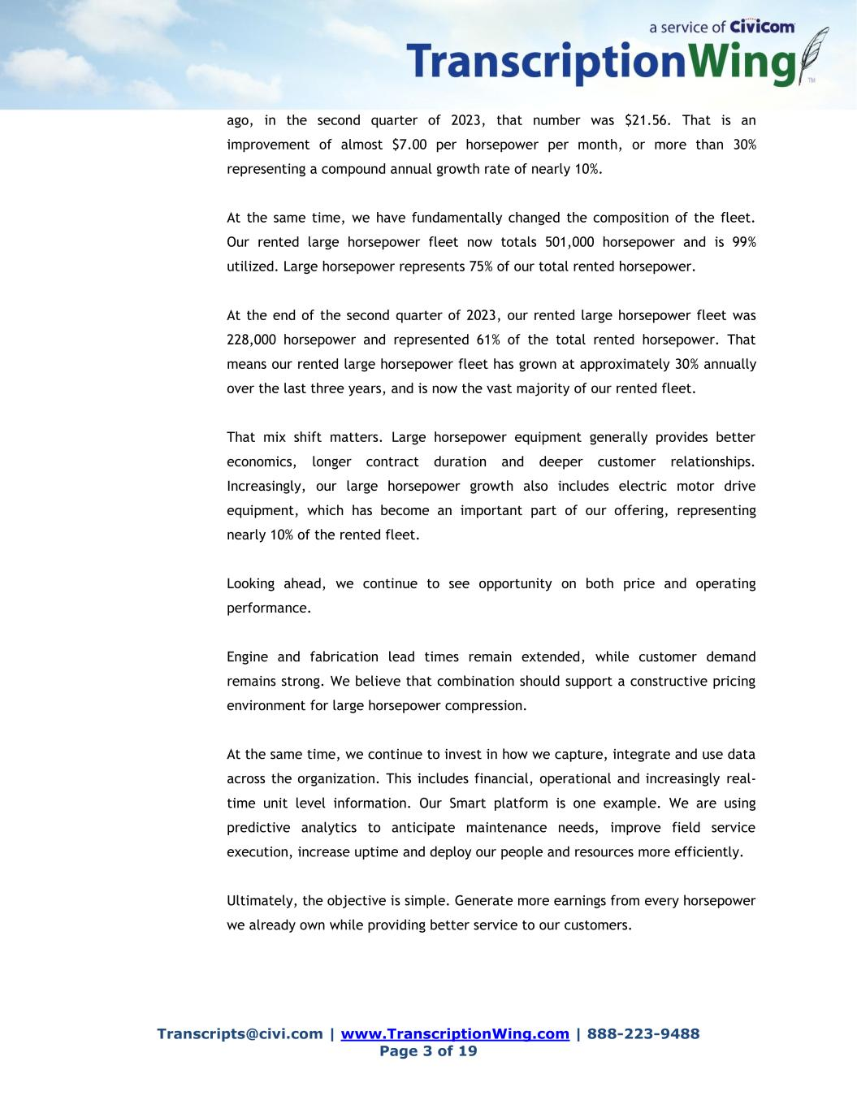
Transcripts@civi.com | www.TranscriptionWing.com | 888-223-9488 Page 3 of 19 ago, in the second quarter of 2023, that number was $21.56. That is an improvement of almost $7.00 per horsepower per month, or more than 30% representing a compound annual growth rate of nearly 10%. At the same time, we have fundamentally changed the composition of the fleet. Our rented large horsepower fleet now totals 501,000 horsepower and is 99% utilized. Large horsepower represents 75% of our total rented horsepower. At the end of the second quarter of 2023, our rented large horsepower fleet was 228,000 horsepower and represented 61% of the total rented horsepower. That means our rented large horsepower fleet has grown at approximately 30% annually over the last three years, and is now the vast majority of our rented fleet. That mix shift matters. Large horsepower equipment generally provides better economics, longer contract duration and deeper customer relationships. Increasingly, our large horsepower growth also includes electric motor drive equipment, which has become an important part of our offering, representing nearly 10% of the rented fleet. Looking ahead, we continue to see opportunity on both price and operating performance. Engine and fabrication lead times remain extended, while customer demand remains strong. We believe that combination should support a constructive pricing environment for large horsepower compression. At the same time, we continue to invest in how we capture, integrate and use data across the organization. This includes financial, operational and increasingly real- time unit level information. Our Smart platform is one example. We are using predictive analytics to anticipate maintenance needs, improve field service execution, increase uptime and deploy our people and resources more efficiently. Ultimately, the objective is simple. Generate more earnings from every horsepower we already own while providing better service to our customers.

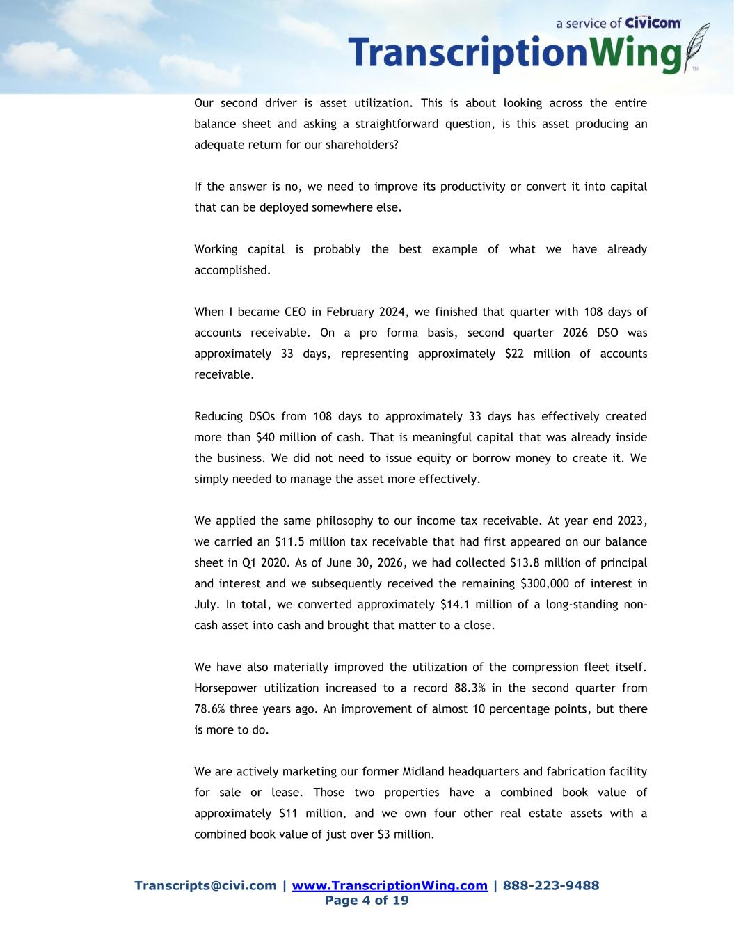
Transcripts@civi.com | www.TranscriptionWing.com | 888-223-9488 Page 4 of 19 Our second driver is asset utilization. This is about looking across the entire balance sheet and asking a straightforward question, is this asset producing an adequate return for our shareholders? If the answer is no, we need to improve its productivity or convert it into capital that can be deployed somewhere else. Working capital is probably the best example of what we have already accomplished. When I became CEO in February 2024, we finished that quarter with 108 days of accounts receivable. On a pro forma basis, second quarter 2026 DSO was approximately 33 days, representing approximately $22 million of accounts receivable. Reducing DSOs from 108 days to approximately 33 days has effectively created more than $40 million of cash. That is meaningful capital that was already inside the business. We did not need to issue equity or borrow money to create it. We simply needed to manage the asset more effectively. We applied the same philosophy to our income tax receivable. At year end 2023, we carried an $11.5 million tax receivable that had first appeared on our balance sheet in Q1 2020. As of June 30, 2026, we had collected $13.8 million of principal and interest and we subsequently received the remaining $300,000 of interest in July. In total, we converted approximately $14.1 million of a long-standing non- cash asset into cash and brought that matter to a close. We have also materially improved the utilization of the compression fleet itself. Horsepower utilization increased to a record 88.3% in the second quarter from 78.6% three years ago. An improvement of almost 10 percentage points, but there is more to do. We are actively marketing our former Midland headquarters and fabrication facility for sale or lease. Those two properties have a combined book value of approximately $11 million, and we own four other real estate assets with a combined book value of just over $3 million.

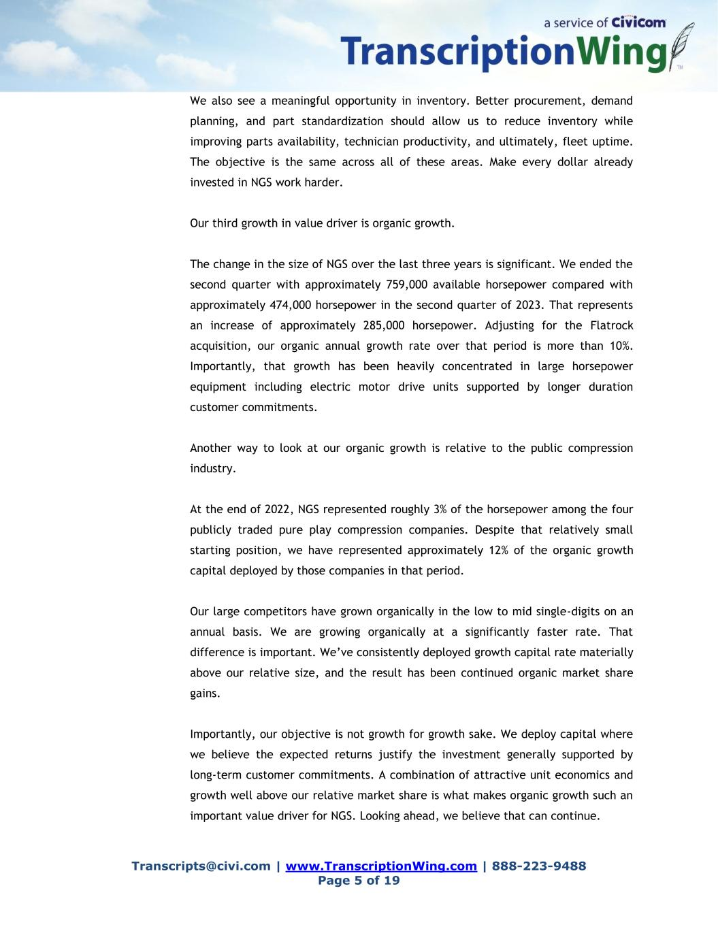
Transcripts@civi.com | www.TranscriptionWing.com | 888-223-9488 Page 5 of 19 We also see a meaningful opportunity in inventory. Better procurement, demand planning, and part standardization should allow us to reduce inventory while improving parts availability, technician productivity, and ultimately, fleet uptime. The objective is the same across all of these areas. Make every dollar already invested in NGS work harder. Our third growth in value driver is organic growth. The change in the size of NGS over the last three years is significant. We ended the second quarter with approximately 759,000 available horsepower compared with approximately 474,000 horsepower in the second quarter of 2023. That represents an increase of approximately 285,000 horsepower. Adjusting for the Flatrock acquisition, our organic annual growth rate over that period is more than 10%. Importantly, that growth has been heavily concentrated in large horsepower equipment including electric motor drive units supported by longer duration customer commitments. Another way to look at our organic growth is relative to the public compression industry. At the end of 2022, NGS represented roughly 3% of the horsepower among the four publicly traded pure play compression companies. Despite that relatively small starting position, we have represented approximately 12% of the organic growth capital deployed by those companies in that period. Our large competitors have grown organically in the low to mid single-digits on an annual basis. We are growing organically at a significantly faster rate. That difference is important. We’ve consistently deployed growth capital rate materially above our relative size, and the result has been continued organic market share gains. Importantly, our objective is not growth for growth sake. We deploy capital where we believe the expected returns justify the investment generally supported by long-term customer commitments. A combination of attractive unit economics and growth well above our relative market share is what makes organic growth such an important value driver for NGS. Looking ahead, we believe that can continue.

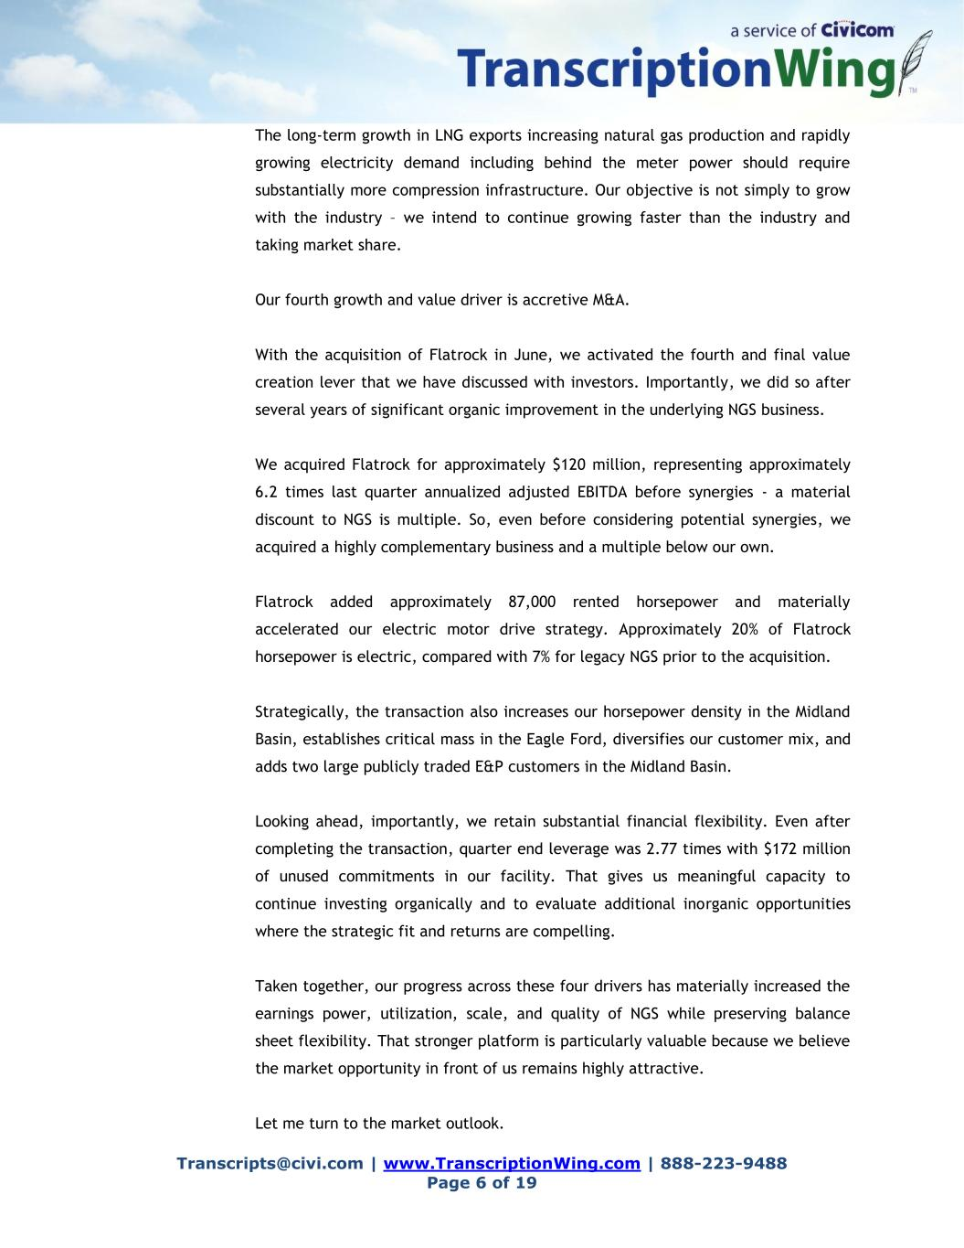
Transcripts@civi.com | www.TranscriptionWing.com | 888-223-9488 Page 6 of 19 The long-term growth in LNG exports increasing natural gas production and rapidly growing electricity demand including behind the meter power should require substantially more compression infrastructure. Our objective is not simply to grow with the industry – we intend to continue growing faster than the industry and taking market share. Our fourth growth and value driver is accretive M&A. With the acquisition of Flatrock in June, we activated the fourth and final value creation lever that we have discussed with investors. Importantly, we did so after several years of significant organic improvement in the underlying NGS business. We acquired Flatrock for approximately $120 million, representing approximately 6.2 times last quarter annualized adjusted EBITDA before synergies - a material discount to NGS is multiple. So, even before considering potential synergies, we acquired a highly complementary business and a multiple below our own. Flatrock added approximately 87,000 rented horsepower and materially accelerated our electric motor drive strategy. Approximately 20% of Flatrock horsepower is electric, compared with 7% for legacy NGS prior to the acquisition. Strategically, the transaction also increases our horsepower density in the Midland Basin, establishes critical mass in the Eagle Ford, diversifies our customer mix, and adds two large publicly traded E&P customers in the Midland Basin. Looking ahead, importantly, we retain substantial financial flexibility. Even after completing the transaction, quarter end leverage was 2.77 times with $172 million of unused commitments in our facility. That gives us meaningful capacity to continue investing organically and to evaluate additional inorganic opportunities where the strategic fit and returns are compelling. Taken together, our progress across these four drivers has materially increased the earnings power, utilization, scale, and quality of NGS while preserving balance sheet flexibility. That stronger platform is particularly valuable because we believe the market opportunity in front of us remains highly attractive. Let me turn to the market outlook.

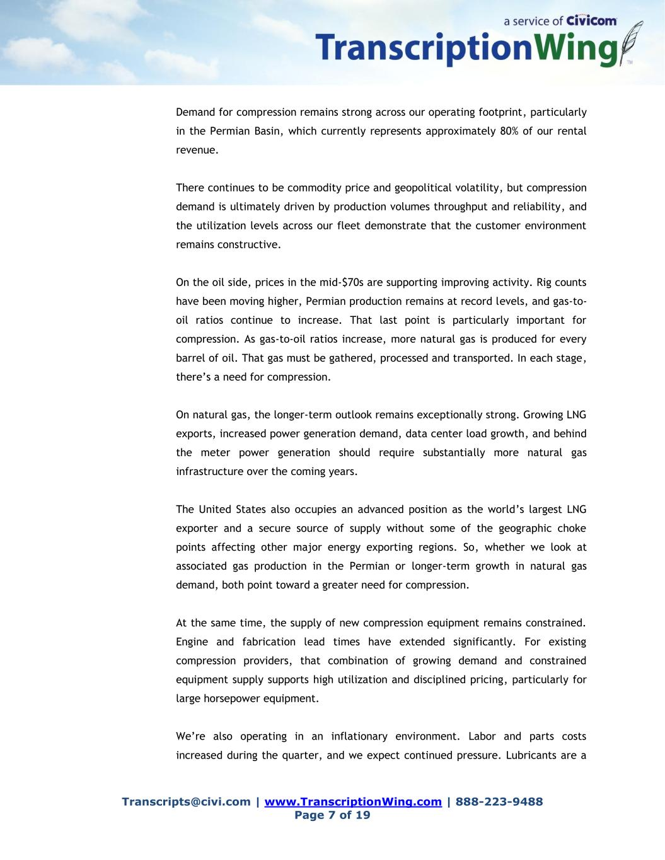
Transcripts@civi.com | www.TranscriptionWing.com | 888-223-9488 Page 7 of 19 Demand for compression remains strong across our operating footprint, particularly in the Permian Basin, which currently represents approximately 80% of our rental revenue. There continues to be commodity price and geopolitical volatility, but compression demand is ultimately driven by production volumes throughput and reliability, and the utilization levels across our fleet demonstrate that the customer environment remains constructive. On the oil side, prices in the mid-$70s are supporting improving activity. Rig counts have been moving higher, Permian production remains at record levels, and gas-to- oil ratios continue to increase. That last point is particularly important for compression. As gas-to-oil ratios increase, more natural gas is produced for every barrel of oil. That gas must be gathered, processed and transported. In each stage, there’s a need for compression. On natural gas, the longer-term outlook remains exceptionally strong. Growing LNG exports, increased power generation demand, data center load growth, and behind the meter power generation should require substantially more natural gas infrastructure over the coming years. The United States also occupies an advanced position as the world’s largest LNG exporter and a secure source of supply without some of the geographic choke points affecting other major energy exporting regions. So, whether we look at associated gas production in the Permian or longer-term growth in natural gas demand, both point toward a greater need for compression. At the same time, the supply of new compression equipment remains constrained. Engine and fabrication lead times have extended significantly. For existing compression providers, that combination of growing demand and constrained equipment supply supports high utilization and disciplined pricing, particularly for large horsepower equipment. We’re also operating in an inflationary environment. Labor and parts costs increased during the quarter, and we expect continued pressure. Lubricants are a

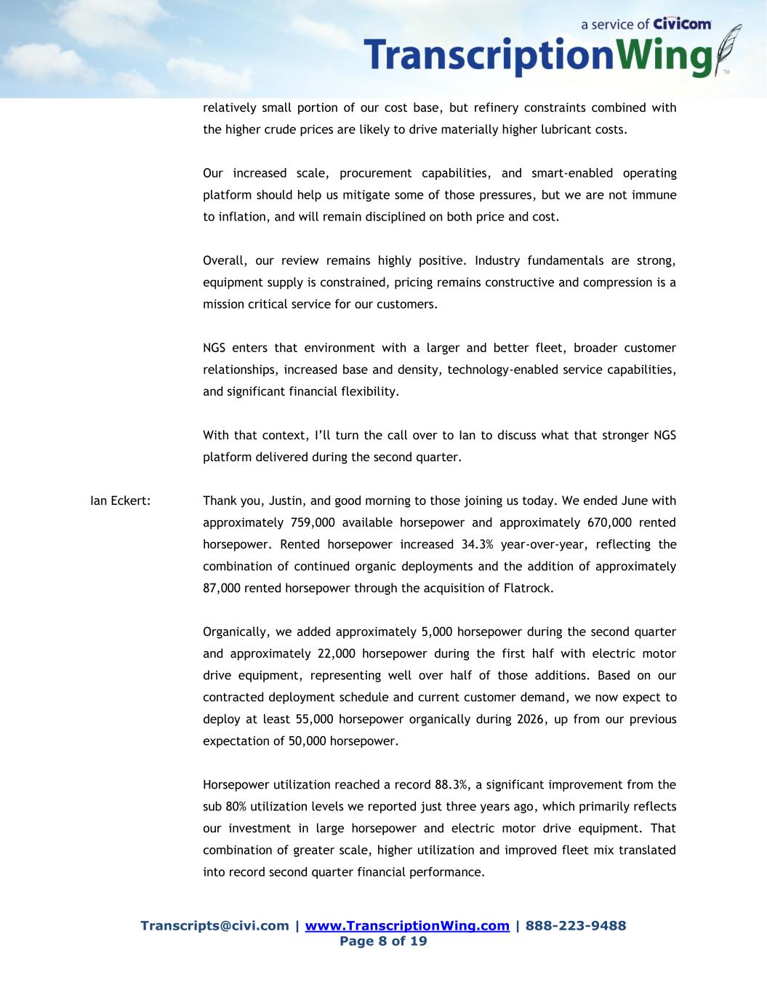
Transcripts@civi.com | www.TranscriptionWing.com | 888-223-9488 Page 8 of 19 relatively small portion of our cost base, but refinery constraints combined with the higher crude prices are likely to drive materially higher lubricant costs. Our increased scale, procurement capabilities, and smart-enabled operating platform should help us mitigate some of those pressures, but we are not immune to inflation, and will remain disciplined on both price and cost. Overall, our review remains highly positive. Industry fundamentals are strong, equipment supply is constrained, pricing remains constructive and compression is a mission critical service for our customers. NGS enters that environment with a larger and better fleet, broader customer relationships, increased base and density, technology-enabled service capabilities, and significant financial flexibility. With that context, I’ll turn the call over to Ian to discuss what that stronger NGS platform delivered during the second quarter. Ian Eckert: Thank you, Justin, and good morning to those joining us today. We ended June with approximately 759,000 available horsepower and approximately 670,000 rented horsepower. Rented horsepower increased 34.3% year-over-year, reflecting the combination of continued organic deployments and the addition of approximately 87,000 rented horsepower through the acquisition of Flatrock. Organically, we added approximately 5,000 horsepower during the second quarter and approximately 22,000 horsepower during the first half with electric motor drive equipment, representing well over half of those additions. Based on our contracted deployment schedule and current customer demand, we now expect to deploy at least 55,000 horsepower organically during 2026, up from our previous expectation of 50,000 horsepower. Horsepower utilization reached a record 88.3%, a significant improvement from the sub 80% utilization levels we reported just three years ago, which primarily reflects our investment in large horsepower and electric motor drive equipment. That combination of greater scale, higher utilization and improved fleet mix translated into record second quarter financial performance.

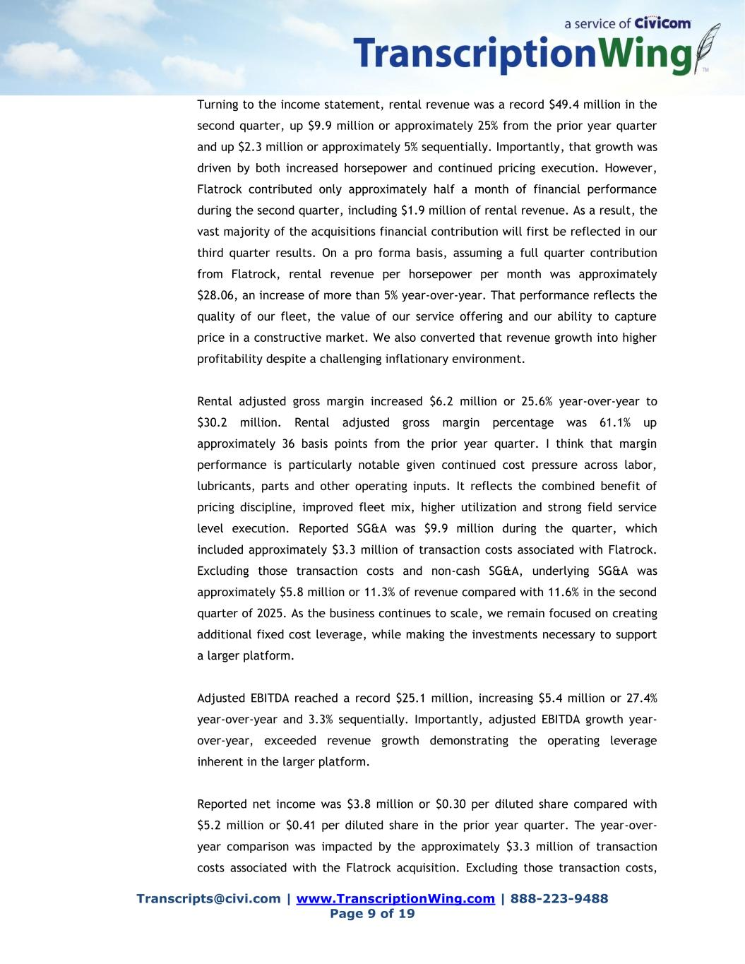
Transcripts@civi.com | www.TranscriptionWing.com | 888-223-9488 Page 9 of 19 Turning to the income statement, rental revenue was a record $49.4 million in the second quarter, up $9.9 million or approximately 25% from the prior year quarter and up $2.3 million or approximately 5% sequentially. Importantly, that growth was driven by both increased horsepower and continued pricing execution. However, Flatrock contributed only approximately half a month of financial performance during the second quarter, including $1.9 million of rental revenue. As a result, the vast majority of the acquisitions financial contribution will first be reflected in our third quarter results. On a pro forma basis, assuming a full quarter contribution from Flatrock, rental revenue per horsepower per month was approximately $28.06, an increase of more than 5% year-over-year. That performance reflects the quality of our fleet, the value of our service offering and our ability to capture price in a constructive market. We also converted that revenue growth into higher profitability despite a challenging inflationary environment. Rental adjusted gross margin increased $6.2 million or 25.6% year-over-year to $30.2 million. Rental adjusted gross margin percentage was 61.1% up approximately 36 basis points from the prior year quarter. I think that margin performance is particularly notable given continued cost pressure across labor, lubricants, parts and other operating inputs. It reflects the combined benefit of pricing discipline, improved fleet mix, higher utilization and strong field service level execution. Reported SG&A was $9.9 million during the quarter, which included approximately $3.3 million of transaction costs associated with Flatrock. Excluding those transaction costs and non-cash SG&A, underlying SG&A was approximately $5.8 million or 11.3% of revenue compared with 11.6% in the second quarter of 2025. As the business continues to scale, we remain focused on creating additional fixed cost leverage, while making the investments necessary to support a larger platform. Adjusted EBITDA reached a record $25.1 million, increasing $5.4 million or 27.4% year-over-year and 3.3% sequentially. Importantly, adjusted EBITDA growth year- over-year, exceeded revenue growth demonstrating the operating leverage inherent in the larger platform. Reported net income was $3.8 million or $0.30 per diluted share compared with $5.2 million or $0.41 per diluted share in the prior year quarter. The year-over- year comparison was impacted by the approximately $3.3 million of transaction costs associated with the Flatrock acquisition. Excluding those transaction costs,

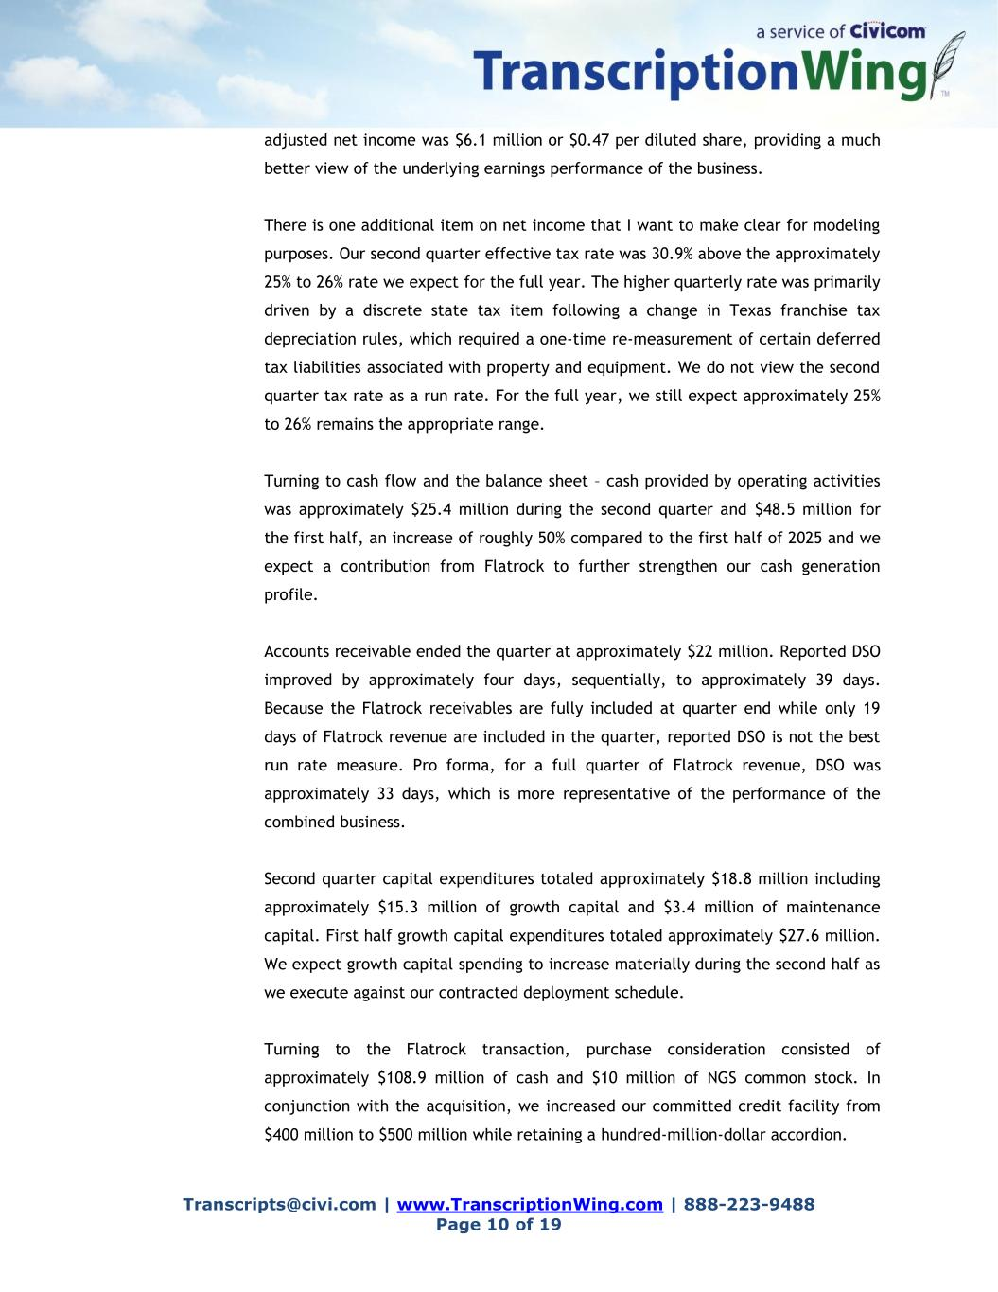
Transcripts@civi.com | www.TranscriptionWing.com | 888-223-9488 Page 10 of 19 adjusted net income was $6.1 million or $0.47 per diluted share, providing a much better view of the underlying earnings performance of the business. There is one additional item on net income that I want to make clear for modeling purposes. Our second quarter effective tax rate was 30.9% above the approximately 25% to 26% rate we expect for the full year. The higher quarterly rate was primarily driven by a discrete state tax item following a change in Texas franchise tax depreciation rules, which required a one-time re-measurement of certain deferred tax liabilities associated with property and equipment. We do not view the second quarter tax rate as a run rate. For the full year, we still expect approximately 25% to 26% remains the appropriate range. Turning to cash flow and the balance sheet – cash provided by operating activities was approximately $25.4 million during the second quarter and $48.5 million for the first half, an increase of roughly 50% compared to the first half of 2025 and we expect a contribution from Flatrock to further strengthen our cash generation profile. Accounts receivable ended the quarter at approximately $22 million. Reported DSO improved by approximately four days, sequentially, to approximately 39 days. Because the Flatrock receivables are fully included at quarter end while only 19 days of Flatrock revenue are included in the quarter, reported DSO is not the best run rate measure. Pro forma, for a full quarter of Flatrock revenue, DSO was approximately 33 days, which is more representative of the performance of the combined business. Second quarter capital expenditures totaled approximately $18.8 million including approximately $15.3 million of growth capital and $3.4 million of maintenance capital. First half growth capital expenditures totaled approximately $27.6 million. We expect growth capital spending to increase materially during the second half as we execute against our contracted deployment schedule. Turning to the Flatrock transaction, purchase consideration consisted of approximately $108.9 million of cash and $10 million of NGS common stock. In conjunction with the acquisition, we increased our committed credit facility from $400 million to $500 million while retaining a hundred-million-dollar accordion.

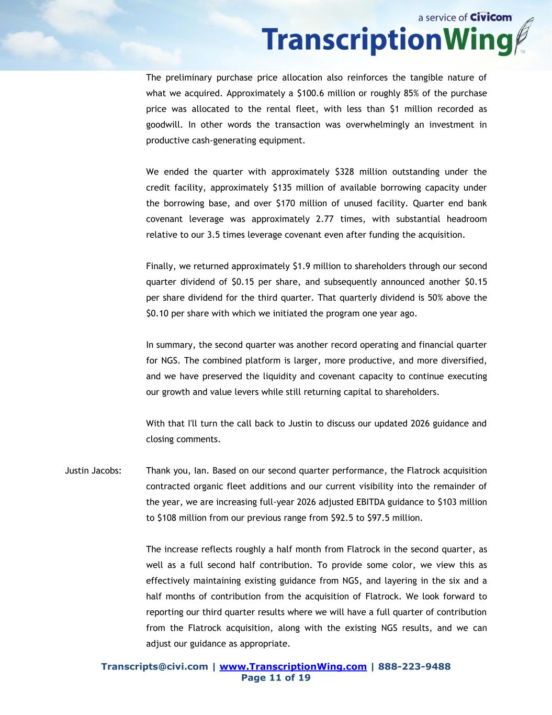
Transcripts@civi.com | www.TranscriptionWing.com | 888-223-9488 Page 11 of 19 The preliminary purchase price allocation also reinforces the tangible nature of what we acquired. Approximately a $100.6 million or roughly 85% of the purchase price was allocated to the rental fleet, with less than $1 million recorded as goodwill. In other words the transaction was overwhelmingly an investment in productive cash-generating equipment. We ended the quarter with approximately $328 million outstanding under the credit facility, approximately $135 million of available borrowing capacity under the borrowing base, and over $170 million of unused facility. Quarter end bank covenant leverage was approximately 2.77 times, with substantial headroom relative to our 3.5 times leverage covenant even after funding the acquisition. Finally, we returned approximately $1.9 million to shareholders through our second quarter dividend of $0.15 per share, and subsequently announced another $0.15 per share dividend for the third quarter. That quarterly dividend is 50% above the $0.10 per share with which we initiated the program one year ago. In summary, the second quarter was another record operating and financial quarter for NGS. The combined platform is larger, more productive, and more diversified, and we have preserved the liquidity and covenant capacity to continue executing our growth and value levers while still returning capital to shareholders. With that I'll turn the call back to Justin to discuss our updated 2026 guidance and closing comments. Justin Jacobs: Thank you, Ian. Based on our second quarter performance, the Flatrock acquisition contracted organic fleet additions and our current visibility into the remainder of the year, we are increasing full-year 2026 adjusted EBITDA guidance to $103 million to $108 million from our previous range from $92.5 to $97.5 million. The increase reflects roughly a half month from Flatrock in the second quarter, as well as a full second half contribution. To provide some color, we view this as effectively maintaining existing guidance from NGS, and layering in the six and a half months of contribution from the acquisition of Flatrock. We look forward to reporting our third quarter results where we will have a full quarter of contribution from the Flatrock acquisition, along with the existing NGS results, and we can adjust our guidance as appropriate.

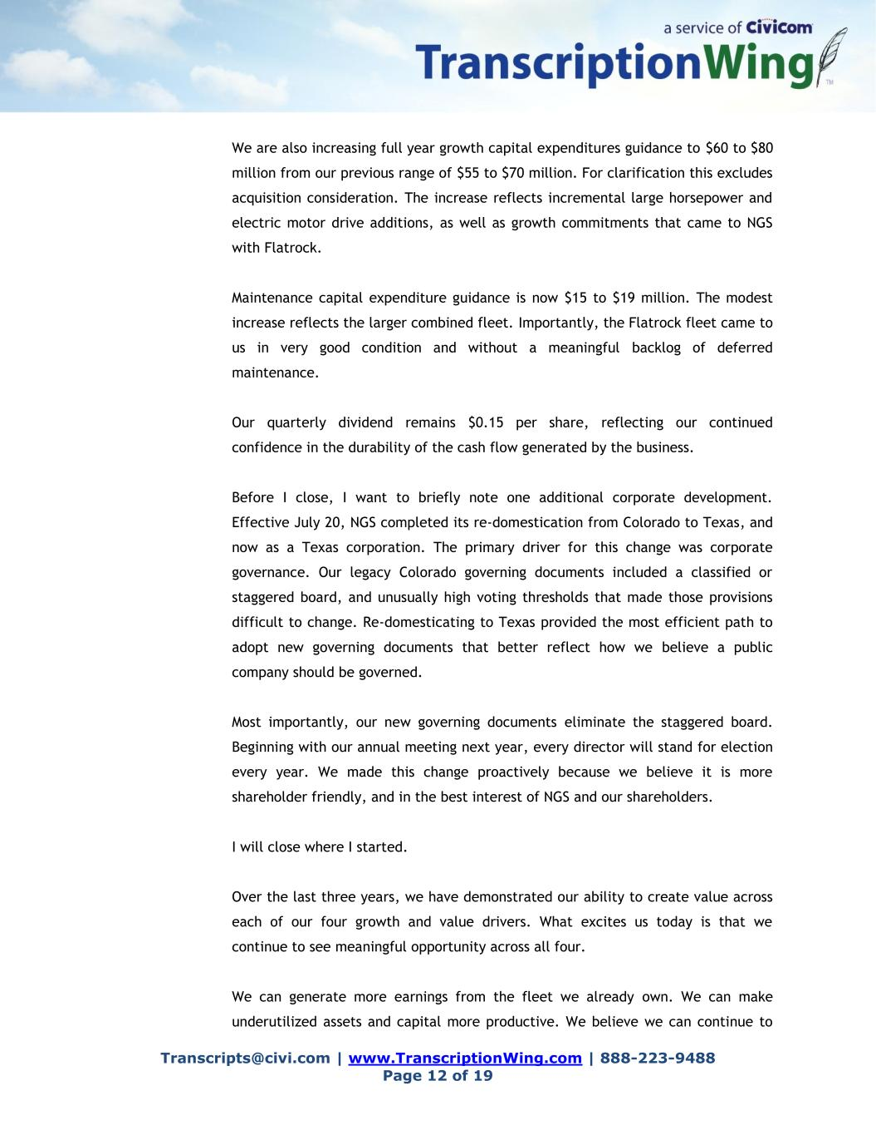
Transcripts@civi.com | www.TranscriptionWing.com | 888-223-9488 Page 12 of 19 We are also increasing full year growth capital expenditures guidance to $60 to $80 million from our previous range of $55 to $70 million. For clarification this excludes acquisition consideration. The increase reflects incremental large horsepower and electric motor drive additions, as well as growth commitments that came to NGS with Flatrock. Maintenance capital expenditure guidance is now $15 to $19 million. The modest increase reflects the larger combined fleet. Importantly, the Flatrock fleet came to us in very good condition and without a meaningful backlog of deferred maintenance. Our quarterly dividend remains $0.15 per share, reflecting our continued confidence in the durability of the cash flow generated by the business. Before I close, I want to briefly note one additional corporate development. Effective July 20, NGS completed its re-domestication from Colorado to Texas, and now as a Texas corporation. The primary driver for this change was corporate governance. Our legacy Colorado governing documents included a classified or staggered board, and unusually high voting thresholds that made those provisions difficult to change. Re-domesticating to Texas provided the most efficient path to adopt new governing documents that better reflect how we believe a public company should be governed. Most importantly, our new governing documents eliminate the staggered board. Beginning with our annual meeting next year, every director will stand for election every year. We made this change proactively because we believe it is more shareholder friendly, and in the best interest of NGS and our shareholders. I will close where I started. Over the last three years, we have demonstrated our ability to create value across each of our four growth and value drivers. What excites us today is that we continue to see meaningful opportunity across all four. We can generate more earnings from the fleet we already own. We can make underutilized assets and capital more productive. We believe we can continue to

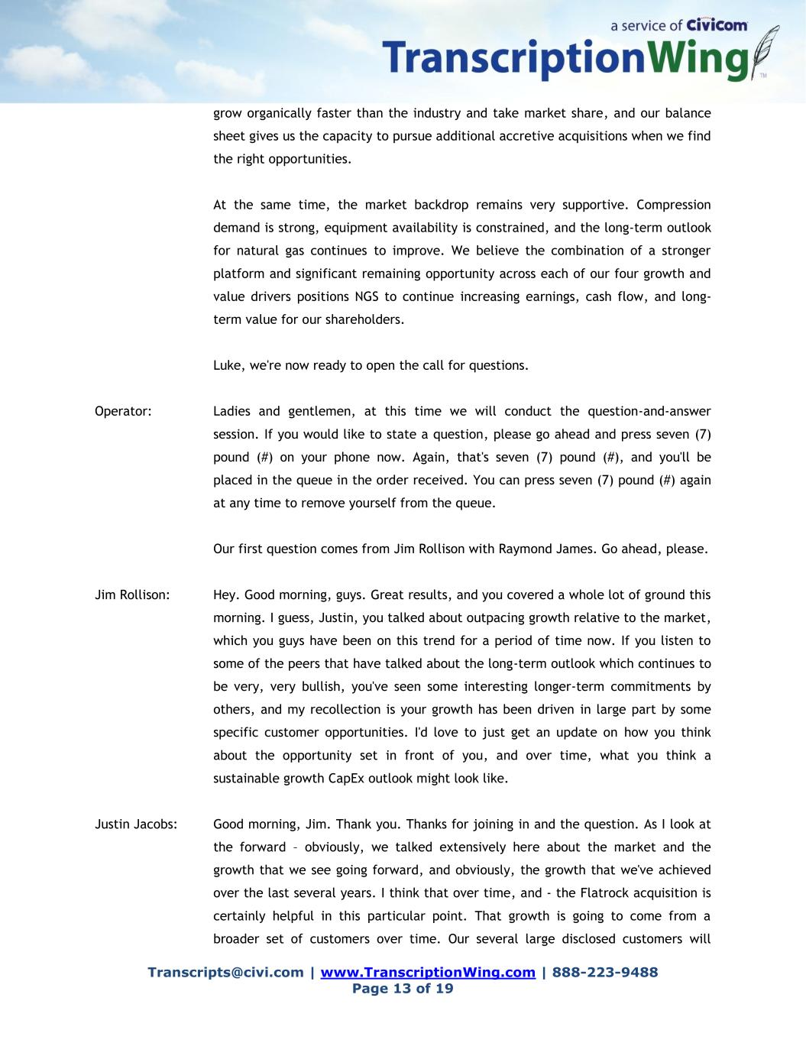
Transcripts@civi.com | www.TranscriptionWing.com | 888-223-9488 Page 13 of 19 grow organically faster than the industry and take market share, and our balance sheet gives us the capacity to pursue additional accretive acquisitions when we find the right opportunities. At the same time, the market backdrop remains very supportive. Compression demand is strong, equipment availability is constrained, and the long-term outlook for natural gas continues to improve. We believe the combination of a stronger platform and significant remaining opportunity across each of our four growth and value drivers positions NGS to continue increasing earnings, cash flow, and long- term value for our shareholders. Luke, we're now ready to open the call for questions. Operator: Ladies and gentlemen, at this time we will conduct the question-and-answer session. If you would like to state a question, please go ahead and press seven (7) pound (#) on your phone now. Again, that's seven (7) pound (#), and you'll be placed in the queue in the order received. You can press seven (7) pound (#) again at any time to remove yourself from the queue. Our first question comes from Jim Rollison with Raymond James. Go ahead, please. Jim Rollison: Hey. Good morning, guys. Great results, and you covered a whole lot of ground this morning. I guess, Justin, you talked about outpacing growth relative to the market, which you guys have been on this trend for a period of time now. If you listen to some of the peers that have talked about the long-term outlook which continues to be very, very bullish, you've seen some interesting longer-term commitments by others, and my recollection is your growth has been driven in large part by some specific customer opportunities. I'd love to just get an update on how you think about the opportunity set in front of you, and over time, what you think a sustainable growth CapEx outlook might look like. Justin Jacobs: Good morning, Jim. Thank you. Thanks for joining in and the question. As I look at the forward – obviously, we talked extensively here about the market and the growth that we see going forward, and obviously, the growth that we've achieved over the last several years. I think that over time, and - the Flatrock acquisition is certainly helpful in this particular point. That growth is going to come from a broader set of customers over time. Our several large disclosed customers will

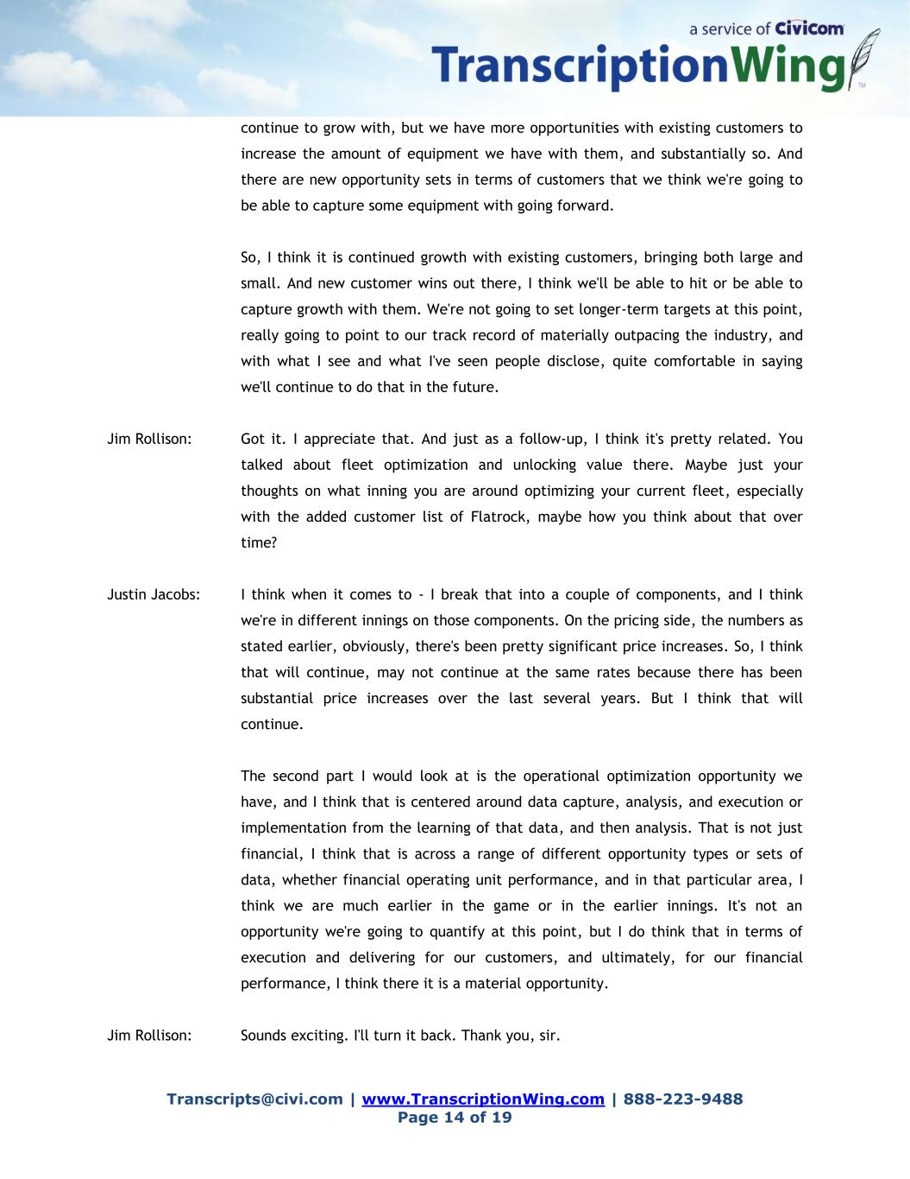
Transcripts@civi.com | www.TranscriptionWing.com | 888-223-9488 Page 14 of 19 continue to grow with, but we have more opportunities with existing customers to increase the amount of equipment we have with them, and substantially so. And there are new opportunity sets in terms of customers that we think we're going to be able to capture some equipment with going forward. So, I think it is continued growth with existing customers, bringing both large and small. And new customer wins out there, I think we'll be able to hit or be able to capture growth with them. We're not going to set longer-term targets at this point, really going to point to our track record of materially outpacing the industry, and with what I see and what I've seen people disclose, quite comfortable in saying we'll continue to do that in the future. Jim Rollison: Got it. I appreciate that. And just as a follow-up, I think it's pretty related. You talked about fleet optimization and unlocking value there. Maybe just your thoughts on what inning you are around optimizing your current fleet, especially with the added customer list of Flatrock, maybe how you think about that over time? Justin Jacobs: I think when it comes to - I break that into a couple of components, and I think we're in different innings on those components. On the pricing side, the numbers as stated earlier, obviously, there's been pretty significant price increases. So, I think that will continue, may not continue at the same rates because there has been substantial price increases over the last several years. But I think that will continue. The second part I would look at is the operational optimization opportunity we have, and I think that is centered around data capture, analysis, and execution or implementation from the learning of that data, and then analysis. That is not just financial, I think that is across a range of different opportunity types or sets of data, whether financial operating unit performance, and in that particular area, I think we are much earlier in the game or in the earlier innings. It's not an opportunity we're going to quantify at this point, but I do think that in terms of execution and delivering for our customers, and ultimately, for our financial performance, I think there it is a material opportunity. Jim Rollison: Sounds exciting. I'll turn it back. Thank you, sir.

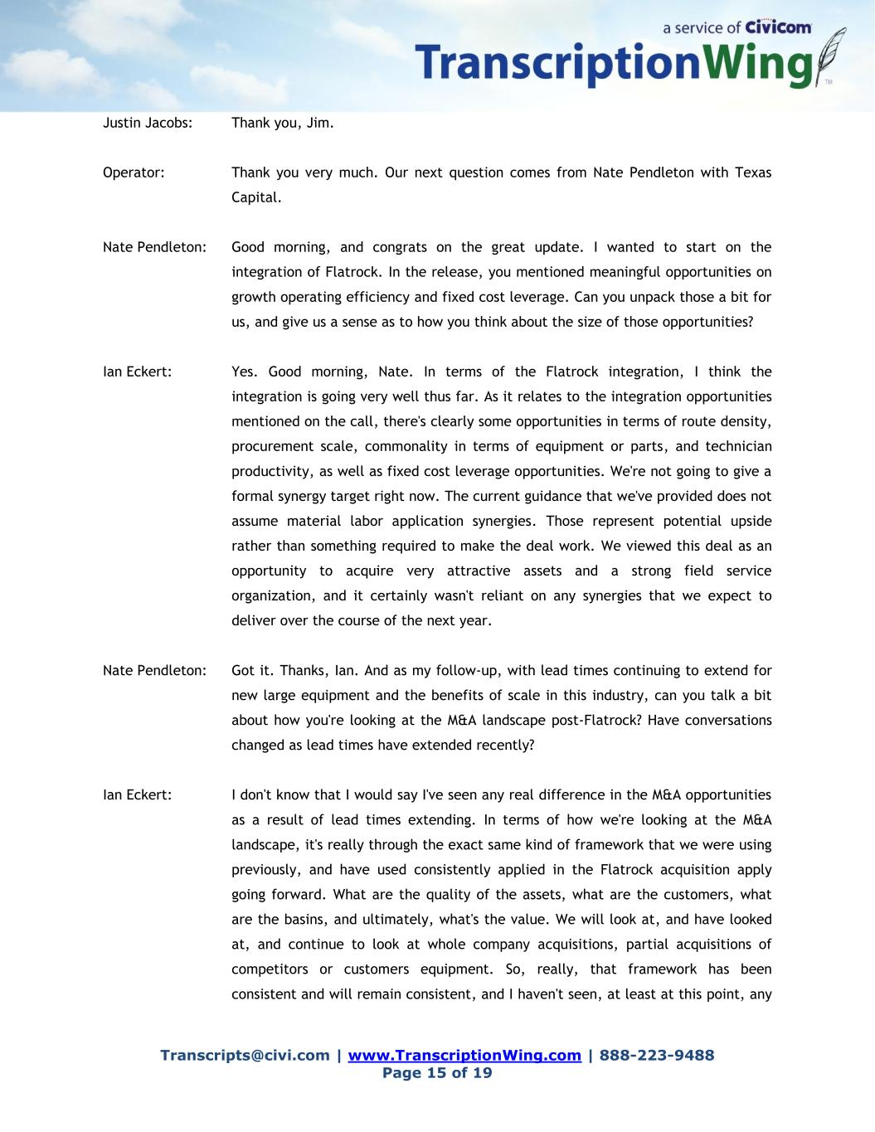
Transcripts@civi.com | www.TranscriptionWing.com | 888-223-9488 Page 15 of 19 Justin Jacobs: Thank you, Jim. Operator: Thank you very much. Our next question comes from Nate Pendleton with Texas Capital. Nate Pendleton: Good morning, and congrats on the great update. I wanted to start on the integration of Flatrock. In the release, you mentioned meaningful opportunities on growth operating efficiency and fixed cost leverage. Can you unpack those a bit for us, and give us a sense as to how you think about the size of those opportunities? Ian Eckert: Yes. Good morning, Nate. In terms of the Flatrock integration, I think the integration is going very well thus far. As it relates to the integration opportunities mentioned on the call, there's clearly some opportunities in terms of route density, procurement scale, commonality in terms of equipment or parts, and technician productivity, as well as fixed cost leverage opportunities. We're not going to give a formal synergy target right now. The current guidance that we've provided does not assume material labor application synergies. Those represent potential upside rather than something required to make the deal work. We viewed this deal as an opportunity to acquire very attractive assets and a strong field service organization, and it certainly wasn't reliant on any synergies that we expect to deliver over the course of the next year. Nate Pendleton: Got it. Thanks, Ian. And as my follow-up, with lead times continuing to extend for new large equipment and the benefits of scale in this industry, can you talk a bit about how you're looking at the M&A landscape post-Flatrock? Have conversations changed as lead times have extended recently? Ian Eckert: I don't know that I would say I've seen any real difference in the M&A opportunities as a result of lead times extending. In terms of how we're looking at the M&A landscape, it's really through the exact same kind of framework that we were using previously, and have used consistently applied in the Flatrock acquisition apply going forward. What are the quality of the assets, what are the customers, what are the basins, and ultimately, what's the value. We will look at, and have looked at, and continue to look at whole company acquisitions, partial acquisitions of competitors or customers equipment. So, really, that framework has been consistent and will remain consistent, and I haven't seen, at least at this point, any

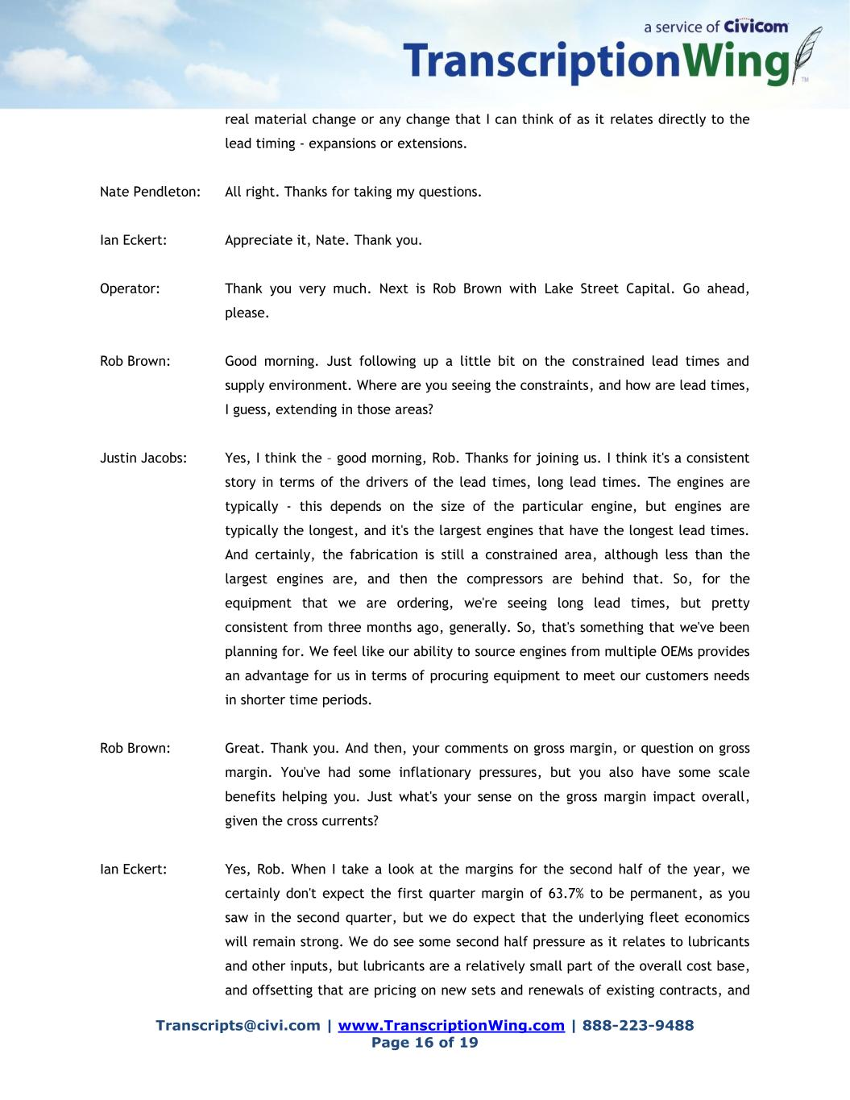
Transcripts@civi.com | www.TranscriptionWing.com | 888-223-9488 Page 16 of 19 real material change or any change that I can think of as it relates directly to the lead timing - expansions or extensions. Nate Pendleton: All right. Thanks for taking my questions. Ian Eckert: Appreciate it, Nate. Thank you. Operator: Thank you very much. Next is Rob Brown with Lake Street Capital. Go ahead, please. Rob Brown: Good morning. Just following up a little bit on the constrained lead times and supply environment. Where are you seeing the constraints, and how are lead times, I guess, extending in those areas? Justin Jacobs: Yes, I think the – good morning, Rob. Thanks for joining us. I think it's a consistent story in terms of the drivers of the lead times, long lead times. The engines are typically - this depends on the size of the particular engine, but engines are typically the longest, and it's the largest engines that have the longest lead times. And certainly, the fabrication is still a constrained area, although less than the largest engines are, and then the compressors are behind that. So, for the equipment that we are ordering, we're seeing long lead times, but pretty consistent from three months ago, generally. So, that's something that we've been planning for. We feel like our ability to source engines from multiple OEMs provides an advantage for us in terms of procuring equipment to meet our customers needs in shorter time periods. Rob Brown: Great. Thank you. And then, your comments on gross margin, or question on gross margin. You've had some inflationary pressures, but you also have some scale benefits helping you. Just what's your sense on the gross margin impact overall, given the cross currents? Ian Eckert: Yes, Rob. When I take a look at the margins for the second half of the year, we certainly don't expect the first quarter margin of 63.7% to be permanent, as you saw in the second quarter, but we do expect that the underlying fleet economics will remain strong. We do see some second half pressure as it relates to lubricants and other inputs, but lubricants are a relatively small part of the overall cost base, and offsetting that are pricing on new sets and renewals of existing contracts, and

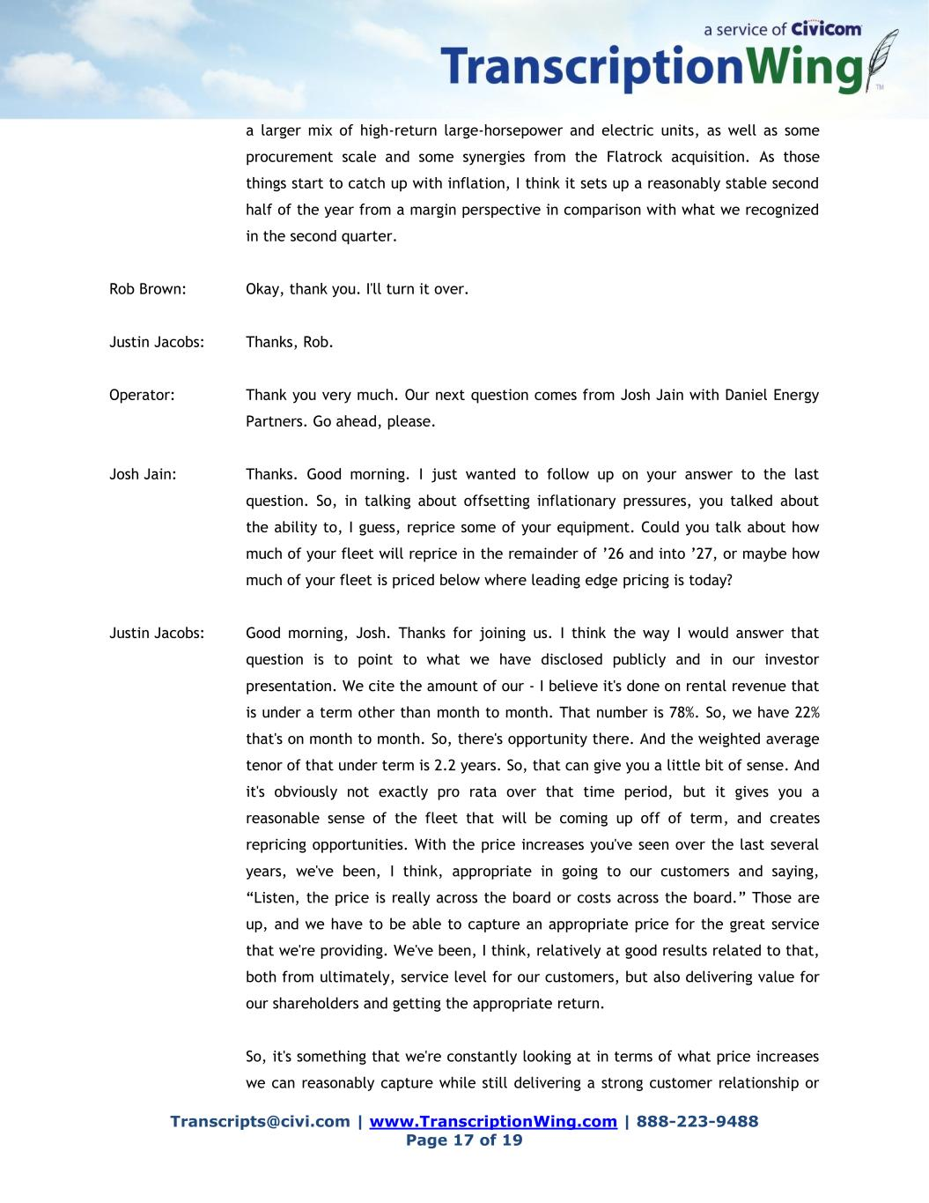
Transcripts@civi.com | www.TranscriptionWing.com | 888-223-9488 Page 17 of 19 a larger mix of high-return large-horsepower and electric units, as well as some procurement scale and some synergies from the Flatrock acquisition. As those things start to catch up with inflation, I think it sets up a reasonably stable second half of the year from a margin perspective in comparison with what we recognized in the second quarter. Rob Brown: Okay, thank you. I'll turn it over. Justin Jacobs: Thanks, Rob. Operator: Thank you very much. Our next question comes from Josh Jain with Daniel Energy Partners. Go ahead, please. Josh Jain: Thanks. Good morning. I just wanted to follow up on your answer to the last question. So, in talking about offsetting inflationary pressures, you talked about the ability to, I guess, reprice some of your equipment. Could you talk about how much of your fleet will reprice in the remainder of ’26 and into ’27, or maybe how much of your fleet is priced below where leading edge pricing is today? Justin Jacobs: Good morning, Josh. Thanks for joining us. I think the way I would answer that question is to point to what we have disclosed publicly and in our investor presentation. We cite the amount of our - I believe it's done on rental revenue that is under a term other than month to month. That number is 78%. So, we have 22% that's on month to month. So, there's opportunity there. And the weighted average tenor of that under term is 2.2 years. So, that can give you a little bit of sense. And it's obviously not exactly pro rata over that time period, but it gives you a reasonable sense of the fleet that will be coming up off of term, and creates repricing opportunities. With the price increases you've seen over the last several years, we've been, I think, appropriate in going to our customers and saying, “Listen, the price is really across the board or costs across the board.” Those are up, and we have to be able to capture an appropriate price for the great service that we're providing. We've been, I think, relatively at good results related to that, both from ultimately, service level for our customers, but also delivering value for our shareholders and getting the appropriate return. So, it's something that we're constantly looking at in terms of what price increases we can reasonably capture while still delivering a strong customer relationship or

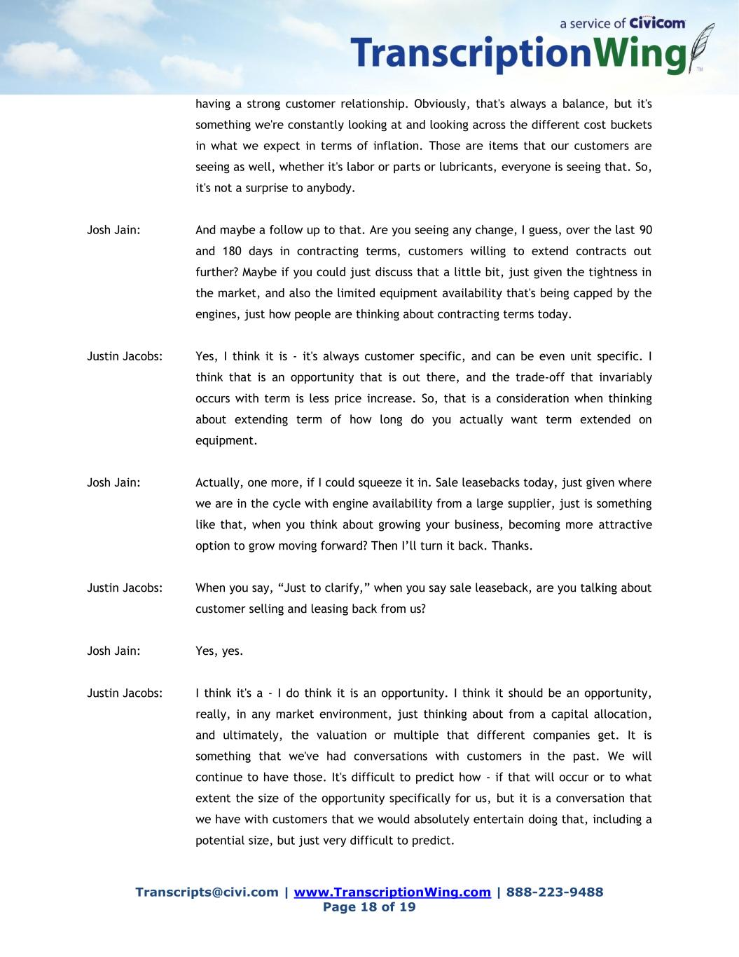
Transcripts@civi.com | www.TranscriptionWing.com | 888-223-9488 Page 18 of 19 having a strong customer relationship. Obviously, that's always a balance, but it's something we're constantly looking at and looking across the different cost buckets in what we expect in terms of inflation. Those are items that our customers are seeing as well, whether it's labor or parts or lubricants, everyone is seeing that. So, it's not a surprise to anybody. Josh Jain: And maybe a follow up to that. Are you seeing any change, I guess, over the last 90 and 180 days in contracting terms, customers willing to extend contracts out further? Maybe if you could just discuss that a little bit, just given the tightness in the market, and also the limited equipment availability that's being capped by the engines, just how people are thinking about contracting terms today. Justin Jacobs: Yes, I think it is - it's always customer specific, and can be even unit specific. I think that is an opportunity that is out there, and the trade-off that invariably occurs with term is less price increase. So, that is a consideration when thinking about extending term of how long do you actually want term extended on equipment. Josh Jain: Actually, one more, if I could squeeze it in. Sale leasebacks today, just given where we are in the cycle with engine availability from a large supplier, just is something like that, when you think about growing your business, becoming more attractive option to grow moving forward? Then I’ll turn it back. Thanks. Justin Jacobs: When you say, “Just to clarify,” when you say sale leaseback, are you talking about customer selling and leasing back from us? Josh Jain: Yes, yes. Justin Jacobs: I think it's a - I do think it is an opportunity. I think it should be an opportunity, really, in any market environment, just thinking about from a capital allocation, and ultimately, the valuation or multiple that different companies get. It is something that we've had conversations with customers in the past. We will continue to have those. It's difficult to predict how - if that will occur or to what extent the size of the opportunity specifically for us, but it is a conversation that we have with customers that we would absolutely entertain doing that, including a potential size, but just very difficult to predict.

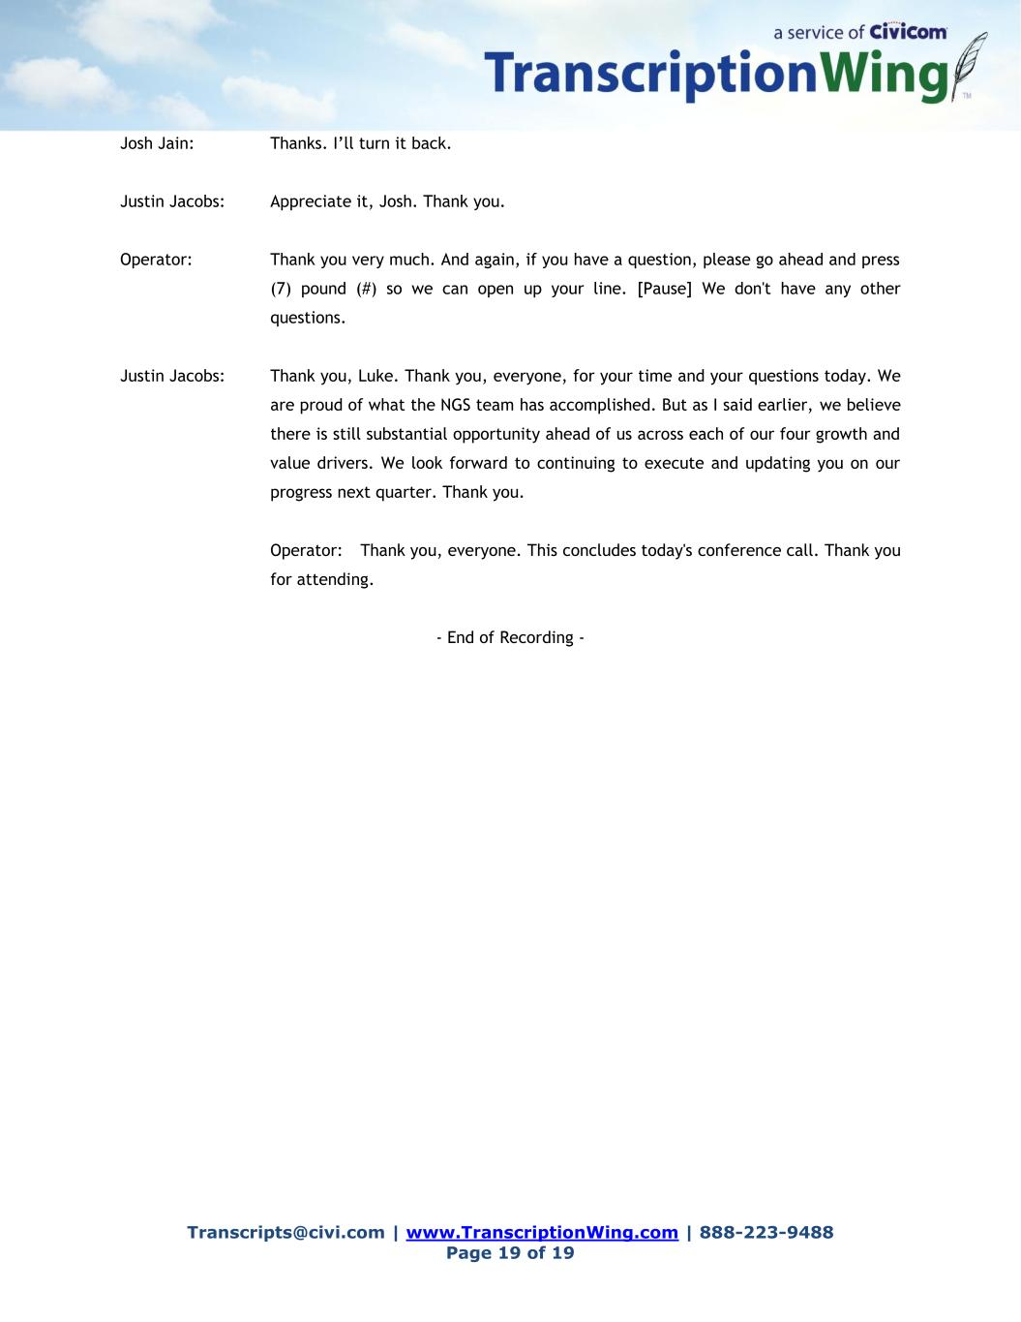
Transcripts@civi.com | www.TranscriptionWing.com | 888-223-9488 Page 19 of 19 Josh Jain: Thanks. I’ll turn it back. Justin Jacobs: Appreciate it, Josh. Thank you. Operator: Thank you very much. And again, if you have a question, please go ahead and press (7) pound (#) so we can open up your line. [Pause] We don't have any other questions. Justin Jacobs: Thank you, Luke. Thank you, everyone, for your time and your questions today. We are proud of what the NGS team has accomplished. But as I said earlier, we believe there is still substantial opportunity ahead of us across each of our four growth and value drivers. We look forward to continuing to execute and updating you on our progress next quarter. Thank you. Operator: Thank you, everyone. This concludes today's conference call. Thank you for attending. - End of Recording -

